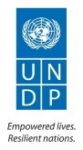



United Nations Development Programme
Country: The Philippines

PROJECT DOCUMENT

Project Title: | Development for Renewable Energy Applications Mainstreaming and Market Sustainability (DREAMS)
UNDAF Outcome(s):
UNDP Strategic Plan Environment and Sustainable Development Primary Outcome: Strengthened national capacities to mainstream environment and energy concerns into national development plans and implementation systems
UNDP Strategic Plan Secondary Outcome:
Expected CP Outcome(s): Outcome 3. Energy and Environment: Improved environmental sustainability of development processes
Expected CPAP Output(s):
Executing Entity/Implementing Partner: Department of Energy (DOE)/REMB
Implementing Entity/Responsible Partners: Department of Energy (DOE)/REMB and UNDP
Brief Description
The objective of the Project is to reduce GHG emissions through the promotion and facilitation of the commercialization of renewable energy (RE) markets through the removal of barriers to increase investments in RE-based power generation projects. This will be achieved through 4 components with the following outcomes: 1) Enforcement of a supportive policy and regulatory environment for leveraging investment in RE development and applications at the local level; 2) strengthened institutional capacity that leads to increased RE investment at the local level; 3) increased share of RE-based power capacity; and 4) enhanced confidence of local RE developers that leads to an enhanced uptake of RE projects and successful replication using proven and emerging RE technologies. The Project will lead to direct lifetime GHG emission reductions of 2.445 ktonnes CO₂, and indirect CO₂ reductions ranging from 4,889 to 141,000 ktonnes CO₂.

Total resources required $ 43,502,222
Total allocated resources:
- GEF $ 5,200,000
- UNDP $ 200,000
- DOE $ 2,300,000
- PEMC $ 2,700,000
- Local Government $ 1,222,222
- Private Sector $ 31,880,000

Leveraged Co-financing $ 270,000,000
Programme Period: 2016- 2020
Atlas Award ID: 00088788
Project ID: 00095299
PIMS # 5194
Start date: 1 January 2016
End Date 31 December 2020
Management Arrangements NIM
PAC Meeting Date tbd

Agreed by (Government):
Date/Month/Year

Agreed by (Executing Entity/Implementing Partner):
Date/Month/Year

Agreed by (UNDP):
Date/Month/Year
Table of Contents

Acronyms 3
Situation analysis 6
Context and Global Significance 6
Threats and Root Causes 10
Barrier Analysis 10
Stakeholder Analysis 16
Baseline Analysis 20
STRATEGY 26
Project Rationale and Policy Conformity 26
Country Ownership: Country Eligibility 27
Country Drivenness 27
Alternative Scenario 27
Project Goal, Objective, Outcomes and Outputs 29
Key Indicators and Risks 49
Cost Effectiveness 50
Sustainability, Replicability, Innovativeness and Impact 51
project results framework 54
total budget and work plan 58
MANAGEMENT ARRANGEMENTS 64
Project Organization Structure 64
General 66
MONITORING FRAMEWORK AND EVALUATION 68
LEGAL CONTEXT 73
Annex I: Risk Analysis 75
Annex II: Detailed CO₂ Calculations and Assumptions 77
Annex III: Co-Financing Letters 82
Annex IV: Terms of Reference for Project Staff and Consultants 90
Annex V: UNDP Social and Environmental Screening Procedure (SESP) 98

Acronyms

Acronym | Meaning
AGMO | autonomous group market operator
APEC | Association of Philippine Electric Cooperatives
APR | Annual Progress Report
BAU | Business-as-usual
BoI | Board of Investment
BOT | Build-Operate-Transfer
BTOR | Back-to-office report
CBRED | Capacity Building to Remove Barriers to Renewable Energy Development
CCC | Climate Change Commission
CPAP | Country Programme Action Plan
CSO | Civil Society Organization
CSR | Corporate social responsibility
CTA | Chief Technical Advisor
DENR | Department of Environment and Natural Resources
DILG | Department of the Interior and Local Government
DLPC | Davao Light and Power Company
DPB | Development Bank of the Philippines
DPWH | Department of Public Works and Highways
DTI | Department of Trade and Industry
DU | Distribution utility
EC | Electrical Cooperatives
ECC | Environmental Clearance Certificate
EE | Energy Efficiency
EIAs | Environmental Impact Assessments
EIS | Environmental Impact Statement
EMB | Environment Management Bureau
EOP | End of Project
EPIMB | Electric Power Industry Management Bureau
EPIRA | Electricity Power Industry Reform Act
EPPB | Energy Policy and Planning Bureau
ER | Energy Regulation
ERC | Energy Regulatory Commission
ERDB | Energy Resource Development Bureau
ESIA | Environmental and social impact assessment
EU | European Union
EWH | Electric water heaters
FFEP | Finance Facility for Energy Projects (under DPB)
FIT  FIT-ALL | Feed-in Tariff  Feed-in Tariff Allowance
FPS | Financial Procurement Specialist
FY | Fiscal year
GDP | Gross Domestic Product
GEF | Global Environment Facility
GFI | Government financial institution
GHG | Greenhouse Gas
GHI | Global horizontal irradiance
GIZ | German Agency for International Cooperation
GoP | Government of the Philippines
GJ | Gigajoules
GWh | Gigawatt-hour
IEA | International Energy Agency
IP | Indigenous People
IPP | Independent power producers
IPRA | Indigenous Peoples Rights Act
IRENA | International Renewable Energy Agency
ktonnes | Kilotonnes
kWh | Kilowatt hours
LBP | Land Bank of the Philippines
LGC | Local Government Code
LGU | Local Government Unit
LGUGC | LGU Guarantee Corporation
MDG | Millennium Development Goals
M&E | Monitoring and Evaluation
MJ | Megajoules
Mtonnes | Million tonnes
MW | Megawatt
MWh | Megawatt - hour
NAMA | Nationally appropriate mitigation actions
NCIP | National Commission on Indigenous Peoples
NEA | National Electrification Administration
NGCP | National Grid Corporation of the Philippines
NGOs | Non-Government Organizations
NPC | National Power Corporation
NPC-SPUG | NPC - Small Power Utilities Group
NPD | National Project Director
NPM | National Project Manager
NREB | National Renewable Energy Board
NREL | National Renewable Energy Laboratory
NREP | National Renewable Energy Program
NWRB | National Water Resources Board
PEMC | Philippine Electricity Market Corporation
PIR | Project Implementation Report
PMU | Project Management Unit
PPA | Power purchase agreement
PPP | Public private partnership
ProDoc | UNDP Project Document
PSALM | Power Sector Assets and Liabilities Management Corporation
PSC | Project Steering Committee
PV | Photovoltaic
QTP | Qualified third party
RE | Renewable energy
REC | Renewable Energy Certificate
REM | Renewable Energy Market
RES | Renewable energy sources
RET | Renewable energy technology
RPS | Renewable Portfolio Standards
SEF | IFC Philippine Sustainable Energy Finance Program
SNC | Second National Communication
TJ | Terajoules
TOE | Tons of oil equivalent
ToR | Terms of Reference
TransCo | National Transmission Corporation
TWG | Technical working group
UNDP | United Nations Development Programme
UNDAF | United Nations Development Assistance Framework
UNFCCC | United Nations Framework Convention on Climate Change
VECO | Visayan Electric Company
VRE | Variable renewable energy
WESM | Wholesale Electricity Spot Market
WTE | Waste-to-energy

- Currency Equivalents
Currency Unit | = | Philippine Pesos (PHP)
1 USD | = | PHP 44.79

Situation analysis

Context and Global Significance

- The Philippines is the second largest archipelago in the world located in Southeast Asia with a diverse population of about 94 million. The country consists of three main groups of islands, namely, Luzon, Visayas and Mindanao. The economy in the Philippines grew on average by 4.5% annually from 2000-2009 which was on par with the economic performance of its neighbors, except Viet Nam, which grew by 7.0% in that period. In 2010, the gross domestic product (GDP) expanded by 7.6 percent, the highest in 24 years. The GDP grew by 7.2% in 2013 and is forecast to grow by 7.5 in 2016.

- The most significant threat to the economic growth of the country, however, is the unreliability and high cost of electricity. Reliable and secure electricity services at competitive rates are essential for improving the investment climate as the Philippines has limited fossil fuel reserves and a high dependence on renewable energy (RE) and imported fossil fuels.

- Developing economic infrastructure is essential, therefore, to support future economic growth including growth in the energy sector. The Government is pursuing policy thrusts and programs in support of national economic development, as embodied in the Philippine Energy Plan 2012-2030 (PEP). The PEP aims to: (a) ensure energy security, (b) achieve optimal energy pricing, and (c) develop sustainable energy system;

- The Philippines has some of the most expensive electricity in Southeast Asia, averaging USD 0.18 per kilowatt-hour in 2009 even higher than the USD 0.17 per kilowatt-hour in Japan. This is due to (i) its archipelagic geography that makes electricity costly in some areas; (ii) inefficient generation, transmission, and distribution systems; and (iii) sector investment is low coupled with the high cost of investments made during the country’s power crisis in the 1990s.

- This is despite the Philippines having geothermal, hydropower and other renewable energy resources as well as a deregulated and privatized power industry under the Electric Power Industry Reform Act (EPIRA) in 2001. A significant proportion of primary fuels for power generation in the Philippines come from imported fossil fuels. Total oil import bill for 2012 was USD 13.8 billion, up 8% from the USD 12.8 billion in 2011 despite a decrease in crude import volume. The growth of electricity generation has grown from 26.2 TWh in 1995 to 69.2 TWh in 2011, an increase of 163% that has been achieved in part from a growth in the use of fossil fuels for power generation. The consequences of continued reliance on fossil fuels for power generation are rising GHG emissions estimated to be 34 million tonnes CO_{2eq} in 2011 from fossil fuel combustion for heat and electricity generation, and the rise in the country’s grid emissions factor from 0.463 tonnes CO_{2eq}/MWh in 1995 to 0.492 tonnes CO_{2eq}/MWh in 2011. With fluctuating global fossil fuel prices, the Philippines is vulnerable to sudden price spikes, a situation the country hopes to mitigate through the development of domestic renewable energy.

Renewable Energy Development in the Philippines

- The interest in renewable energy (RE) in the Philippines has been strong since 2008. Moreover, the current status of RE development has been encouraging due to the successes of previous initiatives of the government through the implementation of various policies and programs. The Republic Act 9513 or the Renewable Energy Act (RE Act) of 2008 and the National Renewable Energy Program (NREP) of 2011 have contributed in creating substantial interest in RE based power generation projects. Through successful implementation of NREP and enforcement of the RE Act, the Government of the Philippines (GoP) targets an increase in RE based power capacity to 12,683 MW by 2020 and 15,236 MW by the year 2030 which is almost triple its 2010 capacity level, as illustrated in Figure 1.

Figure 1: NREP Timelines and Targets from DOE and NREP

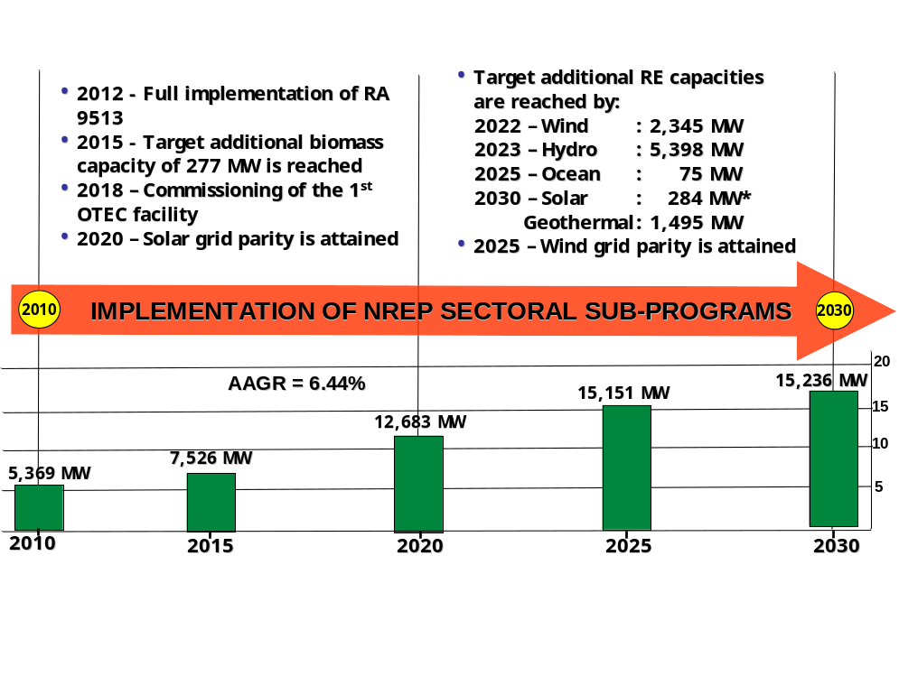
- DOE circulars provide guidelines for implementing various provisions of the RE Act including:
- DOE Circular DC2009-07-0011: Guidelines Governing a Transparent and Competitive System of Awarding Renewable Energy Service/Operating Contracts and Providing for the Registration Process of Renewable Energy Developers. This covers contract awards at both the pre-development and development stages either for power or non-power applications. Details are provided in Annex III;
- DOE Circular No. DC2009-07-0010: Accreditation Process for RE Manufacturers. Details are provided in Annex III;
- DOE Circular DC2009-07-0011: Documentation, permitting and institutional requirements for the development of geothermal, wind, hydro and biomass. Details are provided in Annex V.

- Additional acts that are important to the development of RE projects in the Philippines include (a) Air Quality Management under Republic Act No. 8749 (Clean Air Act of 1999); (b) BOT Law - Republic Act No. 6957; and, (c) Foreign Investment which allows foreign investment of up to 40% in the operation of public utilities and the exploration, development and utilization of natural resources. Foreign investment of up to 25% is allowed in the construction and repair of locally-funded public works subject to exceptions under the Build Operate Transfer Law. Details of these Acts are provided in Annex III.

- RE development at the local level is framed within the Local Government Code (LGC) of 1991 (RA 7160), enacted to “provide for a more responsive and accountable local government structure”. Within this Code, there is the “Government Share in the National Wealth” that defines the national levy from the development and utilization of the national wealth generated from the right of the Local Government Unit (LGU) to benefit from local RE projects. The DOE Law (RA 7638), provides for direct benefits to pertinent LGUs hosting energy resource development projects or energy generating facilities within their jurisdiction.

- From 2002 to 2010, GEF supported the “Capacity Building to Remove Barriers to Renewable Energy Development in the Philippines (CBRED)” project that resulted in the formulation of the aforementioned RE Act including its Implementing Rules and Regulations (IRR) and initial regulatory frameworks. To encourage and accelerate the participation of the private sector, provisions were conceptualized and provided for in the Act as fiscal and non-fiscal incentives (such as the Renewable Portfolio Standard or RPS, Net Metering and Green Energy Option, among others). The CBRED Project was also successful in enhancing awareness of the private sector, local governments and communities on various aspects of renewable energy resource development. As a result of CBRED, the DOE was able to initiate engagement with the private sector as well as with the grassroots communities in the pursuit of renewable energy technology for their livelihoods.

- Despite these efforts to catalyze RE development in the Philippines, barriers still exist at the program and project levels that constrain RE development, notably at the local level where the RE Act has not been effectively implemented. As of October 2015, the DOE has awarded 651 RE-based power generation “Service Contracts” for development, of which 616 projects are proposed to be connected to the grid with a potential capacity of 12,138 MW but with only 2,951 MW of actual installed RE capacity. The entry of this RE capacity has been highly dependent on successful implementation of the NREP and incentive mechanisms under the RE Act. However, as of October 2015, only 37 out of the 616 contracts have secured financing with another 81 project contracts that have expired or lapsed the prescribed pre-development period, and 74 experiencing major delays. This is a strong measure of the constraints facing development of RE projects. Under the RE Act, these contracts will cease to materialize if not pushed to become actual projects unless specific issues and barriers as described in this document are systematically addressed.

- For hydropower development in the Philippines, current installed hydropower capacity is in the order of 3,435 MW (some of which was installed prior to the RE Act). The potential installed capacity of the 389 projects currently awarded under the RE Law is 6,160 MW of which only 118.93 MW have been installed. Hydropower also represents 60% of all awarded RE projects under the RE Law. There are a number of bottlenecks in the hydropower approval process including difficulties with the water sustainability plans as well as settling indigenous people’s claims over revenue from these hydropower projects.

- For solar energy development in the Philippines, there are currently 22 MW of installed solar-PV capacity with another 89 solar projects planned under the RE Law with a potential installed capacity of 1,354 MW. The 1.082 MWp grid-connected PV plant of Cagayan Electric Power and Light Company in Cagayan de Oro City was commissioned in 2004 and was then considered the largest grid-connected PV plant in the developing world. The majority of the solar PV installations in the Philippines are mainly installed as individual solar home systems. The GoP are planning implementation of a Concentrated Solar Thermal Power (CSP) demonstration plant by 2016 or later to demonstrate the cost efficiencies of CSP plants. There are, however, still a number of Service Contracts pending approval that are stalled in the approval process.

- The Philippines is the second largest producer of geothermal power in the world next to the United States with a potential of 5,000 MW. The country’s total geothermal installed capacity currently stands at 1,927 MW, generating 10,256 GWh of electricity in 2010 from the 9 geothermal plants.

- The DREAMS Project is designed to address issues related to RE development, primarily the process of regulatory approvals for RE projects in the Philippines at the national and the local levels. These are issues that have emerged with the GoP’s efforts to accelerate RE development since the completion of the CBRED Project in 2010. The DREAMS Project activities include building capacity of the local government and host communities, and the streamlining of the national approval process that will create an investment-friendly environment, conducive to satisfying local permitting requirements and more widespread promotion of RE projects as intended under the NREP. This would also include operationalization of the remaining implementation mechanisms under the RE Act that were introduced through CBRED (as described in Para 10) including the establishment of the RE Market and Registrar, which are components of the Renewable Portfolio Standards (RPS), designed to accelerate development of RE resources in the country.

Threats and Root Causes

- Seven years have passed since the RE Act was promulgated. Full implementation of the RE Act, however, has not been yet achieved due to incomplete implementation mechanisms, guidelines, rules and regulations. During the 2002-2010 period, the CBRED Project primarily focused on addressing policy and regulatory barriers at the national level with the anticipation that the RE Act and the NREP will facilitate broader RE development at the local level. As such, the policies and regulatory interventions were not specifically targeted at the local level. The consequence to this is a “regulatory disconnect” that has developed between local development priorities and the national RE objective. With local governments recognized more as project beneficiaries and local regulators for issuing permits, they were not cast as key partners who could attract investments at the local level. It was anticipated that securing of permits from the local governments for RE projects, for instance, would follow logically with the RE Act.

- As a consequence to the current regulatory environment for the development of RE projects in the Philippines, DOE outreach to LGUs and other local entities has not been sufficiently effective. As a result of weak collaboration and coordination between local entities and relevant government entities, there have been disruptions in the tedious permitting process at the local level, and RE projects have not been fully accepted from a social perspective at the local level due to their lower level of awareness. These issues only serve to limit the number of RE developers and discourage the entry of new private sector entrants into the RE market in the Philippines. These issues are primary threats to the DOE meeting the RE targets as set in the NREP (see Para 6) that will be addressed by the DREAMS Project.

Barrier Analysis

Regulatory, policy and institutional barriers:

- The DOE have identified three specific main barriers in the regulatory process:

- A cumbersome regulatory approval process;
- Weak coordination between DOE and local government units (LGU) on RE project approvals; and
- The lack of full implementation of de-risking mechanisms that are provided in the RE Act.

- The cumbersome regulatory approval process constrains the RE development process for RE developers. The intermediate causes to this cumbersome approval process includes:
- Lack of clarity of roles and responsibilities of various agencies in RE development. There are no existing laws or presidential directives that would consolidate or integrate the approval process for RE projects of concerned government units and agencies. For example, an RE project proponent will be applying for a small hydropower project permit, and needs approvals from DENR, NCIP and NWRB to obtain an Environmental Clearance Certificate (ECC). There are, however, no official mechanisms to coordinate joint approvals that would streamline the approval process between RE-related agencies. Coordination is required on these issues for an RE project proponent to obtain an ECC. In addition, RE developers are also having problems fulfilling NWRB water sustainability plan guidelines that delays water rights clearances for hydropower and other RE project approvals. Further description of this barrier is provided in Annex III;
- Lack of clarity on share of RE revenues for indigenous people. While the share of LGUs from the national wealth is defined by law, there appears to be conflicting interpretation or ambiguity in the national wealth share of indigenous peoples in ancestral domains and lands. The lack of familiarity of RE developers of the IPRA law and the procedures of obtaining the necessary clearances from IP areas are the direct causes of a number of RE project approvals being stalled. Harmonization of RE revenue rules for indigenous peoples in the Philippines is required; and
- Weakened targets for RE under the Fuel Mix Policy for Power Generation. Current targets of the Policy show an increase in the use of fossil fuels for power generation. This only reinforces the general perception that RE is too costly for many jurisdictions of the Philippines;
- Lack of clarity over requirements of distribution utilities (DU) for approving interconnections with RE projects within their franchise area. Developers of smaller RE projects experience problems due to uncertainties in obtaining access to the grid to sell generated electric power. There are several causes for these difficulties including the DU not having the capacity to assess whether or not a RE project can safely and reliably accept the input of embedded and wheeling RE generated electric power inputs, and most RE developers having difficult access to grid data and information, and inadequate familiarity in preparing mandatory studies assessing the impact of an RE project on the grid and distribution systems.

The DREAMS Project will provide support to streamline these cumbersome regulatory processes.

- There is weak coordination between DOE and local government units (LGUs) on approval of RE projects. This results in challenges to RE developers in obtaining LGU endorsement of their RE projects after the DOE has already issued an RE Service Contract. The intermediate causes to this weak coordination includes:
- Lack of clarity on related implementing rules and regulations of the RE Act pertaining to LGUs;
- LGU perception that during the formulation of the RE Act, they were not adequately consulted and that their preferences and interests were not well addressed. This includes the RE approval process at the national level not taking into account the local permitting processes, thereby, creating inconsistencies between the two approval processes; and
- Difficulties of issuing local permits to RE project proponents with Service Contracts from the national government through DOE due to inadequate communication on these RE projects. This would lead to constraints in proceeding with project implementation.

The root cause to this weak coordination barrier is that LGUs are empowered by the Philippines Local Government Code that is not subsumed under the RE Act, leading to a number of coordination problems where LGU development plans are not in concert with plans and approvals at the national level with DOE. This results in RE developers needing to obtain permits issued by local government that potentially and substantially raises the risk of an RE project not being approved by local authorities if proper and early consultations have not been conducted. It was anticipated that securing of permits from LGUs for RE projects, for instance, would follow logically with the RE Act. However, there has been little or no buy in of the RE Act from the LGUs. The DREAMS Project will provide assistance to strengthen the coordination between DOE and the LGUs and lower the challenges faced by RE developers in obtaining LGU endorsement of their RE projects.

- The lack of full implementation of de-risking mechanisms that are provided in the RE Act has given rise a perception of a higher level of financial risk for RE projects. Several policy mechanisms were put into place including cornerstone measures such as the Feed-in Tariff (FiT) system and the Renewable Portfolio Standards (RPS) to incentivize and encourage investments in RE based electric power generation. Other mechanisms include the establishment of a RE Market for the trading of RE certificates, and distribution and transmission network regulations (such as open access, priority dispatch, imposition of wheeling charges). The root cause leading to the lack of implementation of these mechanisms stem from the delays in the formulation of governing rules and the inconsistent implementation of these policy mechanisms within the current RE regulatory regime. This has discouraged project developers, sponsors, potential investors, local financial institutions, and other stakeholders from assuming high transactional costs (administrative and regulatory) resulting from these regulatory uncertainties. Financial barriers and market development policy mechanisms are further discussed in Paras 30 to 33.

- In summary, these processes for approvals of RE projects are long and tedious. For this reason, new RE market entrants are not fully aware or do not fully execute the required processes for satisfying regulatory and permitting requirements for RE approvals. Moreover, due to the lengthy processes involved, new market entrants view the regulatory approval process as financially risky given that approvals at the end of the process may require additional financial resources to complete. In some instances, RE developers secure endorsement from the LGU first before applying for a service contract, or RE developers request the DOE to discuss the project with LGUs where endorsements could not be obtained. As such, the uncertainty of this process limits the number of RE market players that creates less market competition, contrary to the intentions of the REM. The regulatory process requires more certainty and examples of success that will encourage new RE market entrants and increase the number of RE developers in the market. This in turn will create a more vibrant RE market for the Philippines that will continue minimize electricity prices for the country’s electricity customers. The DREAMS Project seeks to lower or remove the aforementioned barriers and their immediate causes.

Technical Barrier

- A primary technical barrier that affects the pace of RE project development of RE projects is the insufficient focus on developing a national supply chain for RE equipment. The impact of a local supply of some RE equipment would reduce RE project costs and support local employment and manufacturing. In particular, this barrier affects the development of RE projects in off-grid and missionary areas where there is a lack of quality technology performance standards and certification systems coupled with the absence of a dependable system for after-sales service and spare part supply. This also pertains to decentralized RE systems, particularly solar home systems (SHS), micro-hydropower systems, and small wind systems. The Philippine experience indicates that the root causes of the lack of after-sales services and spare part supplies includes:
- The absence of sustained market potentials due to lack of capacity of end-users to pay for up-front costs;
- No guarantees in the availability of the unit; and
- Difficulties faced by suppliers in marketing their products in these remote areas.

- To a lesser extent, another technical barrier is the lack of management of RE resource information and data at the national level in the Philippines. To some extent, this also restricts smaller RE proponents from developing RE projects. The lack of available DOE-managed RE resources information is primarily caused by poor knowledge management practices, particularly in data collection and storage, and some reluctance by the GoP and private investors to allow public access to RE data and information for stakeholders in the energy sector. As a result, only larger and well-financed RE developers have access to appropriate RE resource data through their own data collection investments (such as stream gauges, wind masts and studies on available biomass). The DREAMS project addresses the aforementioned main barriers.

Knowledge and capacity barrier:

- Despite raised awareness of RE from the efforts of the CBRED Project, limitations in advanced knowledge on RE persists as a primary barrier amongst a wide range of key stakeholders involved with RE development such as:
- Public administrators in government institutions and LGUs who are responsible for supporting broader replication and full market development of renewable energy systems;
- Local project developers who are not fully aware of the available financial mechanisms to assist RE development and the process of RE project approvals;
- Local communities where there are an insufficient number of qualified technicians on the installation, operation and maintenance (O&M) of RE equipment.

This has resulted due to immediate causes as discussed below.

- Public policy makers, at both the national and local levels have often demonstrated the lack of capacity to streamline approval processes effectively and inability to implement the RE Act to facilitate investment. The CBRED Project had started to address these issues and was successful in putting the necessary RE knowledge transfer activities in place. These efforts have resulted in encouraging outcomes. There is still, however, a need to deliver knowledge transfer activities that is effective and sustained; this can be delivered by the DREAMS Project.

- Moreover, awareness of RE projects at the local levels of government needs improvement. There are still perceptions amongst some of the 1,800 LGUs that RE is too costly, and a number of LGUs are not making efforts to make the transition to a low carbon economy. With limited evidence of RE projects in the Philippines that have successfully completed all regulatory requirements for approval, a number of potential LGUs will continue to shy away from RE project development that constrains the pace of RE development to meet NREP targets.

- This lack of capacity and knowledge of RE affects smaller RE developers who have expressed the need for assistance to prepare and package local RE projects into financially viable projects or projects that would qualify under various grant programs. Preparation of these projects becomes more difficult for these developers in light of the tedious RE project development process currently in place. The net result has been only a smaller number of well-resourced RE developers who are successfully implementing RE projects in the Philippines. Clearly, if the Philippines wants to scale-up RE development to meet its targets of 15,000 MW installed by 2030, assistance to smaller RE developers with less capacity is required to lower this capacity barrier. This assistance can be delivered by the DREAMS Project

- The lack of RE knowledge is also prevalent at the local levels where there is a lack of trained skilled workers from the vocational schools. The availability of local technicians to install, operate and maintain RE equipment, notably on community-based RE projects, would greatly enhance the integration of a RE project within the economic activities of a local community. The DREAMS project aims to address the aforementioned main barriers.

Financial barrier:

- There are two primary financial barriers to the acceleration of RE development:

- Difficulties in accessing RE finance:
  - for small FiT-ALL eligible RE projects prior to their 85% physical completion;
  - due to lack of a functional REM that would generate RE certificates (RECs) for RE projects, contribute to an additional revenue source for these RE projects, and reduce risk (or de-risk loans) for such projects. The annual revenue streams being generated from RECs would also contribute to the sustainability of the RE project; and

- Lack of appropriate financing mechanisms to assist smaller RE project proponents in developing RE projects. This would include support facilities for these stakeholders in the completing appraisal or pre-feasibility activities to ascertain the viability of an RE project.

- For proponents of small FiT-ALL eligible RE projects, their RE projects must be certified by the DOE as commercially operational before being awarded the FIT. The FIT model takes a results-based approach to avoid designating support for FIT projects that ultimately may not be constructed or do not begin commercial operation by a specified date. Under this model, however, RE project proponents can obtain a FIT contract for the sale of energy only after the project has been deemed “85%” completed and ready for commissioning. This creates a barrier in the financing process for RE projects as local banks are reluctant to provide construction finance for projects without a guaranteed source of long-term payment that would come from the FIT contract. Consequently, out of approximately 114 potentially eligible projects, only 56 have applied for the FIT, with only 9 projects currently possessing a Certificate of Compliance from the Energy Regulatory Commission (ERC).

- Proponents of smaller RE projects especially in missionary areas, also have difficulties in accessing available funds and loan guarantees that results in problems related to the financial closure of a project. The barrier can be attributed to the lack of confidence of financial institutions in incentive mechanisms such as the REM which have been witnessing delayed implementation. Consequently, the financial community perceives that the REM and other similar fiscal incentives (such as the FIT) that would lead to an additional RE project revenue streams cannot be considered as guarantees to secure commercial loans.

- Smaller RE project proponents also have limited access to financial resources to develop RE projects that would include completing appraisal of pre-feasibility activities to ascertain the viability of an RE project. This barrier arises because financial entities and potential investors are generally unable or unwilling to provide financing at this development stage due to higher risks that the project may fail to mature and reach financial closure. In contrast, institutions willing to provide developmental financing may have higher collateral requirements. An example of this involves project proponents for domestic and the micro-to-small scale RE projects and the associated risk perception with regards to the scale of these projects. Most of these project proponents are not able to provide the required collateral to secure credit and to raise the necessary equity requirements of some of the financial products.

- Attempts were made in the past by local financial institutions such as the Land Bank of the Philippines (LBP) to provide project preparation support funds to assist smaller RE developers. However, the fund is underutilized to the extent that it has been inactive with insufficient capital to support a larger number and scale of project preparations, and is not well linked with supplementary credit lines such as appropriate RE loan funds. Efforts are required to facilitate higher utility of the fund through enhanced capitalization and improved awareness and assistance to RE project proponents for accessing the funds. This is especially true for RE proponents in missionary areas served by NPC-SPUG who need this assistance; under the RE Law, NPC-SPUG are mandated to source a minimum percentage of their electricity from RE sources. The DREAMS project aims to address the aforementioned main barriers and their immediate causes.

Stakeholder Analysis

- Stakeholders that will play key roles on the DREAMS Project are listed on Table 1. A complete list of stakeholders involved in RE development in the Philippines can be found under Annex III.

Table 1: Key DREAMS Stakeholders
Stakeholder | Mandate | Role on DREAMS Project
Department of Energy (DOE) | Energy sector reform and responsible for formulating and implementing energy policies and programs, coordinating the government’s energy programs, facilitating the implementation of sector reform, and encouraging private sector participation in the energy sector. | The DOE’s Renewable Energy Management Bureau (REMB) will serve as the key subordinate bureau and serve as the implementing entity for the DREAMS Project. It will also be responsible for the overall management of the Project including communication and coordination with UNDP and key partners, providing staff and administrative support, liaison with local governments, monitoring and project financial management. DOE will chair the NSC.
Department of Interior and Local Government (DILG) | Amongst other responsibilities, DILG strengthens local government capabilities aimed towards the effective delivery of basic services to the citizenry. This may include assistance to improve LGU capacities to develop and operate RE projects. | Provide guidance to LGUs on implementing the Local Philippines Government Code in the context of local RE projects, and in the preparation of local ordinances (Output 1.2). Liaise between DOE as the IP for this Project and LGUs on streamlining the system for permit and license issuance (Output 2.2). DILG will be a member of the NSC.
National Transmission Corporation (TRANSCO) | Provides oversight of the electrical transmission system operations in the Philippines, and administration of the FiT-ALL financial mechanism that will promote the development of RE. | Undertaking of the approval, management and administration of FiT-ALL applications and disbursements (Output 1.1), and clarification of the role of TRANSCO in streamlining joint approvals for transmission and distribution connections (Output 2.2). TRANSCO will be a member of the NSC.
National Grid Corporation of the Philippines (NGCP) | System operator of the Philippine power grid that balances the supply and demand of electricity to efficiently serve all customers including power generators, private distribution utilities, electric cooperatives, and government-owned utilities. | Strengthening oversight of RE project development and ensuring its integration with the plans and operations of NGCP for the delivery of electricity to consumers. This would include NGCP’s role in strengthening and approving guidelines on RE penetration into grids (Output 1.3). NGCP will be a member of the NSC.
National Power Corporation (NPC) and NPC - Small Power Utilities Grid (NPC-SPUG) | Responsible for power generation in off-grid and un-electrified areas (more than 80 SPUG areas all of which are powered with fossil fuels) that are not serviced by DUs and other qualified third parties (QTPs). It has been explicitly stated in the RE Law that whenever feasible, NPC-SPUG shall utilize RE resources | Both NPC and NPC-SPUG will coordinate with LGUs to discuss electric power requirements and electrification concerns, improve integration of small RE projects with RE development entities and source increased RE in all SPUG areas where feasible as a part of the Project assistance to prepare bankable RE project plans (Output 4.2). NPC-SPUG will be a member of the NSC.
Philippine Electricity Market Corporation (PEMC) | Responsible for establishing, maintaining, and governing the “Wholesale Electricity Spot Market” (WESM), an efficient, competitive, transparent and reliable market for the wholesale trade of electricity and ancillary services that will encourage competition in the sector and reduce the cost of energy | Operationalization of an RE Market as a sub-market to the WESM as a part of Outputs 3.1 and 3.2. PEMC will be a member of the NSC.
National Renewable Energy Board (NREB) | Provides recommendations to the DOE on mandated RPS and minimum RE generation capacities in off-grid areas, as it deems appropriate; specific actions to facilitate the implementation of NREP in a manner with no overlapping institutional functions; monitoring implementation of the NREP including compliance with the RPS and minimum RE generation capacities in off-grid areas; and oversight of the utilization of a Renewable Energy Trust Fund | Management of NREP activities to accelerate the pace of RE approval, enforce the RPS and increase development of RE generation in off-grid areas. This will be done through NREB leading a biennial review of the NREP.
Department of Environment and Natural Resources (DENR) | Responsible for the conservation, management, development, and proper use of the country’s environment and natural resources, including the ensuring of compliance of energy projects to environmental regulations and standards. | DENR will work with DOE to improve efficiencies of environmental regulatory approvals of RE projects.
National Water Resources Board (NWRB) | Oversight of “water sustainability plans”, a requirement for NWRB approval of hydropower projects, amongst other responsibilities. | NWRB will work with DOE to improve integration of water sustainability plans with RE project approvals.
Local Government Unit (LGU) | To advance the public good or welfare that includes involvement in the development of renewable energy sources to reduce the cost of electricity to its constituents | Selected LGUs will work with DOE to improve integration of local ordinances and local energy plans with national RE approvals and plans, and coordinate with the DUs and/or NPC-SPUG (for Missionary Areas) to discuss electric power requirements and electrification concerns (activities as specified under Outputs 2.3, 2.4 and 4.2). LGUs from Palawan and Iliolo Provinces will serve as members of the NSC.
Civil Society Organizations (CSOs)
The World Wildlife Fund (WWF)-Philippines | An international organization in sustainable development that focuses on, among others, local stakeholder engagement, capacity-building exercises, public-private cooperation and policy-making that is consistent with GoP policies and programs to ensure that these are implemented on the ground. | WWF will augment capacity building activities at the local level with LGUs and other community groups
Renewable Energy Association of the Philippines (REAP) | A prominent non-stock, non-profit organization of companies and private individuals committed to the nationwide development, promotion, utilization and commercialization of renewable energy technologies/systems for sustainable energy generation | REAP will assisting with the promotion of renewable energy throughout the country in tandem with DOE and LGUs.
Private Sector RE development entities
Cordillera Hydroelectric Power Corporation (COHECO) | Owners of a Service Contract who are currently developing a 60 MW run-of-river hydropower plant in Benguet, and currently engaged in a long regulatory compliance process for the right to complete the project | COHECO will support efforts to pilot the accelerated regulatory approval process for this 60 MW hydropower plant. COHECO will install and commission the hydro power plant. A representative from the private sector will be engaged in the NSC.
Enfinity Philippines Renewable Resource Inc. | Owners of a Service Contract who are currently developing a 1.0 MW Camotes Solar Plant in Barangay Tiguis | Enfinity will support efforts to pilot the accelerated regulatory approval process for the 1.0 MW solar plant. It will install and commission the Solar power plant
Solarus Partners Inc. | Owners of a Service Contract in partnership with SunAsia Energy who are developing a 12 MW off-grid solar PV project on Marinduque Island | Solarus will support efforts to pilot the accelerated regulatory approval process for a 12 MW solar plant. Solarus will invest in, install and commission the Solar power plant
First Envirotech Alliance Corporation | Developers of plans to DOE for obtaining a Service Contract for a 2.0 MW biogas plant in Barangay Armenia, Tarlac City | First Envirotech will support efforts to pilot clarifications for RE developers on FiT payments, wheeling fees and grid impact studies. It will install and commission the biogas power plant

Baseline Analysis

- To fully implement the RE Act, the development of renewable energy in the Philippines is being supported by a number of on-going and planned activities, projects, and programmes. The current policy tools that are enforced at the national level include the National Renewable Energy Program (NREP), the Renewable Energy Market (REM), and the Fuel Mix Policy for Power Generation. The Department of Energy (DOE), in particular the Renewable Energy Management Bureau (REMB) has been the primary driver of these initiatives. Private sector interest and investment levels in the development of RE has significantly increased. The activities, projects and programmes implemented by these proponents including DOE, PEMC, LGUs, RE project proponents and investors, and RE financial institutions are considered as baseline projects to the DREAMS Project. A list of baseline projects is provided on Table 4.

- The National Renewable Energy Program (NREP) contains the policy framework enshrined in RE Act to “promote the development, utilization and commercialization of renewable energy resources and for other purposes”, and strategic targets to achieve the goals set in the RE Act. These strategic interim targets (described in para 6) for the delivery of renewable energy within the timeframe of 2011 to 2030 were set to provide focus and sustained efforts towards energy security and improved access to clean energy. Achieving these 2030 targets will be challenging, requiring resource mobilization for detailed planning and financing, regulatory efficiency in approving RE projects, and the building of renewable energy infrastructure at a scale and within a time frame that has never been done before in the Philippines.

- The framework of NREP is setup as sector sub-programs covering each of the main renewable energy sources including geothermal, hydropower, biomass, wind, solar ocean, and other emerging technologies that could be added depending on their developmental status and utilization. Over the 20-year (2011-2030) period, these RE sources will be developed under DOE under the following common activities:
- Implementation of RE industry services that includes assistance and advisory services to facilitate private sector investments;
- Developing RE resources to intensify the harnessing of the country’s large RE potential;
- Operationalize Research & Development (R&D) programs to determine the viability and adaptability of particular RE systems to the Philippines environment;
- Strengthening of RE technology support to improve quality, performance and cost of local RE systems that increases their competitiveness with conventional forms of energy;
- Coordinated and implemented approach to:
  - Policy support involving formulation, implementation and monitoring of mechanisms, rules and regulations prescribed by RE Law; and
  - Program support that covers common support activities that ensures smooth implementation of the NREP such as establishment of one-stop shops, RE information exchange, M&E systems, and use of ARECs.

Table 2 provides a list of ongoing baseline projects including those of NREP that are expected to be implemented during the 2016-2020 period of DREAMS.

Table 2: Baseline Projects
Project Name & Implementer/Owner | Brief Baseline Description & Implementation Period | Linkage to GEF Project | Estimated 2016-2020 Budget, USD
DOE (activities to implement the NREP)
Policy Support for RE Law: Policy/mechanism formulation, implementation and monitoring | The DOE is developing and amending policies to encourage RE development. For instance, it is currently drafting a “Fuel-Mix Policy for Power Generation” to respond to a mandate of ensuring energy security, promotion of cost-effective low-carbon technologies, developing regional energy plans, and implementing the RE Act. Finalization of the Draft Fuel-Mix Policy is expected in early 2016.  The DOE is currently identifying solutions to facilitate the logjam in the RE regulatory process, for instance, by streamlining the permitting processes and approvals that an RE project proponent is required to obtain. | These potential baseline activities can contribute to the RE policy development work in DREAMS. The enhanced version of these baseline activities can become part and parcel of the DREAMS Project addressing the achievement of a higher target for RE resources and finalizing the draft for the Fuel-Mix Policy.  The streamlining efforts of the DOE and relevant government agencies of the RE regulatory processes could be the baseline activities of DREAMS for delivering updated policies, guidelines and streamlined permitting and licensing processes. | 100,000
RE Industry Service - Support for strengthened outreach to NGCP and LGUs | There are ongoing efforts to strengthen its outreach to LGUs and RE developers to provide more inclusive and integrated involvement in the RE development process. This includes supporting the Affiliated Renewable Energy Centers (AREC) personnel, facilitating stakeholder coordination efforts with NGCP, local DUs, and private sector technical expertise. This is a challenge given that many communities within the country are located on remote islands, and difficult to access. These ongoing efforts will continue until 2020. | These can contribute to the technical capacity development interventions of DREAMS. The enhanced version of these baseline technical training activities on RE development for local officers at the LGU level or with ARECs can be among the activities of the DREAMS Project. The enhanced activities include training on incorporating energy plans into the Regional Development Plans of the LGUs, integrating energy planning in the curriculum of the Local Government Academy for planners, developing manuals or reference material on integration of energy plans into the development plans of LGUs. | 850,000
RE Industry Service - RE Service Contracts Approval and Management | DOE has an ongoing management system of issuing RE Service Contracts, and monitoring their development to ensure delivery of pre-development and development/commercial stages of the Contract within specified time periods. DOE personnel are trained and then provide approvals of RE projects, prepare and sign off service contracts, and oversee the RE regulatory process. This is an ongoing activity extended beyond 2020. | These activities can be the bases for the RE institutional capacity development interventions of DREAMS. The improved activities on the management system can be among the activities of DREAMS that will involve the preparation of guidelines for the streamlining of approvals for RE Service Contracts, and facilitating stronger coordination of permitting requirements from NCIP, NWRB and DENR on RE projects that will shorten the processing time. | 1,000,000
Resource Development: RE Resource Assessment | Oversight of efforts to manage RE resource assessments that includes a) potential hydropower sites; b) biomass resource inventory; c) low enthalpy geothermal areas; and d) detailed wind resource assessments that are locally financed. The assessments are ongoing and scheduled to be completed by 2016. | This project includes pertinent activities that are envisioned for DREAMS and can therefore be subsumed as is to the DREAMS project. Once the assessments are completed, the results will be utilized in the capacity development of LGUs and upload the information on the website developed by the Market Service Centers in Output 2.4. | 250,000
RE Technology Support | Aims to develop standards for RE equipment, improvement of the performance of RE projects, reduction in project costs through local production, and capacity building of local personnel and businesses to implement RE projects. This is an ongoing programme scheduled to end by 2022. | These activities can be among those needed for the RE equipment standards development work in DREAMS. If these are subsumed into the project, the enhanced version will comprise of additional vocational training of local RE technicians to improve the quality of RE equipment installations that will meet best practices. | 100,000
PEMC
RE market assessment and RE market rules | Establishment of a Renewable Energy Market (REM) where participants may trade in certificates confirming the amount of electricity sold or used and produced from RES. Currently, details of the market are being developed formulated including a system for certification of RE developers by the DOE that are registered with the Board of Investments (BoI). PEMC is also undertaking design of RPS Rules as a market based policy, design of RE market rules for the proposed REM, and amendments to WESM Rules. They have plans to conduct a market assessment to account for all the RE injected into the grid. Design of REC system scheduled for completion by late 2017. | This activity is among the planned interventions of DREAMS. If subsumed into the project, the enhanced PEMC activities will include the conduct market assessments to develop the RE market in Output 3.1. | 1,500,000
Establishment of REM and RE Registrar | Purchase of hardware and software for REM operations. Commissioning and operation of the RE Market system  Scheduled completion by 2018. | The same as above, this can be subsumed in DREAMS, and the enhanced version will include investment into the software development and training in the use of the software for REM operations | 1,200,000  (out of which 700,000 is for REM hardware and software
LGUs
Promotion of local energy plan by Province of Palawan | Ongoing efforts to execute the recently formulated local energy plan; promotion of private sector investment into RE projects based on the energy plan that includes the development of low carbon technologies for power generation that would enhance Palawan City’s status as a green city. Ongoing efforts to train local personnel to attract private sector investment to Palawan Province.  These are ongoing programmes that will extend beyond 2020. | These ongoing efforts on energy planning and encouraging private sector involvement in RE-based power generation are eligible baseline activities of DREAMS. If these are subsumed into the Project, the improved version shall include the formulation and execution of local energy plans; harmonization of local level RE activities more closely with national RE programmes and objectives; enhancement of capacity building efforts including that of LGU based focal points to liaise with RE investors and monitor RE project development; and establishment of an operational RE knowledge platform at the local level (Outputs 1.2, 1.3, 2.1, 2.2, 2.3, 2.4 and 2.5), | 700,000
Private sector promotion and capacity development in municipal LGUs represented by the Province of Iliolo | Ongoing efforts include promotion of private sector investment into RE and capacity building trainings of local personnel to attract private sector investment. This is an ongoing programme that will end by 2017 |  | 522,222
RE PROJECT PROPONENTS
Camotes Project (off-grid 1.0 MW solar power project located in Poro, Cebu) developed by Enfinity Philippines Renewable Resource Inc., | Enfinity has been developing this solar project since 2013 as an unsolicited proposal in a SPUG area. The project proponent has undertaken detailed engineering design and undergone a tedious, circuitous and difficult permitting process consuming more than 4 years for a 1.0 MW project. | The ongoing and planned activities of these 4 private sector entities can be part and parcel of the DREAMS project as demonstrations. Considering their expressed interest to be partners of the DREAMS project, their current RE-based power generation projects can be subsumed into DREAMS and can be enhanced with the inclusion of expedited facilitation of the permitting and regulatory requirements for the installation and commissioning of their RE-based power plants.(Output 4.6) | 2.0 million
Mogpog Solar Project (12 MW off-grid solar PV located on Marinduque Island) developed by SunAsia and Solarus Partners Inc. | Solarus Partners Inc. has had the Service Contract since December 2013 in partnership with SunAsia, and is currently completing detailed engineering of the project and permitting requirements of the LGU. Since the project falls under Resolution 21 of the ERC, the project proponent is awaiting approval of a bilateral power purchase agreement that is pending resolution of a procedural requirement between the DOE, ERC and MARELCO (the EC for this RE project who is obligated to bid out the RE project prior to the award of the bilateral agreement for purchase of the electricity from the project) |  | 26.268 million
First Envirotech biogas plant (2.0 MW) located in Barangay Armenia, Tarlac City developed by First Envirotech Alliance Corporation | First Envirotech Alliance Corporation has been developing engineering plans for this project since July 2014. They have also been undertaking efforts to obtain approvals for FiT, wheeling, grid impact studies and VAT exemption status. These efforts have not resulted in any clarity from DOE on the process for their approval. |  | 3.2 million
Kapangan Hydropower Project (60 MW run-of-river located in Benguet Province) developed by the Cordillera Hydroelectric Power Corporation (COHECO) | COHECO has been in the design stages for close to 5 years. It has been developing detailed engineering plans for this project since 2010 with expected commissioning scheduled for 2019, and has been undertaking activities related to obtaining permits and other regulatory compliance. Civil works have not yet started since the project proponents are awaiting key permits to initiate construction. This process has been encountering problems with NCIP and NWRB permitting, placing delays and risks on the commissioning date and the entire investment. The provision of additional clarity and streamlining of NCIP and NWRB permitting would facilitate an approval to the proponents of this hydropower project. |  | 270 million  (leveraged co-financing)

- Additionally, financial institutions in the Philippines have plans to setup a mechanism to meet demands for a bridge loan for financing of small-scale RE projects prior to the 85% electro-mechanical completion milestone when the FiT would be granted. One of these institutions is the Land Bank of the Philippines (LBP) which plans to have an operational financing mechanism for bridge loan by late 2016. Further, financial institutions such as the LBP are also planning to strengthen project preparation support mechanisms to proponents requiring assistance for renewable energy projects development. LBP that administers similar fund (the Project Preparation Fund, PPF) for example is planning to revive the fund and enhance its utilization.

- The DREAMS Project will collaborate with such financial institutions to review, re-strategize, design, and administer an appropriate financial instrument (such as a project preparation fund and bridge loan financing mechanisms) with the intention of increasing the number of successfully developed renewable energy projects in the Philippines. One of the financial institutions that have expressed intent for collaboration is the Land Bank of the Philippines.

Baseline scenario

- In the BAU scenario, the Philippines will undertake more power generation projects using conventional fossil fuels, leading the country along an unsustainable development path to higher GHG emissions from the energy sector without abatement, notably due to lower RE targets from the current Fuel Mix Policy for Power Generation. The current baseline scenario under consideration is dominated by coal. With a current installed capacity of 17,000 MW and a generation of 75,000 GWh with only Luzon and Visayas interconnected. The reference scenario in the policy currently being drafted includes coal achieving a 70% share and RE at 6.5% of generated power by 2050. While the Government has the RE Act in place to drive the development of renewable energy with incentives for RE project developers, the pace of approvals of these RE projects will continue to slow due to a regulatory environment that is slow to respond to the needs of the developers.

- In the absence of GEF support, due to the cumbersome regulatory processes and delays in obtaining the permits for various but specific reasons as explained in detail in Para 19, the RE projects in the baseline will not be realized either (a) within the stipulated time to meet the NREP target; or (b) due to longer lead time in project development, the financial viability of the projects would be compromised and the Project Proponents compelled to pull the plug off the projects; or yet more (c) the projects would have lapsed beyond the prescribed project development period (i.e. the DOE Service Contract would expire) and the project would die a natural death. The project proponents consider such investments at high risk of being shut down due to the slow response of the national and local governments in approving RE projects.

- The outcome of the BAU scenario is a sluggish rate of RE development that will not meet the ambitious RE installed capacity targets of the NREP. This outcome would be facilitated through the continued slow pace of energy planning at the local level, continued difficulties in mainstreaming the RE Act with LGUs, and reluctance of potential investors to develop RE projects. At the national level, there will continue to be a number of service contracts that are stalled in the regulatory approval process, uncertainty for investors in RE development costs for their RE projects, and a lack of coordination between the various national agencies to avoid duplication and time-consuming processes to obtain permits for RE projects. In addition, the additional revenues generated from a functional REM and RE registrar will not be realized due to the current slow process of their development. This will only serve to increase risks to RE investors and discourage them from more RE investments in the Philippines.

      - The BAU outcome with respect to GHG emissions in the Philippines power sector (based on current development of renewable energy and energy efficiency programmes) is an increase from 34 million tonnes CO_{2eq} in 2011 to 75 million tonnes CO_{2eq} in 2020 and 140 million tonnes CO_{2eq} in 2030 (as shown on Table 3). This is based on growth in electricity generation to meet expected demands from 77.3 TWh in 2014 to approximately 120 TWh in 2020 and 190 TWh in 2030 using least cost options (mainly coal) and expected capacity factors. This growth forecast reflects an expected increase in the grid emissions factor from the current 0.5 tonnes CO₂/MWh to approximately 0.74 tonnes CO₂/MWh in 2030. DOE estimates that the implementation of low carbon interventions through the NREP and energy efficiency programmes would reduce the CO₂ emissions in the power sector to 31 million and 43 million tonnes CO_{2eq} in 2020 and 2030 respectively.

Table 3: Power Sector GHG Emission Estimates
 | 2007 | 2010 | 2011 | 2012 | 2014 | 2015 | 2020 | 2030
Baseline (Mtonnes CO_{2eq}) | 26 | 31 | 34 | 38 | 41 | 48 | 75 | 140
DOE Low Carbon Scenario (Mtonnes CO_{2eq}) | - | - | 34 | n/a | n/a | 32 | 31 | 43
Energy Generation (TWh) | 59.6 | 67.7 | 69.2 | 72.9 | 77.3 | n/a | 120 | 190

STRATEGY

Project Rationale and Policy Conformity

- The 2000 Second National Communication (SNC) of the Philippines underscored the country’s reliance in 1995 on fossil fuel imports and the large contribution of the energy sector to GHG emissions. Based on 1995 GHG inventories, the country’s GHG emissions stood at 100.74 million tons CO_{2eq} with the energy sector comprised of 50% of GHG emissions in the Philippines. In 2010, electricity generation and energy sector together contributed to emissions of 31.49 million tons of CO_{2eq} or more than 42% of emissions with the transport in second at 35% of emissions, and industry and other sectors at 23%. Current increases in the growth of electricity generation are in the order of 3.7% per year.

Country Ownership: Country Eligibility

- The UN Framework Convention on Climate Change (UNFCCC) entered into force in the Philippines on 31 October 1994. Due to low levels of emissions, the country is categorized as a Non-Annex 1 country in the UNFCCC process, which does not have obligations to reduce its emissions. Nonetheless, the Philippine Government is taking action to curb emissions across different sectors, notably from energy and transport.

Country Drivenness

- As previously mentioned in the “Baseline Analysis” commencing on Para 36, the country’s renewable energy development is driven by Renewable Energy (RE) Act of 2008 under which the GoP will reduce its GHG emissions from costly imported fossil fuels. Under the NREP that was developed under the Republic Act 9513 provision that will “promote the development, utilization and commercialization of renewable energy resources and for other purposes”, a policy framework with strategic building blocks was provided to help the country achieve the goals set forth in the RE Act that includes amongst others:
- The Renewable Portfolio Standard (RPS) which places an obligation on electric power industry participants such as generators, distribution utilities, or suppliers to source or produce a specified fraction of their electricity from eligible RE Resources, as may be determined by the National Renewable Energy Board (NREB);
- The Renewable Energy Market (REM) which is a policy mechanism toward the acceleration and development of renewable energy resources in the country;
- Feed-in-tariff allowance (FiT-ALL) which is a mechanism applied to RE generation used in complying with the RPS that involves a fixed guaranteed price for each RE system and/or technology;
- A Green Energy Option that gives consumers the choice to use RE; and
- Net metering that allows distribution grid users to generate RE power and be appropriately credited with its contribution to the grid.

A complete listing of the policy provisions of the RE Act are provided in Annex III.

Alternative Scenario

- Under an alternative scenario with GEF support, the barriers described in Paras 18 to 33 would be lowered. The key issue for the DREAMS Project will be to assist the GoP in meeting its RE targets of 12,683 MW by 2020 and 15,236 MW by 2030 (as provided in Figure 1). With the current rate of approvals for RE projects, the GoP will be challenged to meet these targets. Resources from the DREAMS Project can be used to accelerate the current pace of renewable energy development in the Philippines through actions that are designed to increase investor confidence in RE projects.

- Through components designed to streamline a tedious regulatory process for RE projects, DREAMS resources will target specific barriers in the process that were identified by DOE and other key stakeholders during the PPG phase. This would include assistance to fill in policy gaps (such as one on RE projects providing electricity supply directly to local utilities or generators), clarification on institutional responsibilities, assistance with local ordinances to align with national RE objectives, strengthening guidelines for RE developers on assurances on system security with RE, and strengthening financing mechanisms that will minimize developmental and construction delays on an RE project.

- There have also been barriers identified related to a lack of institutional capacity and awareness to process applications related to RE approvals. This lack of institutional capacity and awareness is mainly at the local levels of government, and is not conducive to an investor-friendly environment. An alternative scenario under DREAMS would provide assistance to LGUs to harmonize their RE activities more closely with national RE programmes and objectives; streamline the process of permits and licenses at the national level; build more capacity at the local level to liaise with RE investors and monitor RE project development; provide assistance to broker coordination agreements between national and local agencies; and provide assistance for the establishment of an operational RE knowledge platform that can benefit local groups as well as RE practitioners in the Philippines.

- Currently, there are only a few examples in the Philippines of RE developers having successfully navigated the regulatory process for RE projects. An alternative scenario under GEF is to provide assistance to RE projects that are currently stranded under the process, in obtaining the necessary approvals for implementation. GEF assistance would use the outputs from the other components of DREAMS, namely regulatory and institutional strengthening components to increase the likelihood of an accelerated RE approval process. A functional RE market and other financial incentives under the RE Act will provide additional financial incentives for smaller less experienced RE developers, thereby creating a larger pool of RE developers, a more thriving wholesale electricity market and ultimately lower electricity prices for end consumers in the Philippines.

- With some of the infrastructure for the development of an RE market already conceptualized and partially developed, RE market is currently not fully operational. Until there is a critical mass of RE developers in the RE market, there is a strong likelihood that the RE Market will not be fully functional in the near-term. An alternative scenario under DREAMS is to provide assistance towards:

- Making provisions in the RE Act more efficient (such as net metering, green energy options and FiT qualification and payments) that will increase the number of RE developers generating RE into the Philippines grid; and
- A functional RE market that would ensure the inclusion of a critical number of RE developers in the market. With the functional market, RE developers will be able to forecast more secure and increased revenue streams coming from the registration of the RE project with a new RE registrar, and the awarding and sale of RE certificates.

With this financial incentive as well as a streamlined regulatory process and improved institutional capacities, more players will willingly enter the RE market creating more competition and pressure for reduced electricity prices.

- With more RE projects being approved and implemented under GEF Project support, the power sector should experience a decline in GHG emissions. With proposed GEF Project support during the period of 2016 to 2020, the power sector in the Philippines can work towards reducing the GHG emission forecast in 2020 of 75 million tonnes CO_{2eq} to the 2020 low carbon scenario of 31 million tonnes CO_{2eq} as shown on Table 3. A portion of these GHG emissions will be reduced through the Project interventions of the DREAMS. As such, in the alternative scenario, the direct emissions reductions by the end of the project (EOP) will be 205,181 tonnes of CO_{2eq}. This translates to GHG emissions reductions of approximately 2.44 million tonnes CO_{2eq} (over the lifetime of these RE projects) from successfully piloting RE technologies during the Project period through a streamlined regulatory process under which many RE projects are currently being delayed for implementation. This would be based on an annual electricity generation of 338,002 MWh per year from 75 MW of installed capacity of hydropower, solar PV and biomass gasification.

Project Goal, Objective, Outcomes and Outputs

- With the goal of this Project to reduce GHG emissions from the power sector, the objective of this project is to promote and facilitate the commercialization of the renewable energy (RE) markets through the removal of barriers to increase investments in RE based power generation projects.

- Component 1: RE Policy and Planning. The outputs from this component will lead to the outcome of enforcement of the supportive policy and regulatory environment that will leverage increased investment in RE development and application at the local level. The following outputs will contribute to the achievement of the stated outcome:

- Output 1.1: Approved and enforced cohesive national RE policy, implementing rules and mechanisms. This output will be delivered through the formulation, promotion, awareness raising, lobbying for approval, approval and enforcement of clear policy directions on RE electricity market development. To deliver this output, the following activities will be carried out:
  - Drafting, finalizing, signing and implementation of Executive Orders, by Year 1, mandating all agencies to spell out their respective functions under the RE Act and how they can contribute to RE development. Examples include Bureau of Internal Revenue formulating revenue regulations on implementing fiscal incentives; DENR, NCIP, and NWRB issuing a Joint Administrative Order to streamline the granting of permits/contracts; President issuing directives to streamline the Environmental Compliance Certificate (ECC) process for RE;
  - Amending of Fuel Mix Policy for Power Generation in the Philippine Energy Plan that defines the minimum RE share that will position renewable energy to become more mainstream in energy development in the Philippines. With DOE’s current challenges in meeting RE targets of the NREP, in the alternative scenario, it will undertake efforts to amend the policy and set higher RE targets. Consequently, this will assist in overcoming the common perception that RE is expensive when in fact, electricity prices in the country are more reflective of the market and the high cost of fossil fuels, and that RE can actually contribute to bringing electricity cost down. This ambitious RE targets will also address a higher penetration of RE resources and enhance the investor environment for RE projects;
  - Drafting of policy, by Year 1, by DOE to facilitate RE projects to supply to local distribution utilities or generators instead of injecting RE directly to the national grid. The policy will be finalized through a consultative process among the stakeholders and tabled for adoption;
  - Revise and prepare updated and enforced guidelines of REMB on RE national/local contract awarding, permitting and administration. This would contribute to streamlining approvals of RE Service Contracts including management of DOE’s systems for preparing and issuing Service Contracts, approvals of RE projects, monitoring and evaluation (M&E) of their development to ensure delivery of pre-development and development/ commercial stages of the Contract within specified time periods, oversight of the RE regulatory process, and the measurement, reporting and verification (MRV) of energy generation and GHG emission reductions;
  - Clarifications to DOE on harmonizing the law on NCIP on the interpretations of the share of indigenous peoples from the proceeds of RE projects during Year 1. This would contribute to barrier removal over the inability of RE project proponents to reach agreements with indigenous peoples for RE projects;
  - Efficient processing of the provisions of the RE Act such as net metering, green energy options and FIT approvals. This will take place during Years 1 and 2 to facilitate investment decisions amongst RE developers, many of whom are discouraged at the slow pace of approvals of these provisions;

GEF support is needed for provision of technical assistance during Years 1 and 2 in policy assessments, coordination and draft executive orders, policies and guidelines that will contribute to the required streamlining of the regulatory process for RE project approvals and permits, and the outcome of enforcement of the supportive policy and regulatory environment. The budget from DOE for the baseline activities from 2016 to 2020 is estimated to be USD 250,000.

- Output 1.2: Approved and enforced local ordinances, and policies aligned with national RE objectives. The delivery of this output involves coordination and technical assistance to prepare local ordinances that will be enforced to increase the confidence of an RE developer to obtain RE project approvals in a timely manner at the local level. To deliver this output, the following activities will be carried out:
  - Work with LGUs in preparing local energy plans and ordinances to promote renewable energy development. This will include LGUs in Palawan Province and Iloilo Province in working with DOE to prepare local energy plans. Preparations of these local ordinances are being made with the assistance of DILG;
  - Conduct training workshops (2 per year over a 5-year period) for local government personnel to augment DOE efforts to enhance LGU capacities to leverage RE projects in meeting local development goals, using clear implementation guidelines from the RE Act;
  - Facilitation of the active engagement of the LGUs at all stages of RE project through the conduct of meetings and working with designated focal points in the LGU;
  - Harmonization of the RE approval process that encompasses both national and local requirements; and
  - Conduct workshops and seminars in collaboration with DOE to encourage involvement of local businesses and LGUs as direct investment partners to familiarize them with the process of developing RE projects (2 workshops over the entire 5-year Project period).

By way of background, the Republic Act No. 7160 (Local Government Code, LGC, of the Philippines) vests local autonomy upon LGUs to enable them to attain fullest development as self-reliant communities. The Code provides the scope of authority of LGUs to undertake development planning and disposition of resources, generate revenue, and provide basic services and facilities for the jurisdiction. There is a corporate governance system that creates an enabling environment for LGUs to invest or partner with the private sector in implementing infrastructure and development projects. Any of these projects undertaken by a LGU must undergo several approvals based on the financial value of each project; approvals would come from the local development council, municipality and Provincial Council and/or the NEDA Investment Coordination Council. In addition, the LGU will need to acquire the necessary permits as mandated by national government agencies.

GEF support is needed for preparation of guidelines as well as in designing and conducting training sessions to strengthen local support for RE projects. This will contribute to the outcome of enforcement of the supportive policy and regulatory environment. The estimated budget from DOE for these LGU outreach activities from 2015 till 2019 is USD 100,000;

- Output 1.3: Strengthened and approved guidelines on RE penetration into grids. The delivery of this output will involve coordination and technical assistance to prepare clear guidelines that will define mechanisms to assure grid security with the injection of power from a new RE project. The provision of clear guidelines will accelerate NGCP approval of grid impact studies. To deliver this output, the following activities will be carried out:
  - Organize and conduct outreach and stakeholder coordination activities with NGCP and local DUs (to provide more security to delivery of electricity from RE projects), and with private sector technical expertise on grid studies. This will involve annual consultations over the entire 5-year Project period between DOE and NGCP (5 consultations) during preparation of the PDP where a list of proposed RE projects is provided that will inform and enable NGCP to initially assess the impact of the RE inputs especially those that will be embedded to the DUs and ensure security of power deliveries;
  - Preparation of promotional material and RE workshop presentations during Years 1 and 2 for RE developers on compliance requirements under the Philippine Grid and Distribution Codes as required by EPIRA, and include protocols for the host DU to advise the transmission provider of new RE projects;
  - Conduct training workshops for qualified consultants (2 workshops over the entire 5-year Project period) on new guidelines for grid stability studies for RE developers. With NGCP’s transmission lines and DU’s distribution networks under the “open access” rules, an important mandatory requirement for the RE developer is the completion of a “grid impact study”, facility study and distribution impact study for the RE project. This training will standardize such reports which are mandatory studies for assessment of the impact of the RE on the local grid; and
  - Conduct regular stakeholder meetings (4 each year over the entire 5-year Project period) between DOE, their RE developers with service contracts and all RE stakeholders during the course of RE project development, to ensure full compliance with NGCP requirements that will minimize delays in their approval.

GEF support is required for these DOE-led activities designed to familiarize RE developers on the requirements of the Grid and Distribution Code, and to provide standardized assessment reports to NGCP on the impact their RE projects on the grid system security. This will contribute to the outcome of enforcement of the supportive policy and regulatory environment for RE development. The budget from DOE for outreach activities to NGCP from 2016 to 2020 is estimated to be USD 50,000.

- Output 1.4: Completed assessments on real cost of RE for formulation of tariffs. The delivery of this output involves the conduct of a study for more realistic costs of RE and electricity in off-grid areas and the development of a strategy for the development of RE in these areas. To deliver this output, the following activities will be carried out:
- Conduct a study during Year 3 that involves the collection of all technical specifications and information of RE technologies being proposed for off-grid areas, assesses their capacity for energy generation, and proposes realistic tariffs for each type of RE technology for off-grid areas. The study will also examine at different types of off-grid markets including an electrical cooperative and a qualified third party (QTP) provider of electricity where these types of cooperatives and entities do not have the capacity to deal with more than one power supplier, and provide recommendations on how to encourage off-grid electricity suppliers to use RE;
- Conduct analysis of the existing tariff structure for the FiT and table for propose for adoption by the NREB;
- Conduct workshop with DOE policymakers in Year 4 on study outcomes and policy recommendations to ensure cooperatives and QTPs in SPUG areas utilize RE, possibly through generation of RECs in off-grid applications, and buying RECs when they are in need of energy;
- Conduct studies for DOE on policies to encourage RE development including a study of off-grid tariffs and RECs.

GEF support is required for the technical assistance for these activities, analysis of the existing tariff structure for FiT, conducting a robust study on tariff for off-grid areas and how ECs and QTPs can be encouraged to adopt RE with the appropriate tariffs and use of RECs. These will be tabled for adoption by DOE and NREB in the NREP

- Output 1.5: Approved policy recommendations for promoting local manufacturing and assembly of quality RE systems. The delivery of this output involves the implementation of activities that enhance the national supply chain for RE equipment. With the upcoming 2015 ASEAN Trade & Industry Conference, the Philippines wants to position itself as a reliable supplier of RE products and to set RE-product standards that will prevent an influx of inferior RE equipment. In addition, successful local manufacture and supply of RE equipment will ultimately reduce electricity costs. To deliver this output, the following activities will be carried out:
- Conduct an assessment of the capacity and market of local RE manufacturing industry by Year 1 to develop a strategy to improve the local manufacturing industry for RE equipment and parts. This will include a review of current incentives and their subsequent enhancement to catalyze accreditation of local RE manufacturers. Special considerations will be taken for small off-grid RE systems where there is a high cost of transporting equipment, and where consignment arrangements must be considered to reduce the cost. Recommendations for follow-up will be provided;
- Assessment of the capacity for testing of new RE products on the market as well as quality of assembly of RE systems for compliance to various RE product standards. The activities will be executed by Years 1 and 2. Recommendations for follow-up will be provided;
- Review and strengthen power meter quality standards by Year 1. While it is in the interest of the RE developer to procure the best quality meters, those that are currently available in the market are of low quality in terms of accuracy and durability compared to precision meters from countries such as Germany. A review of these standards and their enforcement will be conducted to support an up-scaled RE market;
- Conduct a workshop for DOE in Year 2 to present a summary of recommendations to improve the involvement of local businesses in the manufacturing and assembly of RE equipment. DOE will adopt these standards and AREC officers will be targeted to carry out the recommendations of the assessment.

GEF support is required for these activities as a follow-up to the already issued Department Circular No. DC2009-07-0010 on accreditation of these manufacturers pursuant to the RE Act (also mentioned in Para 7), and to provide recommendations for follow-up based. Follow-up is required based on the lack of movement on the accreditation (likely due to considerable efforts needed by local businesses to comply with new standards) that would need clearance from the Bureau of Product Standards (BPS) and enhancement of incentives for these manufacturers to obtain accreditation. The DOE budget for this activity is estimated to be USD 25,000.

- Component 2: Institutional Strengthening for RE Mainstreaming. This component is intended to address the barriers associated with the need for improved capacity in the Philippines, mainly at the local level on RE issues and the development, operation and management of RE projects. The outcome resulting from the outputs from this component is strengthened institutional capacity that leads to increased RE investment at the local level. The following outputs will contribute to the achievement of this outcome:

- Output 2.1: Harmonized local level development plans and RE programs with national DOE programs. The delivery of this output will involve coordination and technical assistance to integrate local RE and economic development plans with national RE plans for a selected number of pilot provinces and their LGUs. To deliver this output, the following activities will be carried out:

- Harmonizing local energy plans with national RE plan or policies through preparation of a standard methodology and template, a coordination plan for the various entities and its dissemination through an LGU outreach program. Selected pilot LGUs will prepare potential RE projects for local development and submitted to DOE during Years 1 and 2 as a part of the RE and economic development plans that work towards meeting national and regional RE targets. This would involve DOE energy planners who will be based at the LGUs;
- Organize and conduct training programs to improve the knowledge of local officers in the LGUs of the provinces of Palawan and Iloilo on RE project development issues. LGUs ongoing efforts will be supplemented by training workshops organized for DOE outreach officers (one workshop annually the entire 5-year Project period) to assist and guide implementation of local energy plans and development of pilot RE projects, some of which are RE projects funded by private RE investors as discussed in Output 4.7. Early lessons learned from the implementation of the energy plans will be incorporated during the review and update of the plans. Accordingly, technical assistance will be provided to DOE in supporting additional LGUs in the formulation of local energy plans;
- Streamlining of the regulatory process to be conducted from Years 2 to 3. This will involve identification of several RE projects within a particular pilot LGU that would have similar regulatory permitting requirements, and facilitate setting of a streamlined local regulatory approval process for that LGU. This approach will be reviewed for further streamlining of the regulatory approval every 3 years and could include:

  - Timing of the RE applications to partially mitigate the risks of local elections and possible administrative changes in LGUs every 3 years;
  - Conducting meetings on the contents mechanisms and policy actions to improve LGU efficiency for approvals and permits for RE-based projects in cooperation with the private sector that will be drafted, established and adopted by the LGU;
  - Screening of RE projects to prevent LGUs from pursuing RE projects whose capacity may not be compatible for feeding into the grid; and
  - Conducting workshops with other LGUs to share the lessons learned on the streamlining the LGU regulatory processes, and applying them or replicating to other LGUs.

GEF support is required for these activities to improve the integration of LGUs with RE project development and in the implementation, review, update of existing energy plans or preparation of local energy plans in additional LGUs. The budget from REMB/DOE from 2016 to 2020 for outreach activities to LGUs on these issues is USD 20,000. The budget from Palawan and Iliolo LGUs from 2016 to 2020 is USD 200,000 and USD 125,000 respectively.

- Output 2.2: Streamlined system of issuance of permits and licenses: An RE project developer is required to obtain a multiple number of permits and in light of the experience to date, there are still a number of RE applications that are stalled in the regulatory process which includes approvals from both inside and outside of the DOE. The delivery of this output entails streamlining the permitting process to provide confidence to RE developers in the entire permitting process for the commercial application of RE resources. To deliver this output, the following activities will be carried out:
- Capacity development of DOE personnel on the evaluation and issuance of RE Service contracts. In addition to ongoing DOE training for the issuance and management of Service Contracts, incremental workshops will be conducted with NWRB and DENR, as well as the analysis of the recently imposed requirements for RE developers (2 workshops in Years 1 and 2 that will open discussions between NWRB and DENR on the water sustainability plans required from RE developers). The workshops would clarify what processes may be streamlined (e.g., 30-day posting of water rights application in LGUs and DPWH regional offices), what documents and specific contents may be required from RE developers on their submissions to both NWRB and DENR, and if the two agencies could agree to consolidate these requirements with the intention of accelerating the approval process for RE projects. Analysis and clarification on a recently imposed requirement for RE developers due to its perceived overlaps with the Environmental Impact Statement (EIS) System;
- Conduct coordination meetings among agencies such as National Commission on Indigenous Peoples (NCIP) and Environment Management Bureau (EMB) of the DENR on streamlining the approval process for (i) compliance of the RE project application to the Indigenous People’s (IPs) Right Act, as well as (ii) the Environmental Clearance Certificate (ECC) under the EIS, respectively;
- Assessing and clarifying the consistency in the determination of Government and IP share of revenues generated by RE resources that are developed and utilized from national wealth. This will be completed in Year 1;
- Assessment and provision of recommended measures to streamline the long process at provincial offices to convert public tenured lands to commercial land on which RE projects are located; and
- Forming and convening a task force (twice annually over the entire 5-year Project period) to facilitate development of and approve sustained improvements in the regulatory process including:
  - Plans to implement accelerated development of RE investment facilitation centers or market service centers (MSCs) that would provide assistance to RE developers for streamlined processing of RE projects;
  - A signed coordination agreement between DOE, DILG, NCIP, DENR/NWRB, TRANSCO and NGCP. This agreement will assist in the streamlining of the joint approval of permits for transmission and distribution connections as well as obtaining an ECC with approvals from DENR, NWRB and NCIP;
  - Studies on the realities of securing and implementing the “Right of Way” policy and to include the role of DPWH in the study;
  - Coordination agreement with DOE and NWRB on requirements for fulfilling water sustainability plan guidelines. This would involve discussions with members of NWRB Board on progress and usage of streamlined process to secure water rights; and
  - Coordination agreement between DOE and transmission companies. Under the RE Act, transmission companies are obligated to connect all RE projects. With transmission now being managed by NGCP instead of the national government’s TRANSCO, the coordination agreement will clarify TRANSCO’s obligation to connect RE projects through the use of NGCP lines under a “sub-transmission” arrangement for use of NGCP facilities.

GEF support is required for coordination activities among agencies that will lay down foundations for a streamlined process for RE project approvals and improve RE investor confidence. The budget from DOE/REMB for these activities from 2016 to 2020 is estimated to be USD 1,000,000.

- Output 2.3: Focal points established within LGUs: The delivery of this output entails the implementation of activities to augment DOE’s M&E capacity in the field offices or MSCs and strengthen linkages with LGUs. In this instance, the M&E activity of the DOE would go beyond the normal DOE protocols of simply informing the LGU of ongoing DOE activities at the local level. This provides a partial solution to the lack of DOE human resources for M&E of RE project developments at the local level. To deliver this output, the following activities will be carried out:
- Conduct technical training program for AREC personnel, local officers at the LGU level who are currently under Affiliated Renewable Energy Centers (ARECs) on RE development. Joint training and exchange sessions will be organized during Years 2 and 3 (4 per year) to facilitate coordination among the LGU focal points and ARECs personnel. These personnel will eventually be based in Market Service Centers (see Output 2.4);
- Conducting seminars and workshops during Years 2, 3 and 4 (2 for each year) to improve the capacity of DOE officers on managing local development of RE projects. Workshop topics will include i) processing of financial mechanisms being activated under Output 1.4; ii) DOE M&E systems for RE project monitoring (including contract milestones, facets of establishing electro-mechanical completion, MRV systems from Output 1.1 and other aspects of M&E systems); iii) permitting requirements and obligations by project proponents for compliance as well as legal enforcement mechanisms as detailed under Output 2.2; and iv) best practices for maintaining community relations.

GEF support is required for updating of existing training modules and enhancing training programmes that will build DOE capacity at the LGU level, contribute to the streamlining of the RE project development process, and raise RE investor confidence that local RE projects will be efficiently developed. The budget from DOE/REMB for these activities from 2016 to 2020 is USD 200,000.

The LGUs under Palawan and Iliolo Provinces have training activities for their officers in RE development. The budgets from Palawan and Iliolo LGUs for these activities from 2016 to 2020 is USD 60,000 and USD 40,000 respectively.

- Output 2.4: Operational provincial-level market service centers: This output will be produced through the conduct of activities for revitalizing the DOE-supported MSCs that would assist RE project developers with a “one-stop shop” facility providing services to expedite the RE approval process and accelerate RE project development in concert with LGUs and local partners. To deliver this output, the following activities will be carried out:
- Conduct business planning for the setup of strategically located MSC locations during Years 1, 2 and 3 for the purposes of providing regulatory guidance to private sector investors and project developers getting into a provincial RE market;
- Establishment of strategically located MSCs during Years 2 and 3 to interface with investors, civil society and financers. This will include setting budgets and sustainability plans for DOE to sustain operations of each MSC office;
- Development of promotional materials (i.e. pamphlets, guidebooks, web postings) during Years 2 and 3 that would include information on results of the RE resource assessment that DOE is currently undertaking as a part of their baseline effort, and on financial mechanisms of Output 4.1 that would target potential RE developers, notably at the local level;
- Establishment of a local RE project database and monitoring system during Years 3 and 4 to track RE development and GHG reductions that will be reported to the DOE; and
- Launching and sustained updating of a Provincial RE website during Years 4 and 5. Such a website will contain among other things products from the streamlined RE process developed in Component 1 that will boost the confidence of RE investors and developers that their RE project applications will be efficiently processed. Information from the RE resource assessments will be made available on the website.

GEF support is required for the revitalization of the operations of the MSCs and formulation of business and sustainability plan to ensure sustained operations of the MSCs beyond the EOP, and continue support of a streamlined process for RE approvals to be based at the local level. The budget from DOE/REMB for the baseline activities from 2016 to 2020 is USD 100,000;

- Output 2.5: Established and operational RE knowledge platforms. This output will be delivered through activities that will augment DOE efforts to raise awareness of RE development in the Philippines. To deliver this output, the following activities will be carried out:

- Formulation of a communication strategy for the Project;
- Production and screening of 2 Public Service Announcements by Year 3;
- Production and screening of a Project Documentary by EOP;
- Production of communication pieces, short stories, and knowledge pieces to be published in newspaper, websites, newsletters (at least 1 each year with cumulative 4 by EOP).

GEF support is required for the technical assistance for conceptualization, preparation and dissemination of communication and knowledge products to raise awareness and share best practices of RE development. The budget from DOE /REMB for these activities from 2016 to 2020 is USD 50,000.

- Component 3: Capitalized RE Market Development: This component will address the barrier relating to the absence of a functional RE Market that represents tangible government measures to ensure compliance with the mandated utilization of RE generation and spur the growth of the RE industry. RE projects in the RE Market are to fall within standards of the Renewable Portfolio Standards (RPS) that provide clarity on rules and regulations that qualify certain RE projects for RE Certificates (RECs). The outcome resulting from the outputs from this component will be a “capitalized” RE Market and an accompanying RE registrar that will contribute to an increased share of RE based power capacity, and an increased number of RE project developers at the local level. The following outputs will contribute to the achievement of this outcome:

- Output 3.1: Completed comprehensive market assessments. The “market assessments” will integrate renewables in the electricity markets and market policy mechanisms of the RPS to develop the “capitalized” RE Market. There will be 3 comprehensive market assessments for 2 main grids and one generic one that characterize all off-grid areas. To deliver this output, the following activities will be carried out during Years 1 and 2:
- Forecasting of energy mix and determination of the infrastructure requirements for each energy mix. This will upgrade current forecasting methodology that does not consider the variability of RE plant outputs and will include an inventory of proposed RE projects and commitments that are commensurate with the grid to absorbing variable renewable energy (VRE) inputs into the grid. Information regarding the proportions of solar, wind, hydropower, geothermal and other RE sources into the grid will assist in the forecasts of RE inputs and the energy mix over the short and long term;
- Benchmarking on forecasting standards that will require foreign country experience;
- Evaluating the economics of RE plant operations and the projected impact of market settlements from REC on the RE project;
- Studying battery storage of energy from solar PV and other RE technologies;
- Developing a voluntary RE market where the voluntary purchase of renewable energy certificates (RECs) by private companies that want to boost their “green image” can contribute to reduction in the cost of RE and boost corporate social responsibilities (CSR);
- Developing market monitoring tools and compliance mechanisms that would discourage non-competitive behavior such as hoarding of RECs;
- Developing options for alternative compliance payment mechanisms in the event that an RE power producer has a shortfall of RE power delivered to the market;
- Assessing the requirement of ancillary services;
- Monitoring methodologies for co-gen/hybrid systems. The RE Policy does not yet cover the issue of the renewable proportion of a hybrid system;
- Expanding the implementation of the Green Energy Options and assistance to Electricity Suppliers that market RE-based electricity products under the Retail Competition regime. This would enable the Government to get the support of the general populace in the utilization of the RE-based electricity. The Project will also consider ancillary services in the studies noting that NGCP would not be able to integrate all RE technologies without securing transmission line stability.

GEF support is required for the technical assistance in the thorough analysis of the energy market that would provide a full inventory of all renewable energy into the system coupled with all available market policy mechanisms of the RPS. The budget from PEMC for these activities from 2016 to 2020 is USD 1.5 million.

- Output 3.2: Established “capitalized” RE markets complete with RE Registrar and operational support: The delivery of this output involves the implementation of activities required to operationalize the REM including setup of the hardware and software for the REM and the RE Registrar, and training assigned PEMC personnel to operate and manage the RE Market, and to ensure the REM’s transactions are compliant with the set rules and regulations for the granting of RECs. To deliver this output, the following activities will be carried out:
- Review and enhance existing implementing guidelines for “capitalized” RE market development policy. Enhancements would include details of how RECs are issued, sold and traded, how transaction information is disseminated using a website bulletin posting, how RECs are transferred to REC buyers, and monitoring industry compliance to the RPS. These need to be completed and approved by Year 2;
- Conduct training sessions for PEMC personnel on the assembly, operations and management of the REM;
- Procurement and deployment of software for the web-based RE Registrar in Year 2 up to USD 500,000. Procurement will also include training for operating and maintaining the system; and
- Conduct trials of the capitalized RE market mechanisms during Year 3. .

GEF support is required to establish, operate and manage an operational modern web-based REM that can manage a higher volume of REC transactions. Procurement of hardware required for the REM as well as the RE Registrar will be done by 2017. The PEMC budget for baseline activities from 2016 to 2020 is estimated to be USD 1.2 million.

- Component 4: RE Commercialization: This component will address barriers related to the lack of successful RE projects in the Philippines. There are two outcomes resulting from the outputs of this component: a) increased confidence of local RE developers that leads to an enhanced uptake of RE projects at the local level; and b) increased number of RE projects using proven and emerging RE technologies thus boosting successful replication. The following Outputs 4.1 to 4.4 will contribute to the achievement of Outcome 4a and Outputs 4.5 and 4.6 will contribute to the realization of Outcome 4b:

- Output 4.1: Financing mechanisms to enhance local RE investment. The delivery of this output will entail assistance on facilitating the availability of financing mechanisms for LGUs and RE developers to successfully raise financing and develop RE projects. The assistance will promote the availability of existing project preparation funds to LGUs and smaller RE proponents who do not have access to such funds. To deliver this output, the following activities will be carried out:

  - Review and evaluation of existing funds dedicated to providing support for project preparation and their historical uptake during Year 1. This will include financial products administered by local financial institutions. Similar funds successfully operating in other countries, like those in the region, will also be reviewed. It will also involve evaluation of possible support activities and strategies that can be considered to increase the utility of the existing funds and incentivize project developers and investors for uptake. Findings from the evaluation will serve as a basis for the identification of a suitable financial support mechanism and products to support RE project preparation. The review process will be a coordinated effort between the Project and relevant key stakeholders (e.g. Department of Finance, DOE, local banks such as the Land Bank of the Philippines);
  - Following the review process, the most feasible option will be identified and selected for detailed design and implementation. Strategies will be designed to increase the fund utility; and, new internal rules and regulations formulated to make it more responsive to conditions within the local financing and credit market. This will include, for instance, consideration to relax the current funding limit for RE project proponents, and promoting the use of the fund to a diverse number of small-scale RE applications such as solar PV installations, small wind and micro-hydropower projects. The fund rules should also be cognizant of solar PV installations and their higher probability of implementation than other RE technologies in the Philippines. With the likelihood of solar PV projects, the success rate of such project preparation fund assistance would increase, encourage replication, increase the utility, and a scale-up of RE project development. This activity would be linked with activities on building local technical expertise for RE equipment installation (through other activities such as Outputs 1.5 and 4.3);
  - Promotion of stronger linkages between project preparation fund and RE loan funds by ensuring preparations of the RE projects to meet the conditions of such existing RE funds. The stronger linkages will facilitate improved access for LGUs and other smaller RE proponents to RE financial products that would increase the likelihood of successful RE implementation. This activity would involve the development and implementation of management arrangements within a financial institution with RE funds and proposed Market Service Centers (MSCs) (in Output 2.4) to assist LGUs and potential smaller RE project proponents in developing RE projects through the use of project preparation fund assistance. This, in turn, would enhance the prospect of an RE proponent successfully accessing finance from existing RE funds;
  - A comprehensive fund management and implementation plan will be prepared detailing the fund capital structure, terms, conditions, financing and implementation structures, roles and responsibilities of fund investors and participants, diversification strategy, and other relevant conditions. The activity will also identify a fund manager and secure co-financing commitments from investors. Review and confirmation from stakeholders involved in the implementation phase will be sought before the fund is adopted;
  - A financial institution will be identified to anchor the fund mechanisms. A core unit or fund manager for the administration and implementation of financial mechanism will be established within the implementing institution such as a government financial institution. Once the fund secures approval, implementation will kick off, and policy and management guidelines executed.
  - A training program will be designed and executed to develop the capacity and appreciation on RE projects among the staff of the financial institution and to enhance their technical skills on the administration and management of the fund. Underlying training activities of the fund manager shall form part of the overall training program; and
  - Organizing and conducting seminars and workshops (2 annually for the entire 5-year Project period) to improve awareness of RE developers of the availability of project preparation funds and RE loan funds within smaller communities. This will encourage increased fund utility that will increase development of RE in SPUG missionary areas.

GEF support is required for technical assistance to participating financing institutions on detailed design of the measures to improve the utility of available project preparation funds or related financing mechanisms, its integration with RE loan products in the Philippines financial sector, formulation of implementation plans, and in the design and execution of seminars and workshops to improve awareness of the availability of funds. GEF support will also be required for USD 1.0 million funding for the capitalization of the identified project preparation fund that would lead to the intended outcome of “increased confidence of local RE developers that leads to an enhanced uptake of RE projects”.

- Output 4.2: Bankable RE project plans through financial mechanisms. The delivery of this output involves activities for assisting potential RE project proponents from small communities in remote missionary areas in the development of bankable plans for small scale RE projects at the local level. To deliver this output, the following activities will be carried out:
- Development of a least 2 potential RE projects based on the streamlined process developed in Component 2 (Output 2.2). This activity will utilize the raised awareness of the PPF financial mechanisms from Output 1.4, the operational MSCs at the provincial level (Output 2.4) and the knowledge products from Output 4.1 (Off-grid rural electrification model with innovative RE services) and Output 4.3 (FiT and tariff for off-grid areas), in preparing and developing RE projects;
- On-the-job training of local energy professionals to assist these RE project proponents in obtaining concessional loans for the financing of their RE project;
- On-the-job training of DOE personnel to assist and process service contracts for these RE projects.

GEF support is needed for the technical assistance in demonstrating the process of preparing RE projects using PPF funds. This will build local capacity for RE project development, and lead to an outcome of increased confidence of local RE developers and enhanced uptake of RE projects at the local level. The DOE/REMB budget for this activity is USD 250,000.

- Output 4.3: Rural electrification models incorporating innovative RE market services for off-grid areas. DOE has plans to strengthen policies to further encourage RE development in off-grid missionary areas. The delivery of this output involves the implementation of a study of rural electrification models for areas that are underserved and cross subsidized in terms of electricity delivery and where RE development reduces electricity costs to these areas in the long term. With the estimated market size of these rural households targeted for electrification being in the range of 4.4 million households, the model would simulate an actual electrification project that “models” a particular innovative delivery mechanism showcasing renewables. Technical and financial tools used in the development and implementation of the model will be properly documented and be made available for possible replication in other areas. EPIMB estimates around 66% of the total unelectrified households are in the franchise areas of the ECs, which also happen to cover some major cities in the country, while off-grid areas covered by SPUG still have around 300,000 unelectrified households. To deliver this output, the following activities will be carried out:
- Selection of a pilot area for a rural electrification study in Year 3 that is underserved and cross-subsidized for electricity delivery and where the potential for RE can reduce electricity costs;
- Development of the rural electrification model for the selected pilot area that changes the current approach of planning the use of conventional and least-cost fossil fuel combustion for rural electrification to RE and ensuring it incorporates investment risks associated with climate resilience (i.e. hurricanes, flooding events, drought, etc.). The model should be consistent with DOE policies that encourage RE development and assessments of off-grid electrification using RE;
- Preparation and peer review of a report by Year 4 that summarizes the rural electrification model developed for the pilot area. The report will be disseminated to other similar areas;
- Monitoring and reporting on the number of other areas by EOP who are adopting the rural electrification model and the firm plans in place by the EOP for implementation.

GEF support is required for the technical assistance in the development of a robust rural electrification model that uses innovative RE market services for off-grid areas, can be disseminated to other interested LGUs and stakeholders for adoption, and can be used for strengthening existing policies to encourage RE development. This will lead to an outcome of increased confidence of local RE developers that leads to an enhanced uptake of RE projects at the local level. The DOE/REMB budget for this activity from 2016 to 2020 is USD 25,000.

  - Output 4.4: Training and certification programs for local technical experts: The delivery of this output involves the development of RE training modules for the training and certification of technical experts. To deliver this output, the following activities will be carried out:
- Organization and update of existing training modules of the DOE for RE and design of the training and certification programs by Year 1. DOE will execute training and certification programme of DOE personnel and other energy professionals under its management of Service Contracts;
- Conduct training of trainers workshops during Years 1 and 2 (4 per year) towards certification of local technical experts;
- Conduct RE project-based training during Years 2, 3 and 4 (6 per year) on solar and small hydro projects that will include in-class training and on-the-job training;
- Formalization and funneling of training program to the Commission on Higher Education (CHED) and Technical Education and Skills Development Authority (TESDA) during Year 1. CHED and TESDA will guide training course development with affiliated RE centers at the provincial level with provincial colleges and universities. Certification of local technical experts will be under the purview of these affiliated RE centers. The training modules are on the following: 1) Basics of Renewable Energy; 2) Project Development and Management; 3) Project Appraisal; 4) Pricing; 5) Power Purchase Agreement; 6) Project Financing; 7) Entrepreneurial Skills; 8) Social Marketing/Community Organizing; 9) Database and Information Management; 10) Technician’s Training - Solar, Wind and Hydro; and 11) Training of Trainers.

GEF support is required for technical assistance to formalize training for RE technicians and energy professionals through the use of CHED and TESDA training modules for RE. This will lead to increased availability of locally-based qualified RE technical persons who can assist in the development of RE projects. This will result in an outcome of increased confidence of local RE developers that leads to an enhanced uptake of RE projects at the local level. The DOE/REMB budget for this activity from 2016 to 2020 is estimated to be USD 150,000.

- Output 4.5: Site-specific RE resource databases. For its delivery, this output would require conducting activities for the enhancement of RE resources assessments for site-specific hydro, wind, solar and biomass projects that are now being actively considered for investment and implementation. To deliver this output, the following activities will be carried out by the DOE:
- Management and compilation of hydropower resource assessments from stream gauging and other reconnaissance-level information;
- Collection and compilation of biomass resource information into an inventory including waste streams from agricultural processes and municipal solid waste;
- Collection and compilation of geological and reconnaissance-level information to develop an inventory of potential low enthalpy geothermal project sites; and
- Conducting locally-financed detailed wind resource assessments through measurements from wind masts and computer-generated wind models.

The activities described above are a part of the baseline project, subsumed as is, hence, GEF support is not required for the delivery of this output.

- Output 4.6: Expedited RE service contracts: The delivery of this output involves the provision of assistance to RE project proponents with DOE Service Contracts and whose RE projects are stalled in the approval process. Four RE project proponents participating on the Project, namely COHECO, Enfinity, SunAsia/Solaris Partners, and First Envirotech Alliance have all made substantial investments into planning, site investigations, and design engineering which are at various stages of development; however, despite their best efforts to respond to the demands of the RE approval process, they have been unable to obtain full approvals and permits to implement these RE projects. To deliver this output, the following activities will be carried out:

- Facilitation of the approval of the fully engineered design of COHECO’s 60 MW Kapangan Hydroelectric Power Project by working with NCIP and NWRB on clarity of permitting requirements that are now placing risks on delays to their commissioning date. GEF involvement on this particular RE project would facilitate the necessary discussions and define information necessary to obtain approvals for these permits. This would reduce the risk of this RE investment being entirely removed (the investment to date has been on preliminary and feasibility level engineering as well as efforts to obtain regulatory approvals). Once the permit is secured, activities related to civil work construction, equipment installation and commissioning will follow. The benefit of the Project intervention in this case is to demonstrate the process of acceleration and streamlining of regulatory approvals and permits that can be replicated with other backlogged RE project developments;
- Facilitation of the approval of the full engineered design of Enfinity’s 1.0 MW Camotes Solar Project. This would include streamlining of the regulatory process including:
- Preparing documentation for land acquisition, resolutions of support, interconnection as well as the technical and feasibility studies;
- DOE review of the proposal to decide if the proponent is a QTP over a 2-mnonth period followed by their issuance of a RFP to gauge interest of other QTPs;
- DOE review of best QTP options;
- Negotiation of a waiver agreement with DU and EC;
- Review of project by NPC and the negotiation of a QTP Service Contract and Supply Agreement;
- DOE endorsement of a qualified service contract to ERC followed by ERC approval of the full cost recovery rate of the Contract;
- Application to ERC through NPC for a “subsidized approved recovery rate” for unviable areas;
- Once the approval is secured the project proponent will proceed with site preparation, equipment procurement and assembly and commissioning.

- Accelerating approval of SunAsia’s and Solarus Partners’ 12 MW Mogpog Solar PV Project located on the Island of Marinduque. Since this project falls under Resolution 21 of the ERC, assistance will be provided to the project proponents on facilitating the approval of a bilateral power purchase agreement that is pending resolution of a procedural requirement between the DOE, ERC and MARELCO that requires MARELCO to bid out the RE project prior to the award of the bilateral agreement for purchase of the electricity from the project. Once these approvals are received, the project proponents will proceed with site preparations for the solar PV plant including the procurement, equipment assembly and commissioning;

- Provision of regulatory assistance for the accelerated development and approval of First Environtech Alliance’s 2.0 MW Biomass Project located in Barangay Armenia, Tarlac City. With this project in development since July 2014, the project proponent has made substantial investments into site investigations and feasibility studies but is unable to proceed further with development due to lack of responses from the regulatory process. The regulatory approval of the 2.0 MW biomass plant will allow the project proponent to proceed with the Phase 2 consisting of the expansion of the current plant. This would include detailed engineering, equipment procurement and installation and commissioning. Assistance will involve:
- FiT payments for electricity sold. Project proponents had targeted the sale of excess power under the FiT pricing scheme. Phase 1 of the project will generate 6,880 MWh/yr that will be used by the project proponent, and Phase 2 will generate 17,200 MWh/yr to be sold to the grid under the FiT scheme. The uncertainty of FiT pricing is placing Phase 2 of the project on hold;
- Wheeling Fee. With the biogas plant embedded within the grid of TARELCO, there has been no clear directives from ERC on the wheeling fee;
- Grid Impact Study. The project proponent has not received any clear indications from NGCP on the need for a grid impact study for the 2.0 MW biogas plant. The cost of this study is high and similar to a study for a 100 MW RE project. The lack of a decision from NGCP is forcing the project proponent to place this project on further hold until a decision is made;
- VAT for imported goods. Though a biogas plant is VAT exempt, the project proponent has had to pay VAT for imported goods despite government regulations on the exemption status of these goods. As such, Phase 2 of the biogas plant is on hold until there is clarification on the VAT exemption status for imported goods related to RE projects.

GEF support is required for these activities to support RE project proponents and demonstrate that inefficiencies in the regulatory approval process can be overcome. This will boost RE investor confidence and lead to an outcome of an increased number of RE projects using proven and emerging RE technologies that will boost successful replication.

The project proponents of these demo RE projects have proposed investments in these projects including USD 2.0 million from Enfinity, USD 26 million from Sun Asia and Solaris, and USD 3.2 million from First Environtech Alliance. These investments are considered as co-financing commitments and reflected in detail in the Total Budget and Work Plan section. The investment in the COHECO Kapangan Hydroelectric Project at 127 million is considered as “leveraged” cofinancing as it will be realized subject to successful delivery of the above mentioned activities in the Project.

- Without these planned interventions and successful demonstrations of a streamlined approval process for new RE generation projects, it is difficult to envision the current growth of RE development meeting targets of the NREP. Figure 3 is a flowchart of how the Project will be implemented. Figure 4 is an indicative implementation schedule of how DREAMS will be implemented.

Figure 3: Project Flowchart
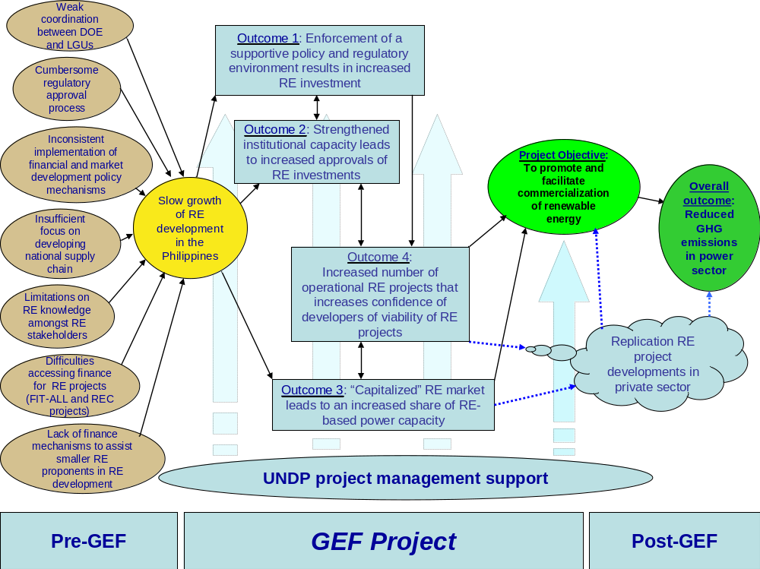

Legend:
Barriers
Current scenario
GEF activities
Project objective
Figure 4: Indicative Implementation Schedule for DREAMS
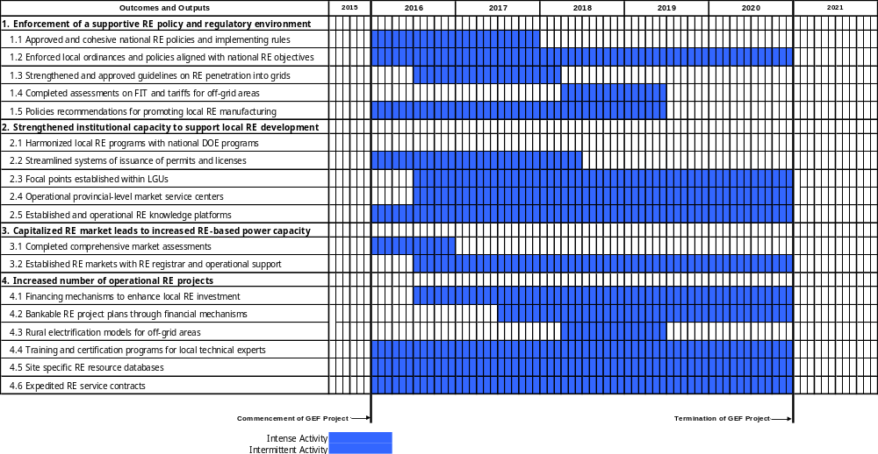

Key Indicators and Risks

Indicators

- The key project indicators are shown in the table below

Indicator | Target
Direct cumulative CO_{2eq} emission reductions by End-Of-Project (EOP, Year 2020), kilo | 205
% share of RE in the power generation mix of the Philippines by EOP | 35
Number of sitio households in far-flung areas that have obtained access to reliable sources of renewable energy due to the Project, by EOP | 20,000
Number of approved and enforced policies and guidelines for leveraging RE investments by Year 2 | 8
Number of sitios with off-grid rural electrification plans using RE by EOP | 12
Number of businesses who have accreditation or applied for DOE accreditation by EOP to manufacture, fabricate or supply locally-produced RE components | 50
Number of funded and implemented RE projects championed or facilitated by LGU-based RE focal points by EOP | 5
Number of RE projects facilitated by operational provincial-level RE market service centers by EOP; | 5
Number of RE projects that were designed based on information and technical advice obtained from the established RE knowledge platform by EOP | 6
Cumulative MW of installed capacity registered in the RER established in the “capitalized” RE market by EOP | 10
Number of RE developers registered in the RER by EOP | 15
MW of RE projects that are being developed through the PPF by EOP | 15
Number of bankable RE plans completed by other LGUs who were interested in RE-based energy systems by Year 3; | 3
Number of certified technicians for RE equipment assembly and supply working with locally DOE accredited RE manufacturing entities by EOP. | 10
MW of installed capacity of RE projects being implemented that received support from new RE financial mechanisms that combine PPF, RE loan financing and the LGUGC (when appropriate) by EOP; | 5
MW of installed capacity of RE projects resulting from accelerated expediting of RE service contracts by EOP. | 75

- During the Project inception and conclusion of the implementation work plan, the Project will develop an output level Monitoring & Evaluation framework with appropriate indicators for each output. The target values for these indicators will be monitored as per the overall project M&E framework throughout Project implementation.

Risks

- The overall project risk is low. While all possible efforts have been made in the design of DREAMS to mitigate perceived risks, there are inevitably a number of unavoidable residual risks that will require careful monitoring to guide the Project towards achievement of its intended objectives. These risks are identified with recommended mitigation measures on Table 4 and in detail in the “Offline Risk Log” in Annex I.

Table 4: Internal Project Risks and Mitigating Actions
Risk | Level of Risk | Mitigating Actions
Inadequate human resources to implement higher volume of RE project approvals leading to continued delays and long approval periods | Moderate | One of the main Project activities is to address the lack of institutional capacity at all levels, notably at the local level where DOE outreach will be improved.
Inability to sell and absorb RE into the existing power market | Low | Project assistance will be extended to facilitation of the start-up and implementation of RE Market mechanisms which will provide assurances of RE sales and make sales of RE competitive with conventional sources of energy.
The lower global price of oil reduces incentives of potential proponents and communities from pursuing RE development. | Low | Through Project assistance to improve outreach to smaller and more remote communities and increase their awareness of the long-term benefits of RE, these communities will continue pursuit of indigenous sources of power generation through renewables.
Climate change impacts the level of RE generation | Moderate | The Project will assist in the planning and design processes to improve the resilience of RE projects through extremes of climate change.

Cost Effectiveness

- The GEF contribution of USD 5.2 million will result in a cumulative direct emission reduction of 205,181 tonnes CO_{2eq} by the EOP from the accelerated approvals of 4 RE projects as listed in Output 4.6. In consideration of the service life of the RE technologies, lifetime emission reductions from these accelerated approvals will be 2.44 million tonnes CO_{2eq}. This translates into a GEF abatement cost of USD 2.13 per tonne CO_{2eq}.

      - The approach of the DREAMS Project is to remove barriers to the commercialization of RE in the Philippines at a pace to meet the targets of the NREP, and reduce the country’s power sector related GHG emissions. By collaborating with demo RE projects (as outlined in Output 4.6), DREAMS Project will demonstration how regulatory and other barriers hindering RE project development (as explained in the Barrier Analysis section) can be addressed to expedite the installation and commissioning of RE projects that have been long stuck in the DOE pipeline. The approach of the DREAMS Project can be used as a template for expediting the development of other backlogged projects, thereby, benefitting the overall RE development in the Philippines. Moreover, GHG emissions from the energy sector will continue to increase without abatement. While energy efficiency can provide GHG reductions, the development of renewable energy for the Philippines is the most cost-effective means of long-term reduction of GHG emissions from the energy sector. The DREAMS Project will accelerate RE project commercialization with significant participation from the private sector, boost investor confidence and generate lessons and knowledge on effective implementation of RE projects, and generate indirect emission reductions resulting from the development of a renewable energy investment facilitation center (managed by the DOE) and an enabled RE investment environment (top-down) that will result in the reduction of 141,000 ktonnes CO_{2eq} based on a causality factor of 20%. Details of the GHG calculations can be found in Annex II.

- DREAMS also seeks to produce knowledge of global value on how to implement adaptation measures in small island states that can be applied in other countries in the region that are not participating in the Project and even for islands in other regions of the world. The value of these early lessons will make the GEF resources applied, more cost-effective in the medium term.

Sustainability, Replicability, Innovativeness and Impact

Sustainability

- By adopting a strategy which focuses first and foremost on the provision of de-risking instruments (such as RE policy design, ensuring long term local RE targets consistent with that called for by the NREP) the DREAMS Project aims to address risks to the investors. By way of establishing a supportive enabling environment, this will enhance the confidence to the private sector, consequently, leading to full scale transition and commercialization of RE in the country. More specifically, the enabling environment will be reinforced as the Project will formulate and enforce clear policies, decrees and guidelines on RE development as well as streamline permitting processes both at the national and local levels. It will capacitate and enhance active engagement of local governments to prioritize RE in their local development plans which will ensure sustainability, as RE will form an integral part of local planning processes even after the Project closure (Outputs 1.1, 1.2, 2.1, 2.2). Market service centers will assist local RE project proponents through the regulatory approval process (Output 2.4) as well as institutionalize coordination mechanism and linkages between the DOE and the local governments to expedite the RE development processes at the sub-national levels. Training of local personnel in RE development to eventually serve as personnel at the market service centers (Output 2.3) will ensure that the capacity is built and sustained over a longer period of time beyond the 60 month direct project implementation cycle. Likewise, the capitalized RE market that will be fully operational through the support of the Project will open up market opportunities and financial incentives for project developers (Outputs 3.1 and 3.2). The DREAMS Project is designed to ensure that RE investment conditions by the EOP are de-risked and favorable to the extent that RE development in the Philippines is sustained well after Project completion. Sustainability of this GEF project will be ensured through policy design that focuses on a combination of appropriate instruments responding to a gamut of barriers and risks to RE investment: (a) policy de-risking such as consistent RE targets, streamlined permitting processes; and (b) financial de-risking through the promotion and operationalization of Renewable Energy Market.
  - Streamlined permitting process for RE projects at both local and national levels that will reduce RE project approval times and contribute to the confidence of RE developers and investors that development costs of RE projects is more defined;
  - Ensuring that long-term programmes for implementation of RE projects notably at the local level, is consistent with NREP targets;
  - The development of functional RE market service centers that will assist in the facilitation of RE investments at the local level. These MSCs will be staffed by local Government personnel with improved knowledge on RE development and the regulatory approval process; and,
  - Actions to ensure full implementation of the RE Market and its financial incentives (i.e. FiT-ALL and RECs) that will de-risk investments into RE projects.

Replicability

- Through building the capacities of selected local governments, the Project can demonstrate improvements of the effectiveness of LGUs as agents in the mainstreaming of RE efficiently, responding to project development and implementation needs of the private sector in RE development. The achievement of the Project outcomes with these LGUs in successfully developing RE projects will be replicated by other LGUs.

- RE project development will also be scaled-up through increased investor confidence in the streamlined regulatory process and viable RE demonstrations and a financial package that includes project preparation funds coupled with RE loans and increased access to loan guarantees for smaller RE project proponents. This will improve access to RE projects in small communities, and boost investor confidence that on-grid RE projects can be successfully developed in the Philippines with attractive rates of return. This demonstration of RE viability and favorable RE investment conditions in the Philippines will facilitate replication of RE project investments throughout the country.

Innovativeness

- The innovativeness of the proposed DREAMS Project can be attributed to its focus on strengthening the communication and coordination linkages between national and local governments for RE development. No project in the Philippines has yet focused on strengthening this linkage which has the potential to accelerate RE development in the Philippines to meet the RE targets of the NREP. Therefore, the concept of involving the local governments in the conceptualization, design, development and financing of RE-based power generation projects to address the persistent regulatory and institutional obstacles barriers and logjams in the approval & permitting processes is among the innovation that the DREAMS Project will bring about. Such approach is expected to result in something different from the results of the previous standard, run-of-the mill interventions that have been usually carried out to deal or resolve such issues. By way of background, local governments were perceived as not having a synchronous relationship with the DOE and national RE objectives, and having insufficient levels of knowledge to support RE development in their communities. Moreover, local governments were not included in the RE Act. The DREAMS Project is innovative in its approach to assisting the country in meeting its NREP targets through setting up favorable conditions for engaging local governments to facilitate RE investments. This would strengthen local commitments to RE projects through stronger ownership, and accelerate its local approval and timely implementation.

Impact

- There are a number of positive national social and environmental impacts from the implementation of this Project including:
- Improving energy security for many Filipinos including those in remote communities through indigenous generation of renewable energy. With diesel power generation in remote communities being costly and further restricting access to electricity, the generation of indigenous and less costly renewable energy will be a long-term benefit notably for marginal income households who will be able to improve their quality of life;
- Long term reduction of energy costs to the country that could lead to increasing government budgets on expenditures other than on imported fossil fuels. While there are no subsidies in the Philippines energy market, the country’s dependence on fossil fuels exposes end users to global fluctuations in fossil fuel prices. The development of indigenous renewable energy mitigates this exposure to local businesses, benefitting the development of local economies;
- Development of green jobs that provide opportunities for diversification of local economies. This Project is providing direct support to creating local businesses and employment related to supporting local manufacture and assembly of equipment related to renewable energy projects as well as jobs related to the planning, design, construction, operation and maintenance of these facilities;
- Gender benefits are expected for marginal income households that will benefit from an expected reduction of electricity costs from renewable energy.

- One potential negative impact is the displacement of residents on lands where RE projects are to be located. As such, these RE projects will need to undergo resettlement reviews on identify displaced households and resettle them on new property, a process that currently exists within the regulatory process.

- Global impacts include the reduction of GHG emissions associated with the combustion of fossil fuels for electricity generation, as well as the emissions of harmful pollutants such as carbon monoxide, NOx, SOx and other harmful volatile organic compounds would also be reduced.

- The impact of this project with regards to transformational change on the energy market in the Philippines is significant. The Project contributes towards the realization of the ambitious NREP target by expediting the approval and development of RE projects delayed in the DOE Service Contract, stimulating greater private sector investments and strengthening local government participation. The Project will provide an impetus in transforming the fragmented and halting RE sector into a focused, sustained and commercialized RE market.

project results framework
Primary applicable Key Environment and Sustainable Development Key Result Area (same as that on the cover page, circle one): 1. Mainstreaming environment and energy OR
2. Catalyzing environmental finance OR 3. Promote climate change adaptation OR 4. Expanding access to environmental and energy services for the poor.
Applicable GEF Strategic Objective and Program: GEF-4 CC4 Strategic Program SP3: Increased production of renewable energy in electricity grids
Applicable GEF Expected Outcomes: Total avoided GHG emissions from on-grid RE electricity generation
Applicable GEF Outcome Indicators: Market penetration of on-grid renewable energy (% from renewables); GHG emissions from electricity generation (tons CO_{2eq}/kWh); and $/ tons CO_{2eq}

 | Indicator | Baseline | Targets  End of Project | Source of verification | Assumptions
Project Objective:  To promote and facilitate the commercialization of the renewable energy (RE) markets through the removal of barriers to increase investments in RE based power generation projects | - Cumulative direct project CO₂ emission reductions from RE development by end-of-project (EOP), ktonnes CO₂  - % share of RE in the power generation mix of the Philippines by EOP  - Number of sitio households in far-flung areas that have obtained access to reliable sources of renewable energy due to the Project, by EOP | - 0  - 14.4  - 0 | - 205  - 35  - 20,000 | - Project final report as well as annual surveys of energy generation for the entire energy sector of the Philippines as well as the energy generation of each RE project  - NEA surveys on the development of RE on rural electrification projects within their Sitio Electrification Program | - Economic growth in the country will continue  - Government support for RE development and utilization will not change
Outcome 1:  Enforcement of a supportive policy and regulatory environment for leveraging investment in RE development and applications at the local level | - Number of approved and enforced policies and guidelines for leveraging RE investments by Year 2  - Number of sitios with off-grid rural electrification plans using RE by EOP  - Number of businesses who have accreditation or applied for DOE accreditation by EOP to manufacture, fabricate or supply locally-produced RE components | - 0  - 0  - 0 | - 8  - 12  - 50 | - Guidebooks on operational rules that assist DOE on developing RE power projects in the country  - Documentation and resolutions passed during TWG meetings  - Studies of rural electrification models that incorporate innovative RE services  - Feasibility studies of FIT-ALL and tariffs for off-grid areas  - Report on policy recommendations for promotion of local manufacturing and assembly of quality RE systems | - Continued government support for legislative and regulatory reform to promote and accelerate RE development  - Capacity of government does not substantially delay approval of RE policies and RE projects
Outcome 2:  Strengthened institutional capacity that leads to increased RE investment at the local level | - Number of funded and implemented RE projects championed or facilitated by LGU-based RE focal points by EOP  - Number of RE projects facilitated by operational provincial-level RE market service centers by EOP;  - Number of RE projects that were designed based on information and technical advice obtained from the established RE knowledge platform by EOP | - 0  - 0  - 0 | - 5  - 5  - 6 | - Workshop and seminar proceedings  - RE training course materials  - Training evaluations by participants  - Functional revived RE website | - Government budgets for RE data collection are replenished on an annual basis
Outcome 3:  Capitalized RE market leads to an increased share of RE based power capacity | - Cumulative MW of installed capacity registered in the RER established in the “capitalized” RE market by EOP  - Number of RE developers registered in the RER by EOP | - 0  - 0 | - 10  - 15 | - Comprehensive market assessments of electricity markets and market policy mechanisms of the RPS  - Outputs from the RE Registrar software  - Bankable documents with business plans and financing options for RE projects entering the REM  - PPAs and approval permits to construct  - Contract documents for construction and RE technology installation  - Work inspection reports | - Substantial increase in RE development occurs during DREAMS Project  - There are sufficient number of RE entrants onto the REM that will allow the market to function without fear of collusion or price fixing
Outcome 4a:  Enhanced confidence of project developers on the viability of RE projects at the local level | - MW of RE projects that are being developed through the PPF by EOP  - Number of bankable RE plans completed by other LGUs who were interested in RE-based energy systems by Year 3;  - Number of certified technicians for RE equipment assembly and supply working with locally DOE accredited RE manufacturing entities by EOP. | - 0  - 0  - 0 | - 15  - 3  - 10 | - Completed studies on RE policy/tariffs, and RE grid integration  - RE project approvals  - Documentation and resolutions passed during TWG meetings  - Studies of rural electrification models that incorporate innovative RE services  - Numbers of trained and certified local RE technicians  - Feasibility studies of site specific RE technology deployment | - Capacity of government does not substantially delay approval of RE policies and RE projects  - Sustained local support for RE projects  - Sufficient annual replenishment of RE development funds
Outcome 4b:  Increased number of operational RE projects using proven and emerging RE technologies that boosts successful replication | - MW of installed capacity of RE projects being implemented that received support from new or improved RE financial mechanisms, by EOP;  - MW of installed capacity of RE projects resulting from accelerated expediting of RE service contracts by EOP. | - 0  - 0 | - 5  - 75 | - PPAs and approval permits to construct  - Contract documents for construction and RE technology installation  - Work inspection reports | - Capacity of government does not substantially delay approval of RE policies and RE projects  - Sustained local support for RE projects  - Construction and RET installations are undertaken by qualified and competent technicians

total budget and work plan
Award ID: |  | 00088788 |  |  |  |  | Project ID(s): |  | 00095299
Award Title: |  | Development for Renewable Energy Applications Mainstreaming and Market Sustainability (DREAMS)
Business Unit: |  | PHL10
Project Title: |  | Development for Renewable Energy Applications Mainstreaming and Market Sustainability (DREAMS)
PIMS no. |  | 5194
Implementing Partner (Executing Agency) |  | Department of Energy
GEF Outcome/Atlas Activity | Responsible Party/  Implementing Agent |  | Fund ID | Donor Name | Atlas Budgetary Account Code | ATLAS Budget Description |  | Amount (USD)  Year 1 2016 |  | Amount (USD)  Year 2 2017 | Amount (USD)  Year 3 2018 | Amount (USD) Year 4 2019 | Amount (USD) Year 5 2020 | Total (USD) | Budget Notes
Outcome 1: Enforcement of a supportive policy and regulatory environment for leveraging investment in RE development and applications at the local level, and | DOE |  | 62000 | GEF | 71200 | International Consultants |  | 12,000 |  | 12,000 | 8,000 | 0 | 4,000 | 36,000 | See Note 1
 |  |  |  |  | 71300 | Local Consultants |  | 46,221 |  | 43,639 | 17,925 | 17,925 | 14,001 | 139,711 | See Note 2
 |  |  |  |  | 72100 | Contractual Services – Companies |  | 60,000 |  | 125,000 | 27,000 | 40,000 | 0 | 252,000 | See Note 3
 |  |  |  |  | 71600 | Travel |  | 10,000 |  | 10,000 | 5,000 | 5,000 | 5,000 | 35,000 | See Note 4
 |  |  |  |  | 75700 | Training, Meetings & Workshops Costs |  | 16,000 |  | 10,000 | 10,000 | 16,000 | 8,000 | 60,000 | See Note 5
 | Total GEF Outcome 1 |  |  |  |  |  |  | 144,221 |  | 200,639 | 67,925 | 78,925 | 31,001 | 522,711
 | Total Outcome 1 |  |  |  |  |  |  | 144,221 |  | 200,639 | 67,925 | 78,925 | 31,001 | 522,711
Outcome 2: Strengthened institutional capacity that leads to increased RE investment at the local level | DOE |  | 62000 | GEF | 71200 | International Consultants |  | 0 |  | 0 | 8,000 | 0 | 4,000 | 12,000 | See Note 6
 |  |  |  |  | 71300 | Local Consultants |  | 84,377 |  | 85,668 | 90,417 | 90,417 | 82,980 | 433,859 | See Note 7
 |  |  |  |  | 72100 | Contractual Services - Companies |  | 72,500 |  | 82,500 | 92,000 | 66,500 | 5,000 | 318,500 | See Note 8
 |  |  |  |  | 71600 | Travel |  | 25,000 |  | 25,000 | 15,000 | 15,000 | 15,000 | 95,000 | See Note 9
 |  |  |  |  | 74200 | Audio-Visual & Print Prod Costs |  | 10,000 |  | 10,000 | 5,000 | 0 | 0 | 25,000 | See Note 10
 |  |  |  |  | 75700 | Training, Meetings & Workshops Costs |  | 15,000 |  | 33,000 | 24,000 | 15,000 | 9,000 | 96,000 | See Note 11
 | Total GEF Outcome 2 |  |  |  |  |  |  | 206,877 |  | 236,168 | 234,417 | 186,917 | 115,980 | 980,359
 | Total Outcome 2 |  |  |  |  |  |  | 206,877 |  | 236,168 | 234,417 | 186,917 | 115,980 | 980,359
Outcome 3: Increased share of RE-based power capacity | DOE |  | 62000 | GEF | 71200 | International Consultants |  | 18,000 |  | 18,000 | 22,000 | 18,000 | 16,000 | 92,000 | See Note 12
 |  |  |  |  | 71300 | Local Consultants |  | 23,396 |  | 23,087 | 29,386 | 21,640 | 28,664 | 126,173 | See Note 13
 |  |  |  |  | 72100 | Contractual Services - Companies |  | 150,000 |  | 60,000 | 58,000 | 50,000 | 10,000 | 328,000 | See Note 14
 |  |  |  |  | 71600 | Travel |  | 5,000 |  | 5,000 | 5,000 | 5,000 | 5,000 | 25,000 | See Note 9
 |  |  |  |  | 72100 | Contractual Services - Companies |  | 0 |  | 500,000 | 0 | 0 | 0 | 500,000 | See Note 15
 | Total GEF Outcome 3 |  |  |  |  |  |  | 196,396 |  | 606,087 | 114,386 | 94,640 | 59,664 | 1,071,173
 | Total Outcome 3 |  |  |  |  |  |  | 196,396 |  | 606,087 | 114,386 | 94,640 | 59,664 | 1,071,173
Outcome 4a: Increased confidence of local RE developers that leads to an enhanced uptake of RE projects; and | DOE |  | 62000 | GEF | 71200 | International Consultants |  | 6,000 |  | 6,000 | 18,000 | 12,000 | 20,000 | 62,000 | See Note 16
 |  |  |  |  | 71300 | Local Consultants |  | 81,639 |  | 81,639 | 89,181 | 55,103 | 58,924 | 366,486 | See Note 17
 |  |  |  |  | 72100 | Contractual Services - Companies |  | 50,000 |  | 50,000 | 62,500 | 82,500 | 27,000 | 272,000 | See Note 18
 |  |  |  |  | 71600 | Travel |  | 10,000 |  | 10,000 | 10,000 | 10,000 | 10,000 | 50,000 | See Note 19
 |  |  |  |  | 74200 | Audio-Visual Print Production Costs |  | 0 |  | 0 | 10,000 | 10,000 | 3,000 | 23,000 | See Note 20
 |  |  |  |  | 72100 | Contractual Services - Companies |  | 0 |  | 1,000,000 | 0 | 0 | 0 | 1,000,000 | See Note 21
 |  |  |  |  | 75700 | Training, Meetings & Workshops Costs |  | 12,000 |  | 30,000 | 18,000 | 21,000 | 0 | 81,000 | See Note 22
 | Total GEF Outcome 4a |  |  |  |  |  |  | 159,639 |  | 1,177,639 | 207,681 | 190,603 | 118,924 | 1,854,486
 | Total Outcome 4a |  |  |  |  |  |  | 159,639 |  | 1,177,639 | 207,681 | 190,603 | 118,924 | 1,854,486
Outcome 4b: Successful replication of operational RE projects using proven and emerging RE technologies |  |  |  |  | 71200 | International Consultants |  | 0 |  | 0 | 0 | 6,000 | 14,000 | 20,000 | See Note 23
 |  |  |  |  | 71300 | Local Consultants |  | 59,739 |  | 59,739 | 69,754 | 111,578 | 112,094 | 412,904 | See Note 24
 |  |  |  |  | 72100 | Contractual Services - Companies |  | 0 |  | 0 | 0 | 0 | 16,000 | 16,000 | See Note 25
 |  |  |  |  | 71600 | Travel |  | 15,000 |  | 15,000 | 15,000 | 15,000 | 15,000 | 75,000 | See Note 26
 | Total GEF Outcome 4b |  |  |  |  |  |  | 74,739 |  | 74,739 | 84,754 | 132,578 | 157,094 | 523,904
 | Total Outcome 4b |  |  |  |  |  |  | 74,739 |  | 74,739 | 84,754 | 132,578 | 157,094 | 523,904
Project Management | DOE & UNDP |  | 62000 | GEF | 71300 | Local Consultants and Local Staff |  | 18,172 |  | 17,707 | 15,849 | 15,849 | 15,333 | 82,910 | See Note 27
 |  |  |  |  | 72200 | Equipment & Furniture |  | 8,000 |  | 4,000 | 2,457 | 2,000 | 0 | 16,457 | See Note 28
 |  |  |  |  | 72400 | Communications & Audio Visual Equip |  | 5,000 |  | 5,000 | 6,000 | 6,000 | 6,000 | 28,000 | See Note 29
 |  |  |  |  | 72500 | Office Supplies |  | 12,000 |  | 12,000 | 12,000 | 12,000 | 12,000 | 60,000 | See Note 30
 |  |  |  |  | 74500 | UNDP Cost Recovery Charges |  | 7,000 |  | 7,000 | 7,000 | 7,000 | 7,000 | 35,000 | See Note 31
 |  |  |  |  | 74100 | Professional Services (Audit) |  | 3,000 |  | 3,000 | 3,000 | 3,000 | 3,000 | 15,000 | See Note 32
 |  |  |  |  | 75700 | Training, Meetings & Workshops Costs |  | 10,000 |  | 0 | 0 | 0 | 0 | 10,000 | See Note 33
Total GEF M&E and Project Management |  |  |  |  |  |  |  | 63,172 |  | 48,707 | 46,306 | 45,849 | 43,333 | 247,367
Total M&E and Project Management |  |  |  |  |  |  |  | 63,172 |  | 48,707 | 46,306 | 45,849 | 43,333 | 247,367
GEF Total |  |  |  |  |  |  |  | 845,044 |  | 2,343,979 | 755,469 | 729,512 | 525,996 | 5,200,000
Grand Total |  |  |  |  |  |  |  | 845,044 |  | 2,343,979 | 755,469 | 729,512 | 525,996 | 5,200,000

Summary of Funds:
 | Amount  Year 1 | Amount  Year 2 | Amount  Year 3 | Amount Year 4 | Amount Year 5 | Total
GEF | 845,044 | 2,343,979 | 755,469 | 729,512 | 525,996 | 5,200,000
Co-financing: | 12,701,000 | 22,111,222 | 1,170,000 | 1,160,000 | 1,160,000 | 38,302,222
UNDP | 40,000 | 40,000 | 40,000 | 40,000 | 40,000 | 200,000
DOE/REMB | 460,000 | 460,000 | 460,000 | 460,000 | 460,000 | 2,300,000
PEMC | 950,000 | 480,000 | 430,000 | 420,000 | 420,000 | 2,700,000
Iloilo Provincial Government | 111,000 | 111,222 | 100,000 | 100,000 | 100,000 | 522,222
Palawan Provincial Government | 140,000 | 140,000 | 140,000 | 140,000 | 140,000 | 700,000
SunAsia (Mogpog 12 MW Solar) | 10,000,000 | 16,680,000 | 0 | 0 | 0 | 26,680,000
Enfinity (Camotes 1.0 MW Solar) | 0 | 2,000,000 | 0 | 0 | 0 | 2,000,000
EnTech (Armenia 2.0 MW Biomass) | 1,000,000 | 2,200,000 | 0 | 0 | 0 | 3,200,000
Total: | 13,546,044 | 24,455,201 | 1,925,469 | 1,889,512 | 1,685,996 | 43,502,222

Budget Notes:
    - This includes contractual services for the International Energy Expert (IEE) for 4 wks each for Yrs 1 and 2 and an International Evaluation Specialist (IES) for 2 wks in Yr 3 and 1 wk in Yr 5;
    - Local consultant services including Chief Technical Advisor (CTA) for 18 weeks each for Yrs 1 and 2, 4 weeks each for Yrs 3 and 4, and 2 weeks for Yr 5; the National Finance Expert (NFE) for 5 weeks each for Yrs 1 to 5; the Communications Knowledge Specialist (CKS) for a total of 10 wks each for Yrs 1 to 5 and other technical backstopping team of local consultants required for surveys, policy analysis, strategic planning, techno-economic feasibility studies, etc.
    - USD 60,000 for RE grid integration specialists (for Output 1.3), USD 75,000 for various documentation services for drafting policies and guidelines for REMB, USD 60,000 for FIT, and tariffs for offgrid areas (Output 1.4), USD 50,000 study on assessment local manufacturing capacity and power meter quality standards (Output 1.5), USD 7,000 during Year 3 for national team to work with IES on mid-term evaluation (cost shared with Components 2 and 3);
    - Travel required to and from various meetings and workshops;
    - More than 30 workshops assumed to be around USD 2,000 per workshop;
    - This includes professional time for an IES for 2 wks in Yr 3 and 1 wk in Yr 5;
    - Local consultants including the CTA for 16 weeks each for Yrs 1 to 4 weeks and 12 weeks for Yr 5; the NFE for 16 weeks each for Yrs 1 to 5; the CKS for a total of 20 wks each for Yrs 1 to 5; three Community Officers (NCOs) for 26 weeks for Yrs 1 to 5; the Capacity Development Specialist (CDS) for 12 weeks each in Yrs 1 to 5. This also includes other technical services for the preparation of standard methodologies and templates for harmonizing and streamlining the regulatory processes;
    - USD 197,500 for preparing RE training programs and delivery of training services to LGUs and DOE M&E officers (Output 2.1), USD 29,000 for study on MSC roll-out strategy, USD 35,000 to upgrade DOE RE website, USD 25,000 for outsourcing documentation, USD 25,000 (over Yrs 1 and 2) to assist in technical issues related to RE equipment, USD 7,000 during Year 3 for national team to work with IES on mid-term evaluation (cost shared with Components 1 and 3)
    - Frequent travel Palawan and Iliolo Province LGUs and MSC location throughout the country is required by all Project personnel;
    - Costs related to production of training materials;
    - More than 32 workshops and seminars assumed to be around USD 3,000 per workshop;
    - This includes professional time for the International Energy Expert (IEE) for 6 wks each for Yrs 1 to 4, and 4 weeks for Yr 5; and an IES 1 wk each in Yrs 3 and 5;
    - Local consulting services including the CTA for Yrs 1, 2 and 4, 8 weeks for Yr 3, and 6 wks for Yr 5; the NFE for 6 weeks each for Yrs 1 to 5; the CKS for a total of 5 wks each for Yrs 1 to 5; the CDS for 4 wks for Yrs 1, 2 and 5, and 12 weeks each in Yrs 3 to 4; local technical backstopping for the REM market assessments, preparation of guidelines, procurement and operational support for setting up the RE registrar;
    - USD 160,000 for the outsourcing of comprehensive market assessments for REM as described under Output 3.1, and USD 160,000 for a technology firm in the setup of the REM and trial runs, USD 8,000 during Year 3 for national team to work with IES on mid-term evaluation (cost shared with Components 1 and 2);
    - This grant is for software and training for RER software in support of start-up of the RE Market;
    - This includes professional time for the IEE for 2 wks each for Yrs 1 and 2, 6 wks for Yr 3 and 4 wks each in Yrs 4 and 5; and an IES for 2 wks in Yr 5;
    - This includes professional time for NFE; backstopping support for data gathering, surveys and feasibility assessments on financial instruments; assistance to project proponents;
    - USD 80,000 for setup of rural electrification model (Output 4.2), USD 160,000 for setup of curriculum for training and the training and certification of RE technicians (Output 4.3), USD 25,000 (during Yrs 3 and 4) to assist with technical issues related to RE equipment procurement; preparation of bankable RE proposals, and USD 7,000 during Year 5 for national team to work with IES on final evaluation (cost shared with Component 4b);
    - Frequent travel will be required to pilot project sites in remote areas and to pilot LGUs;
    - For printed awareness raising materials on the availability of PPF and other products from the Project;
    - Provisions for additional funds for PPF with participating banks with RE specific funds;
    - More than 27 workshops and seminars assumed to be around USD 3,000 per workshop;
    - This includes professional time for the IEE for 2 wks each in Yrs 4 and 5; and an IES for 2 wks in Yr 5;
    - Local consulting services including the CTA for 8 weeks each for Yrs 1, 2 and 3, 16 wks each for Yrs 4 and 5; the NFE for 5 weeks each for Yrs 1 to 5; the CKS for a total of 7 wks each for Yrs 1 to 5; three Community Officers (NCOs) for 13 weeks for Yrs 1 to 5; the CDS for 8 weeks each in Yrs 1, 2 and 3, 16 wks each in Yrs 4 and 5;
    - USD 9,000 for technical support services related to technical issues such as FiT, wheeling, grid impacts and discussions with ERC, USD 7,000 during Year 5 for national team to work with IES on final evaluation (cost shared with Component 4a);
    - Frequent travel to remote project sites, LGUs and MSCs will be required;
    - This includes professional time for the PMU including PM, M&EO, FO and AO;
    - For office equipment;
    - For knowledge management products and mobile phone communications;
    - Budget set up for office supplies used in PMU;
    - Budget set up for Provision of support services (UNDP Cost Recovery Charges) for financial services, procurement of goods and services, HR and issuance of contracts, travel, etc. Draft LOA for UNDP support services will be available for review at DOA issuance stage;
    - Budget set up for Project audit;
    - For Inception Workshop at commencement of Project operations

MANAGEMENT ARRANGEMENTS

Project Organization Structure

- The project will be executed according to UNDP’s National Implementation Modality (NIM), as per the NIM project management implementation guidelines agreed by UNDP and the Government of the Philippines. The Project is co-financed with funding from the GEF and UNDP acts as the GEF Executing Agency. All components of the Project will be implemented by the REMB under the DOE, who will assume the overall responsibility for the achievement of Project results as the Implementing Partner (GEF Local Executing Agency). REMB will designate a senior official as the National Project Director (NPD) for the Project. The Implementing Partner will assume the overall responsibility of ensuring that all activities are executed accordingly and as per the approved Project Document. The NPD will be responsible for the achievement of the project objectives through institutional coordination with the key stakeholder members of the PB and overall alignment of the DREAMS Project with the relevant national programs of the Philippines. The DREAMS Project Management Unit (PMU) will consist of a Project Manager (PM), Monitoring and Evaluation Officer (M&EO), a Finance Officer (FO), and an Administrative Officer (AO). The organization structure of DREAMS is depicted on Figure 7. The Terms of Reference (ToRs) of PMU personnel are provided in Annex VI.

- The Project Board (PB) established at the inception of the project will play the role of policy and decision making body for the project implementation. It will have oversight of the Project Management Unit (PMU) and monitor project progress, guide implementation and support the project in achieving its overall outputs, outcomes and objective. The PB will consist of a Chairperson (REMB/DOE); with PSC members from (REMB/DOE), PEMC, DILG, TRANSCO, NGCP, NPC-SPUG, LGUs from Palawan and Iliolo Provinces, UNDP Philippines, a financial institution, and a nominee from the private sector. The primary functions of the PB will be to provide the necessary policy and strategic direction that allows the Project to function and achieve its policy and technical objectives, and to approve the annual Project plans and M&E reports. One of the key tasks of the PB will be to ensure coordination and synchronization of all activities supported by the Project and will serve as a platform for key project stakeholders and beneficiaries to share experience and design joint strategies on the Project. PB meetings will be conducted twice annually or more frequently if necessary allowing for the stakeholders to review the progress with the project implementation and to agree on a coordinated annual project implementation strategy and plan. The first PB meeting should be held within the first 12 months following the inception workshop.

- The PB will be responsible for the following: (a). Reviewing of annual progress reports for necessary guidance; (b) Reviewing and approving the annual work plans and budgets; (c) Providing guidance on the effectiveness of the DREAMS project implementation, and its linkages to corporate UNDP policy decisions, and other UNDP initiatives; and, (d) Monitoring and evaluating the implementation of DREAMS Project towards the intended outputs, after two (2) years of project execution.

Figure 7: Project Organization Structure
Project Management Unit (PMU)
1. Project Manager
2. M&E Officer
3. Finance Officer
4. Administrative Officer

Project Board (PB)
REMB (under DOE), PEMC, DILG, TRANSCO, NGCP, NPC-SPUG, LGUs (from Palawan and Iliolo Provinces), a financial institution, one nominated member from the private sector
Executive
REMB

UNDP

Project Assurance
- UNDP Programme Officer
- Regional Technical Adviser

National Project Director (NPD)
National and International Consultants

- There are a number of other stakeholders that will be involved in the development and implementation of the DREAMS Project including the following who are also co-financiers of the Project, namely those named on Table 5, a summary of co-financing from stakeholders. The DOE will ensure co-finance and cooperation from its other programs, some of which are funded by other donor agencies.

- The NPD will be responsible for overall guidance to project management (for all components), including adherence to the Annual Work Plan (AWP) and achievement of planned results as outlined in the ProDoc, and for the use of UNDP funds through effective management and well established project review and oversight mechanisms. He/She will ensure the delivery of the project outputs and the judicious use of the project resources. This will ensure that expected outputs are delivered using the most efficient and cost‑effective implementation strategies and procedures. The NPD also will ensure coordination with various ministries and agencies provide guidance to the Project team to coordinate with UNDP, review reports and manage administrative arrangements as required by the GoP and UNDP. This would include the contribution of office space within the premises of the DOE to personnel in the Project Management Unit (PMU).

- The DREAMS Project has been designed as an umbrella project that will initially develop and provide coordination for the Philippines efforts to promote the development of renewable energy in the Philippines. As such, the NPD in close collaboration with the Project’s NPM will chart and implement the Philippines activities of this Project towards its objectives of catalyzing RE development in the Philippines. This will include outsourcing of technical assistance such as a study for integrating RE financing mechanisms, preparation of training programmes for LGUs and DOE M&E Officers, comprehensive assessments for the REM, and studies on a rural electrification model and FiT and tariffs for power in off-grid areas. Under the guidance of the NPD, the PMU will manage the day-to-day activities of the Project and carrying out the prescribed monitoring system. The PMU will have one full-time staff, the National Project Manager, and two part-time staff, the M&E Officer and an Administrative Assistant The Project Manager (NPM) will be tasked with the day-to-day management of project activities, as well as with financial and administrative reporting. The Project Manager will be responsible for project implementation and will be guided by Annual Work Plans (AWP) and follow the RBM standards. The NPM will prepare AWPs in advance of each successive year and submit them to the PB for approval. The NPM will be supported by the PMU staff and will have the authority to run the project on a daily basis on behalf of the Implementing Partner within the constraints laid down by the Board. Prime responsibility of the NPM is to ensure that the project produces the planned outputs and achieves the planned indicators by undertaking necessary activities specified in the project document to the required standard of quality and within the specified constraints of time and cost. This will require linking the indicators to the work plan to ensure RBM.

- Terms of Reference (ToRs) for these PMU staff are contained in Annex IV.

- Project Assurance: UNDP will provide overall management and guidance from its Country Office (CO) in Manila and the Bangkok Regional Hub (BRH) in Bangkok, and will be responsible for monitoring and evaluation of the project as per normal GEF and UNDP requirements. UNDP will designate an Advisor to provide independent project oversight and monitoring functions, to ensure that project activities are managed and milestones accomplished. The UNDP Advisor will be responsible for reviewing Risk, Issues and Lessons Learned logs, and ensuring compliance with the Monitoring and Communications Plan. The UNDP-GEF Regional Technical Advisor will also play an important project assurance role by supporting project implementation oversight and annual APR/PIR process.

General

Collaborative Arrangements with Related Projects

- The proposed Project will have collaborative arrangements with a number of other donor initiatives that support renewable energy, described as follows:

- The Philippines Renewable Energy Development Project (PHRED) is scheduled to be implemented in 2016 by the DOE and LGUGC through a USD 40 million World Bank loan (P147646). PHRED is designed to increase renewable energy generation in all parts of the Philippines, including off-grid areas, and to bolster private sector RE lending to electric cooperatives that are focused on operational and financial efficiency. This will complement the DREAMS Project through the identification of more potential RE proponents from NPC-SPUG areas, and their subsequent and increased exposure to financial products such project preparation financing and RE financing to ECs, LGUs and private sector entities at the local level. The PHRED Project currently is awaiting approval from a Special Presidential Authority;
- EU-funded, GIZ-implemented “Technical assistance for access to sustainable energy” (ASEP) grant assistance project of €65 million will provide technical assistance, policy advice and capacity-building services to DOE and other stakeholders in the energy sector. Through ASEP, the EU will focus its support to off-grid SPUG areas with efforts to increase operational efficiencies of Electrical Cooperatives (ECs), mainstreaming solar PV in off-grid areas through regulatory and project preparation assistance and stakeholder grants, and support for integrating RE generation in SPUG areas. The DREAMS Project will collaborate with ASEP through its planned activities on technical assistance and capacity building at the local levels, and will avoid duplication efforts. ASEP is expected to commence operations in early 2016;
- IRENA-Renewable Readiness Assessment Project (RRA) is designed for (a) a comprehensive assessment of the current renewable energy status in a country; (b) providing an opportunity and international platform to initiate a national dialogue with all relevant stakeholders to pinpoint renewable energy drivers, comparative advantages, and areas requiring improvement to determine the concerted actions needed to enable the development and scale-up of renewable energy; and (c) consolidating the existing efforts and mobilizing the resources needed for the implementation of actions identified. The DREAMS Project will collaborate with RRA through planned activities on institutional strengthening and activities related to scale up of RE project development. The RRA project is scheduled for early 2016.

- As mentioned in Table 2 and Para 54, the proposed Project will make efforts to closely collaborate with available RE specific loan facilities with financial institutions based in the Philippines. The selection of participating financial institutions will be made during the Inception Phase.

      - This proposed Project will establish the necessary communication and coordination mechanisms through its PMU and PSC with the Project Management Board to ensure proper coordination between the various projects. UNDP Philippines will also take the lead in ensuring adequate coordination and exchange of experiences. The Project will seek to coordinate its actions with other UNDP energy and climate change activities in the Philippines and regionally in Southeast Asia; similar strategies of the proposed Project may extend an opportunity to share lessons and exploit synergies, in particular in areas of harmonization and mutual recognition. The proposed Project will also seek to coordinate actions with other existing government commitments and non-government initiatives.

Prior Obligations and Prerequisites

- There are no prior obligations and prerequisites.

Audit Arrangements

- The Government will provide the UNDP Resident Representative with certified periodic financial statements, and with an annual audit of the financial statements relating to the status of UNDP (including GEF) funds according to the established procedures set out in the programming and finance manuals. The audit will be conducted by the legally recognized auditor of the Government, or by a commercial auditor engaged by the Government.

Communications and visibility requirements

- Full compliance is required with UNDP’s Branding Guidelines. These can be accessed at http://intra.undp.org/coa/branding.shtml, and specific guidelines on UNDP logo use can be accessed at http://intra.undp.org/branding/useoflogo.html. Amongst other things, these guidelines describe when and how the UNDP logo needs to be used, as well as how the logos of donors to UNDP projects needs to be used. For the avoidance of any doubt, when logo use is required, the UNDP logo needs to be used alongside the GEF logo. The GEF logo can be accessed at http://www.thegef.org/gef/GEF_logo. The UNDP logo can be accessed at http://intra.undp.org/coa/branding.shtml

Full compliance is also required with the GEF’s Communication and Visibility Guidelines (the “GEF Guidelines”). The GEF Guidelines can be accessed at http://www.thegef.org/gef/sites/thegef.org/files/documents/C.40.08_BRanding_the_GEF%20final_0.pdf. Amongst other things, the GEF Guidelines describe when and how the GEF logo needs to be used in project publications, vehicles, supplies and other project equipment. The GEF Guidelines also describe other GEF promotional requirements regarding press releases, press conferences, press visits, visits by Government officials, productions and other promotional items.

Where other agencies and project partners have provided support through co-financing, their branding policies and requirements should be similarly applied.

Agreement on Intellectual Property Rights and Use of Logo on Project Deliverables

- To accord proper acknowledgement to GEF for providing funding, a GEF logo should appear on all relevant GEF-supported project publications, including among others, project hardware, if any, purchased with GEF funds. Any citation on publications regarding projects funded by GEF should also accord proper acknowledgement to GEF. Alongside GEF and UNDP logo, a GoP logo may also be featured as the Implementing Partner of the proposed project.

MONITORING FRAMEWORK AND EVALUATION

- The project team and the UNDP Office in Manila supported by the UNDP-GEF Regional Coordination Unit in Bangkok will be responsible for project monitoring an evaluation conducted in accordance with established UNDP and GEF procedures. The Project Results Framework provides performance and impact indicators for project implementation along with their corresponding means of verification. The GEF CC Tracking Tool will also be used to monitor progress in reducing GHG emissions. The M&E plan includes: inception workshop and report, project implementation reviews, quarterly and annual review reports, independent mid-term evaluation, and independent final evaluation. The following sections outline the principle components of the Monitoring and Evaluation Plan and indicative cost estimates related to M&E activities. The M&E budget is provided on Table 8.

- Project start: A Project Inception Workshop will be held within the first 4 months of the project starting with those with assigned roles in the project organization structure, UNDP country office and where appropriate/feasible regional technical policy and program advisors as well as other stakeholders will be invited. The Inception Workshop is crucial to building ownership for the project results and to plan the first year annual work plan. The Inception Workshop would address a number of key issues including:
- Assisting all partners to fully understand and take ownership of the project;
- Detailing the roles, support services and complementary responsibilities of UNDP CO and RCU staff vis-à-vis the project team;

Table 8: M&E Work Plan and Budget
Type of M&E activity | Responsible Parties | Budget US$  Excluding project team staff time | Time Frame
Inception Workshop and Report | - Project Manager  - UNDP CO, UNDP GEF | Indicative cost: 10,000 | Within first four months of project start up
Measurement of Means of Verification of project results. | - UNDP GEF RTA/Project Manager will oversee the hiring of specific studies and institutions, and delegate responsibilities to relevant team members. | To be finalized in Inception Phase and Workshop. | Start, mid and end of project (during evaluation cycle) and annually when required.
Measurement of Means of Verification for Project Progress on output and implementation | - Oversight by CTA with support from the Project Manager  - Project team | To be determined as part of the Annual Work Plan's preparation. | Annually prior to ARR/PIR and to the definition of annual work plans
APR/PIR | - Project manager and team  - UNDP CO  - UNDP RTA  - UNDP GEF Directorate | None | Annually by July
Project Board meetings | - Project Manager | None | Following IW and annually thereafter.
Periodic status/ progress reports | - Project manager and team | None | Quarterly
Mid-term Review | - Project manager and team  - UNDP CO  - UNDP RCU  - External Consultants (i.e. evaluation team) | Indicative cost: 42,000 | At the mid-point of project implementation.
Final Evaluation | - Project manager and team,  - UNDP CO  - UNDP RCU  - External Consultants (i.e. evaluation team) | Indicative cost : 42,000 | At least three months before the end of project implementation
Project Terminal Report | - Project manager and team  - UNDP CO  - local consultant | 0 | At least three months before the end of the project
Audit | - UNDP CO  - Project manager and team | Indicative cost: 15,000 | Yearly
Visits to field sites (UNDP staff travel costs to be charged to IA fees) | - UNDP CO  - UNDP RCU (as appropriate)  - Government representatives | For GEF supported projects, paid from IA fees & operational budget | Yearly
Dissemination of lessons learnt | - Project Manager and team  - Local consultant | None | At least three months before the end of the project
TOTAL indicative COST  Excluding project team staff time and UNDP staff and travel expenses |  | Total: 109,000  (+/- 5% of total budget)

- Discussing the roles, functions, and responsibilities within the Project's decision-making structure including reporting and communication lines, and conflict resolution mechanisms. The Terms of Reference of project staff will be discussed again as required;
- Finalization of the first annual work plan based on the project results framework and the relevant GEF Tracking Tool if appropriate. A review and agreement on the indicators, targets and their means of verification will be required as well as a re-check of assumptions and risks;
- Providing a detailed overview and reach consensus on reporting, monitoring and evaluation (M&E) requirements, the M&E work plan and budget;
- Discussion of financial reporting procedures and obligations, and arrangements for annual audit;
- Planning and scheduling Project Board meetings;
- Clarification of roles and responsibilities of all project organization structures as well as planned dates of meetings where the first PSC meeting should be held within the first 12 months following the inception workshop.

- An Inception Workshop report is a key reference document and must be prepared and shared with participants to formalize various agreements and plans decided during the meeting.

- Quarterly Progress Report: Contents of the QPR include:
- Progress made as reported in the Standard Progress Report and monitored in the UNDP Enhanced Results Based Management Platform;
- Based on the initial risk analysis submitted, the risk log shall be regularly updated in ATLAS (if applicable otherwise outside ATLAS). Risks become critical when the impact and probability are high;
- Project Progress Reports as generated in the Executive Snapshot and based on the information recorded in Atlas;
- Other ATLAS logs that are used to monitor issues and lessons learned. The use of these functions is a key indicator in the UNDP Executive Balanced Scorecard.

- Annual Project Review /Project Implementation Reports (APR/PIR): APRs/PIRs are key reports prepared to monitor progress since project start and in particular for the previous reporting period (30 June to 1 July). The APR/PIR combines both UNDP and GEF reporting requirements, and includes, but is not limited to, reporting on the following:
- Progress made toward project objective and project outcomes, each with indicators, baseline data and end-of-project targets (cumulative);
- Project outputs delivered per project outcome (annual);
- Lesson learned/good practice;
- AWP and other expenditure reports;
- Risk and adaptive management;
- ATLAS QPR;
- Portfolio level indicators (i.e. GEF focal area tracking tools) that are used by most focal areas on an annual basis.

- Periodic Monitoring through site visits: UNDP CO and the UNDP RCU staff will conduct visits to project sites based on the agreed schedule in the project's Inception Report/Annual Work Plan to assess first hand project progress. Other members of the Project Board may also join these visits. A Field Visit Report/BTOR will be prepared by the CO and UNDP RCU and will be circulated no less than one month after the visit to the project team and Project Board members.

- Mid-Term Review of Project cycle: The Project will undergo an independent Mid-Term Review (MTR) at the mid-point of implementation. The MTR will determine progress being made toward the achievement of outcomes and will identify course correction if needed. It will focus on the effectiveness, efficiency and timeliness of project implementation; will highlight issues requiring decisions and actions; and will present initial lessons learned about project design, implementation and management. Findings of this review will be incorporated as recommendations for enhanced implementation during the final half of the project’s term. The organization, terms of reference and timing of the mid-term evaluation will be decided after consultation between the parties to the Project document. The Terms of Reference for this MTR will be prepared by the UNDP CO based on guidance from the Regional Coordinating Unit and UNDP-GEF. The management response and the evaluation will be uploaded to UNDP corporate systems, in particular the UNDP Evaluation Office Evaluation Resource Center. The relevant GEF Focal Area Tracking Tools will also be completed during the mid-term evaluation cycle.

- End of Project: An independent Final/Terminal Evaluation will take place three months prior to the final Project Board meeting and will be undertaken in accordance with UNDP and GEF guidance. The final evaluation will focus on the delivery of the project’s results as initially planned (and as corrected after the mid-term evaluation, if any such correction took place). The final evaluation will look at impact and sustainability of results, including the contribution to capacity development and the achievement of global environmental benefits/goals. The Terms of Reference for this evaluation will be prepared by the UNDP CO based on guidance from the Regional Coordinating Unit and UNDP-GEF.

- The Terminal Evaluation should also provide recommendations for follow-up activities and requires a management response which should be uploaded to PIMS and to the UNDP Evaluation Office Evaluation Resource Center. The relevant GEF Focal Area Tracking Tools will also be completed during the final evaluation. During the last three months, the project team will prepare the Project Terminal Report. This comprehensive report will summarize the results achieved (objectives, outcomes, outputs), lessons learned, problems met and areas where results may not have been achieved. It will also lay out recommendations for any further steps that may need to be taken to ensure sustainability and replicability of the project’s results.

- Learning and knowledge sharing: Results from the Project will be disseminated within and beyond the Project intervention zone through a number of existing information sharing networks and forums. In addition:
  - The Project will participate, as relevant and appropriate, in UNDP/GEF sponsored networks, organized for senior personnel working on projects that share common characteristics;
  - The project will identify and participate, as relevant and appropriate, in scientific, policy-based and/or any other networks, which may be of benefit to project implementation though lessons learned.

- The project will identify, analyze, and share lessons learned that might be beneficial in the design and implementation of similar future projects. Identifying and analyzing lessons learned is an on-going process and the need to communicate such lessons as one of the project's central contributions is a requirement to be delivered not less frequently than once every 12 months. UNDP/GEF shall provide a format and assist the project team in categorizing, documenting and reporting the lessons learned. To this end a percentage of project resources will also need to be allocated for these activities.

LEGAL CONTEXT

- This Project Document shall be the instrument referred to as such in Article I of the Standard Basic Assistance Agreement (SBAA), the Government of the Philippines and the United Nations Development Program, signed by the parties on 17 November 1993. The host country-implementing agency shall, for the purpose of the SBAA, refer to the government co-operating agency described in that Agreement.

- Consistent with the Article III of the SBAA, the responsibility for the safety and security of the implementing partner and its personnel and property, and of UNDP’s property in the implementing partner’s custody, rests with the implementing partner. The implementing partner shall:
- Put in place an appropriate security plan and maintain the security plan, taking into account the security situation in the country where the project is being carried;
- Assume all risks and liabilities related to the implementing partner’s security, and the full implementation of the security plan.

- UNDP reserves the right to verify whether such a plan is in place, and to suggest modifications to the plan when necessary. Failure to maintain and implement an appropriate security plan as required hereunder shall be deemed a breach of this agreement.

- The implementing partner agrees to undertake all reasonable efforts to ensure that none of the UNDP funds received pursuant to the Project Document are used to provide support to individuals or entities associated with terrorism and that the recipients of any amounts provided by UNDP hereunder do not appear on the list maintained by the Security Council Committee established pursuant to resolution 1267 (1999). The list can be accessed via:

http://www.un.org/Docs/sc/committees/1267/1267ListEng.htm.

This provision must be included in all sub-contracts or sub-agreements entered into under this Project Document.

ANNEXURES

Annex I: Risk Analysis
OFFLINE RISK LOG
Project Title: Development for Renewable Energy Applications Mainstreaming and Market Sustainability (DREAMS) | Project ID: | Date:

# | Description | Date Identified | Type | Impact &  Probability | Countermeasures / Management Response | Owner | Submitted, updated by | Last Update | Status  (compared with previous evaluation)
1 | Inadequate human resources to implement higher volume of RE project approvals leading to continued delays and long approval periods |  | Institutional | P = 3  I = 3 | One of the main Project activities is to address the lack of institutional capacity at all levels, notably at the local level where DOE outreach will be improved. Project resources will be used to build market service centers (MSCs) in selected areas designed to assist in the promotion and developmental support of RE projects. These MSCs will be staffed with personnel familiar with RE regulatory requirements and DOE M&E systems for RE projects. With the successful piloting of these MSCs, other areas can replicate this development and provide adequate support for increased volume of RE project approvals. | Project manager | Submitted by Project Proponent, updated by Project Manager
2 | Inability to sell and absorb RE into the existing power market |  | Market | P = 1  I = 3 | Project assistance will be extended to facilitation of the start-up and implementation of RE Market mechanisms which will ensure sale of RE supply into the grid through the WESM at competitive prices coupled with improved returns on RE projects that makes RE very competitive against conventional energy sources. The Project will also build local capacity for the supply and servicing of local RE projects that should have the impact of lowering the cost of RE development and generation. | Project manager | Submitted by Project Proponent, updated by Project Manager
3 | The lower global price of oil reduces incentives of potential proponents and communities from pursuing RE development. |  | Social/ Political | P = 4  I = 1 | Through Project assistance to improve outreach to smaller and more remote communities and increase their awareness of the long-term benefits of RE, these communities will continue pursuit of indigenous sources of power generation through renewables. Central to the advantages of community-based RE power generation is that there is still a cost to all stakeholders on fossil-fuelled power generation; this cost only serves as a burden notably to smaller communities where fossil-fuelled power generation will remain costly. | Project manager | Submitted by Project Proponent, updated by Project Manager
4 | Climate change impacts the level of RE generation |  | Environmental | P = 3  I = 5 | This is especially true for hydropower projects where runoff forecasting is becoming less predictable. This can also apply to solar PV installations and wind projects where cyclone wind forces can damage RE power generation equipment. The Project will assist in the planning and design processes for RE projects that account for climate change and to mitigate its negative consequences to the operations of RE power generation. | Project manager | Submitted by Project Proponent, updated by Project Manager

Submitted by Project Manager ________________ Approved by UNDP Programme Analyst ______________

Annex II: Detailed CO₂ Calculations and Assumptions

- Direct Emission Reductions
Direct emission reductions will be generated during the 5-year DREAMS Project from RE projects that have benefitted from a streamlined approval process being piloted by the Project, and improved knowledge from local and national government personnel. RE projects anticipated for streamlined approvals include:

RE project name | Location | Installed Capacity (MW) | Date of Commissioning
Kapangan Hydropower Project | Benguet Province | 60 | 2019
Mogpog Solar Project | Mogpog, Marinduque Island | 12 | 2017
Camotes Solar Project | Poro, Cebu | 1.0 | 2017
Armenia Biomass Project | Barangay Armenia, Tarlac City | 2.0 | 2017

The lifetime direct GHG emission reductions will be generated from this solar, hydropower and biomass projects listed above that will benefit from the new streamlined regulatory process being piloted by the DREAMS Project. An assumed lifetime of 15 years was assumed for hydro projects and 10 years for solar and biomass projects. A grid emission factor of 0.5 tCO_{2eq}/MWh for the Philippines national electricity grid has been considered.

The lifetime direct GHG emission reductions was calculated at 2.444 million tonnes CO_{2eq}. The lifetime post-project direct GHG emission reductions was calculated at 2.239 million tonnes CO_{2eq}. The calculation of these GHG emission reductions is shown on Table II-1.

- Direct Post-Project Emission Reductions
The Direct Post-Project Emissions will be incorporated once the financial mechanism (Output 4.1) will be set up and operationalized. For a conservative estimation, direct post-project emission reductions have not been incorporated.

- Indirect Emission Reductions
These are estimated using the GEF Manual for guidance on top-down and bottom-up factors.

Top-down RE ER calculations are based on the 10-year market potential for RE in the Philippines. The top-down indirect GHG reductions from DREAMS is based on the NREP 2030 target of developed RE potential of 15,236 MW that has grown from NREB’s targets for RE development of 12,683 MW in 2020, the date of the EOP. This serves as the basis for DOE’s GHG estimates as shown on Table II-2.

The “baseline” outcome with respect to GHG emissions in the Philippines power sector is shown on Table 3 (based on current development of renewable energy and energy efficiency programmes). Table 3 shows an increase from 34 million tonnes CO_{2eq} in 2011 to 75 million tonnes CO_{2eq} in 2020 and 140 million tonnes CO_{2eq} in 2030. This is based on growth in electricity generation to meet expected demands from 69.2 TWh in 2011 to approximately 120 TWh in 2020 and 190 TWh in 2030 using least cost options (mainly coal) and expected capacity factors. This growth forecast reflects an expected increase in the grid emissions factor from the current 0.5 tonnes CO₂/MWh to approximately 0.74 tonnes CO₂/MWh in 2030. DOE estimates that the implementation of low carbon interventions through the NREP and energy efficiency programmes would reduce the CO₂ emissions in the power sector to 31 million and 43 million tonnes CO_{2eq} in 2020 and 2030 respectively.

The 10-year GHG reduction potential can be calculated from Table 3 as follows:

- ((140-43)+(75-31)/2) Mtonnes CO_{2eq} = 70.5 Mtonnes CO_{2eq} as the average annual GHG reductions during the 2021-2030 period. Over 10 years, the GHG reduction potential from RE deployment can be assumed to be 705 Mtonnes CO_{2eq}.

A causality factor of 20% has been assumed to account for slow adoption of streamlined RE approval processes, difficulties in managing increased volumes of RE applications and expected difficulties in the monitoring and effective management of the development of RE projects to generate their intended RE power generation. The top-down indirect GHG emission reductions for the DREAMS Project are assumed to be 141,000 Mtonnes CO_{2eq}.

Bottom-up RE ER calculations are based on the replication of lifetime direct GHG reductions. The lifetime direct emission reductions from the Project were assumed to be 2.44 Mtonnes CO_{2eq} as taken from Table II-1. The replication factor of 2 was assumed leading to a possible lower limit of indirect emission reductions of 4.89 Mtonnes CO_{2eq} over a 10-year period after the EOP.

The calculations and assumptions for the indirect emission reductions are shown on Table II-2.

Table II-1: Emission Reductions from RE Projects through Streamlined Regulatory Process
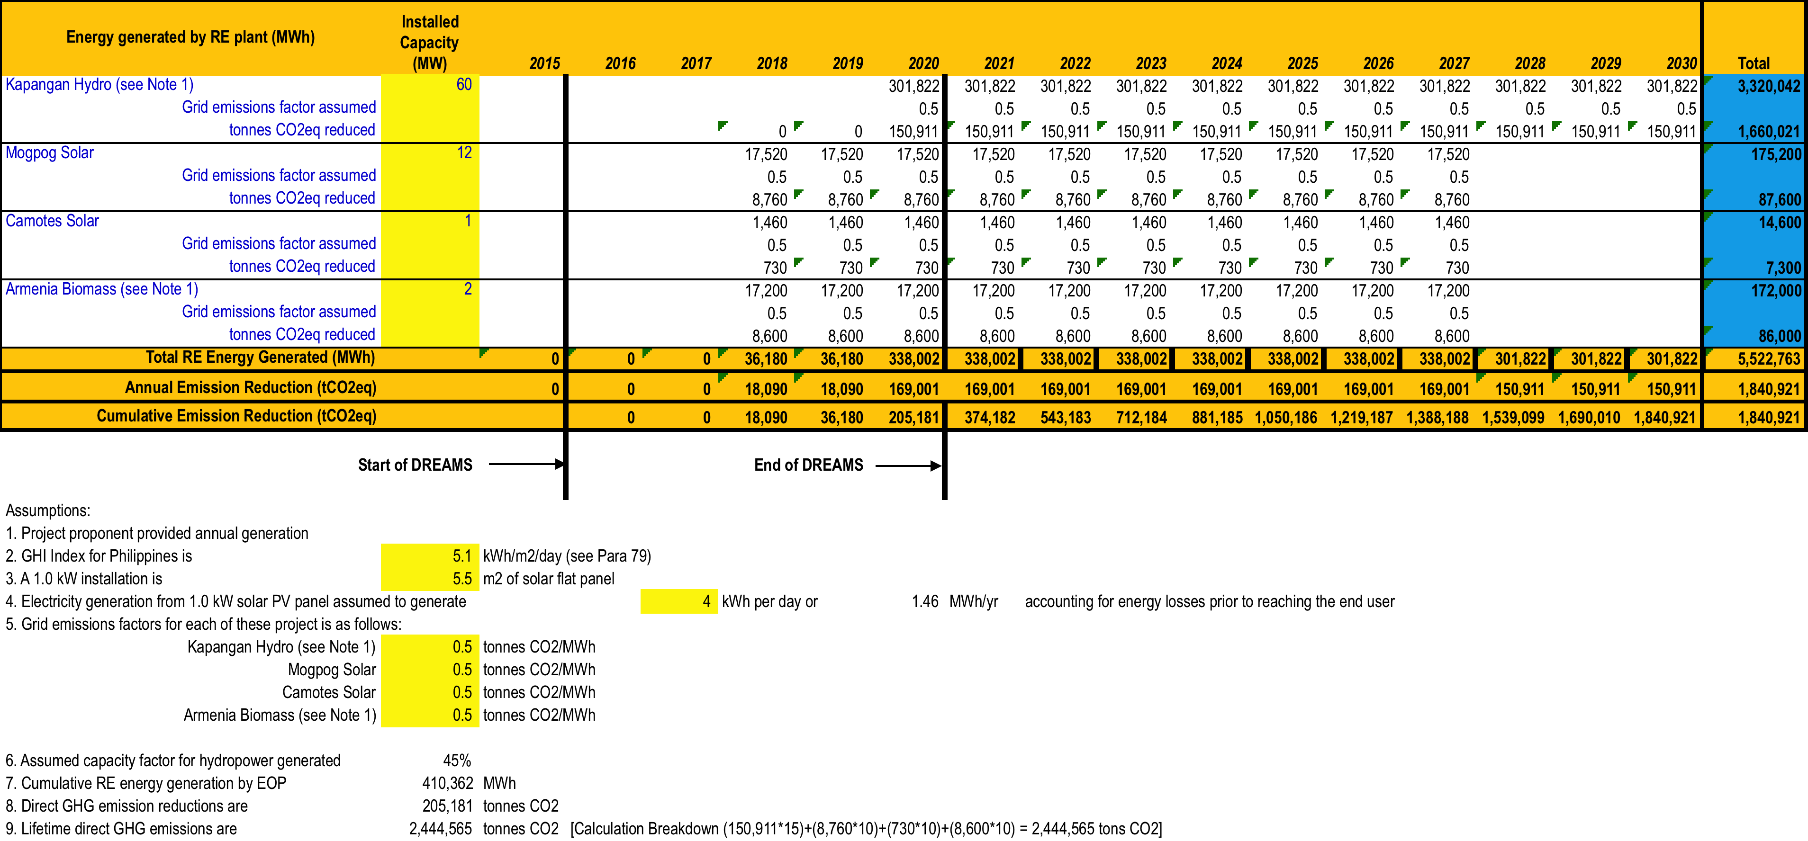

Table II-2: Indirect Emission Reductions from DREAMS Project
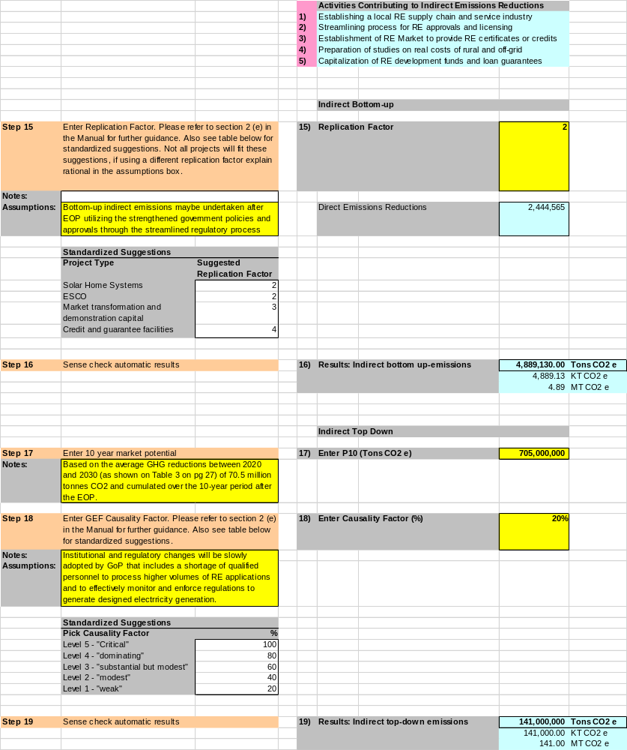

Annex III: Co-Financing Letters
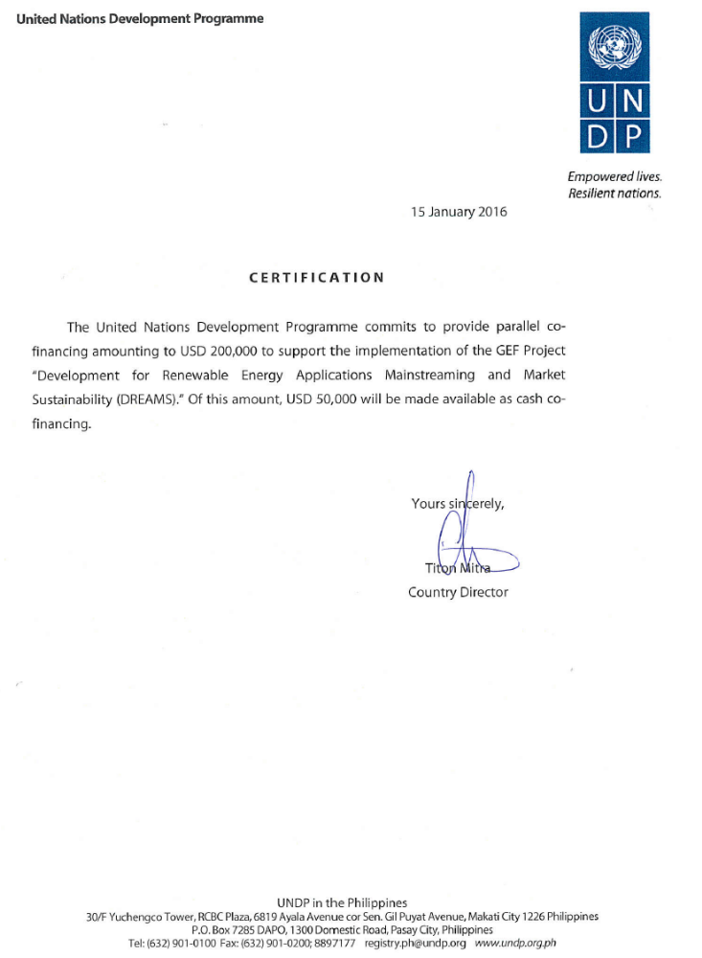
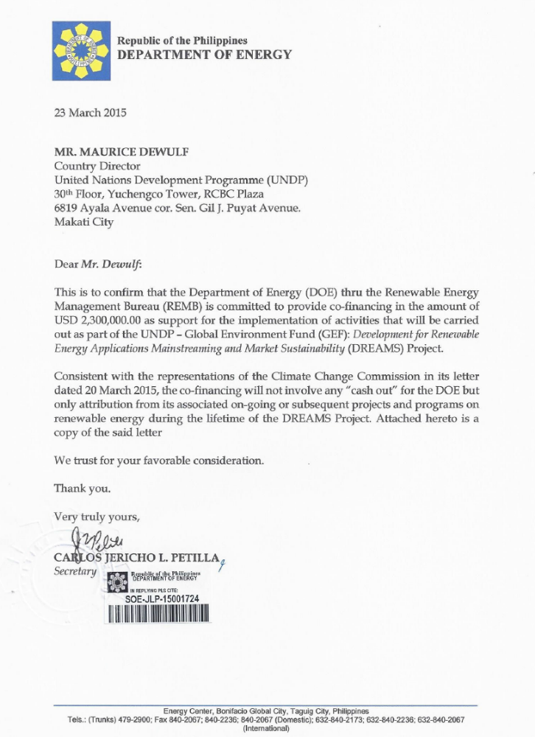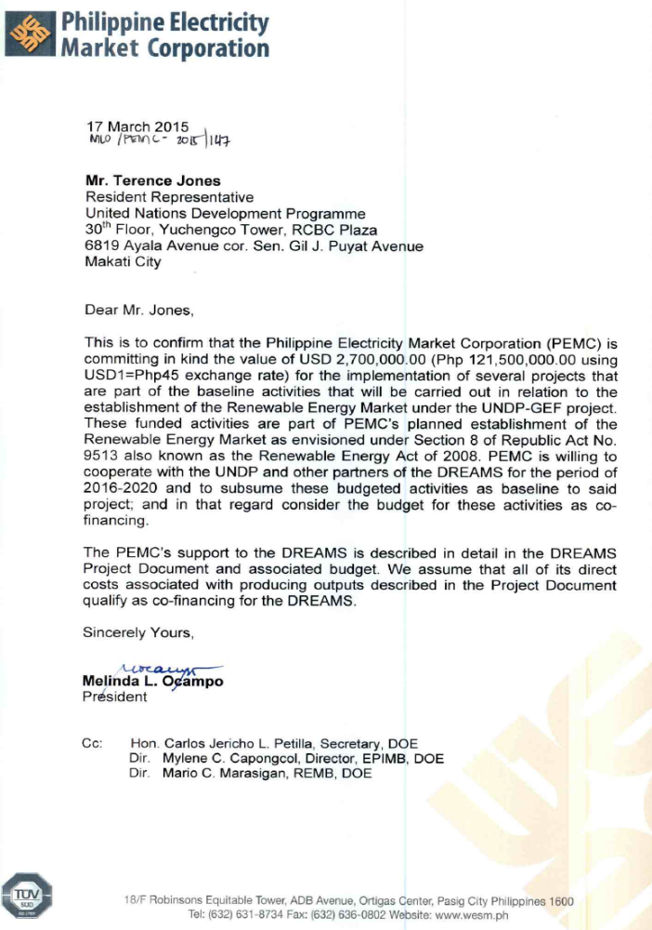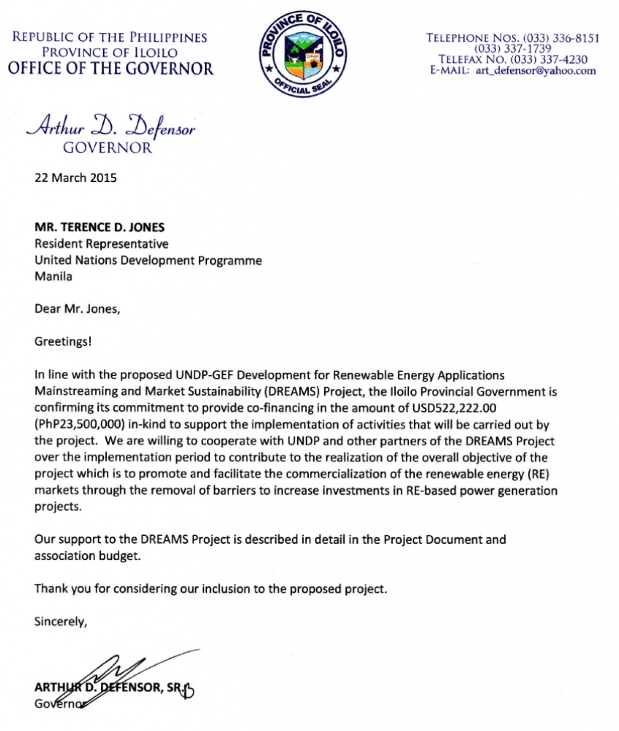

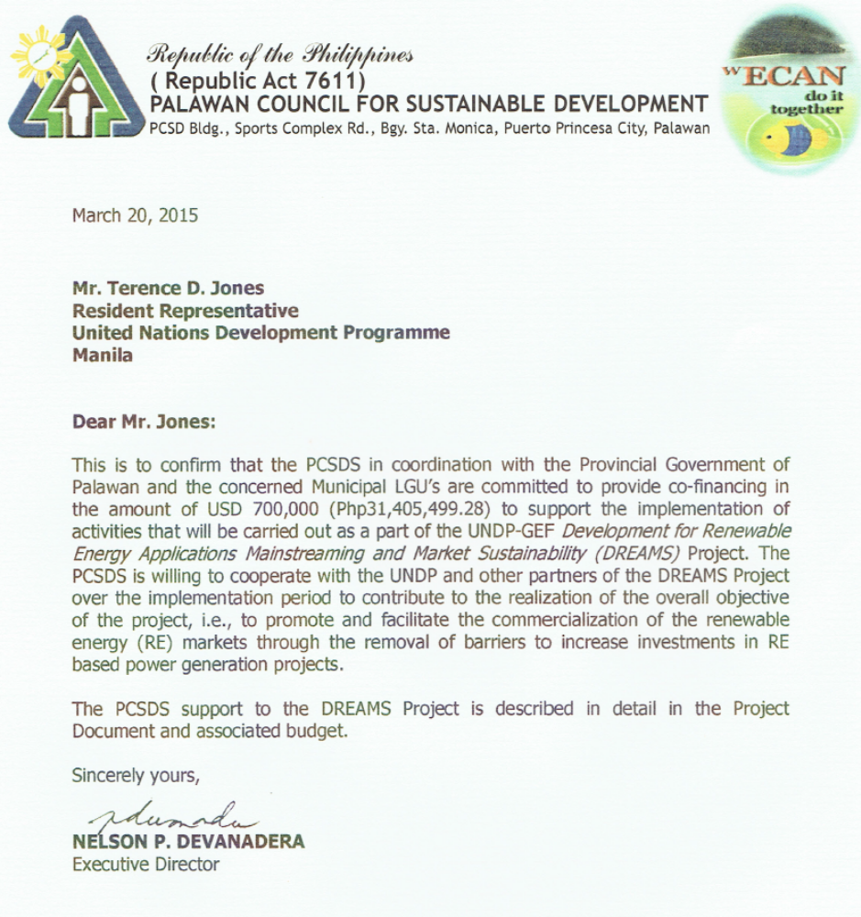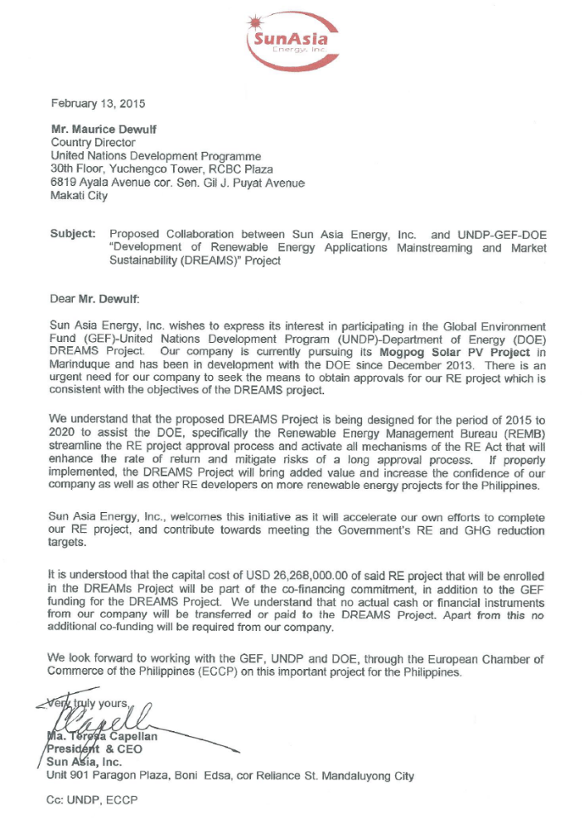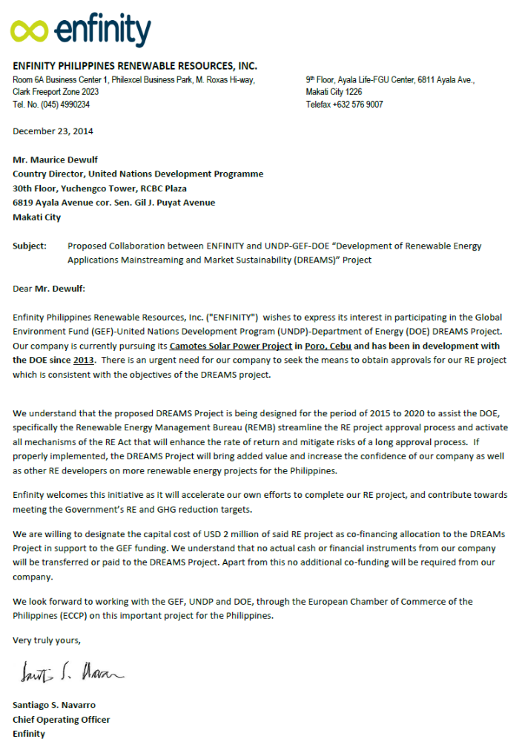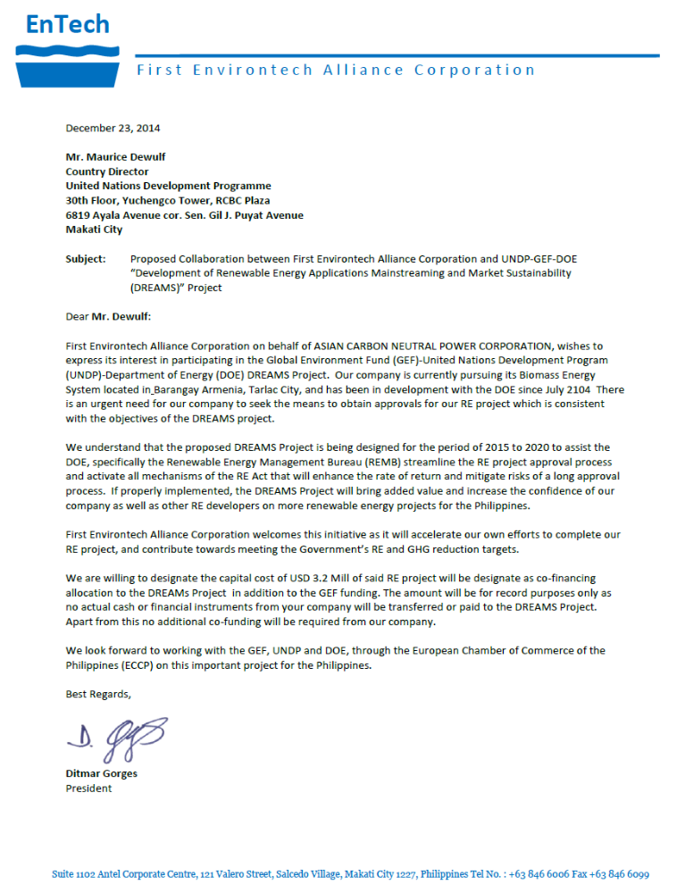

Annex IV: Terms of Reference

Project Staff

1. Project Director

Duties and Responsibilities: The day-to-day operational management of the Project will be the responsibility of the PMU based within the DOE for the project. It shall be the role of the PMU to undertake the following activities under the PMU Director’s direct responsibility:

- Coordination with the PMUs of other related on-going projects for the purpose of facilitating the implementation of top management’s decision on delineation of project thrusts and direction
- Preparation of work plans, budget, and TORs of consultants, trainers, and subcontractors;
- Assist in the selection and hiring of other national professionals, administrative staff and subcontractors needed in the Project;
- Monitoring and evaluation of progress of project activities;
- Arranging of regular review meetings and ensuring effective coordination of project activities;
- Preparation and dissemination of project reports and other information materials. The primary goal of this activity will be to enhance the transparency of project implementation.
- Oversee the financial record-keeping and internal control management of the PMU and the Project as a whole;
- Submission of timely and accurate financial reports and progress reports to UNDP
- Provide technical and administrative support for the initial operation of the PB.

The Director of the PMU will take responsibility for the management and administration of the Project. He/she will report directly to the DOE and UNDP in the overall operation and management of the Project with the following functions:

- Be ultimately responsible for the fiscal management of the project
- Manage the PMU staff and be responsible for ensuring high staff performance and motivation
- Directly and indirectly manage and coordinate multi-faceted local and international consultant contracts to ensure their timely completion and high quality
- Manage the monitoring and evaluation of both the overall project and its components
- Be responsible for ensuring that project objectives are being met in terms of budget and project outputs and must be prepared to recommend changes to the PB to ensure that all outputs are realized over the project life
- Be the primary project advocate and representative and meet regularly with key stakeholders from the public, the RE industry, relevant government agencies and international donors to further project objectives.

Qualifications and Experience: (a) a university graduate of business, science or engineering course; (b) at least 10 years of proven track record of project management experience preferably in the area of energy; (c) senior management reporting skills; (d) excellent English communication skills, both written and verbal. Skilled presenter of ideas in one-on-one situations, conferences and meetings; (f) proven track record of experience in successful contract management; (g) a self-motivated individual with good leadership skills capable of planning, initiating and managing multi-disciplinary activities within the context of a multi-donor international project; (h) an understanding of and links with the RE industry.

- Project Manager (PM):
Duties and Responsibilities: The incumbent will be responsible for implementation of the project, including mobilization of all project inputs, supervision of project staff, consultants and oversight of sub-contractors. The PM will be the leader of the Project Team (PT) and shall liaise with the government, UNDP, and all stakeholders involved in the Project. S/he will be specifically responsible for (a) overall management of the project, (b) work closely with project stakeholders and ensure the project deliveries as per project document and work plan, (c) ensure technical coordination of the project and the work related to legal and institutional aspects, (d) mobilize all project inputs in accordance with UNDP procedures and GEF principles, I finalize the ToR for the consultants and subcontractors and coordinate with UNDP Procurement for recruitment, procurement and contracting, (f) supervise and coordinate the work of all project staff, consultants and sub-contractors, (g) ensure proper management of funds consistent with UNDP requirements, and budget planning and control, (h) prepare and ensure timely submission of monthly reports, quarterly consolidated financial reports, quarterly consolidated progress reports, annual, mid-term and terminal reports, and other reports as may be required by UNDP; (i) submit the progress reports and key issue report to the National Project Board, (j) prepare quarterly and annual work plan, (k) provide regular input to UNDP corporate system ATLAS for financial and program management on project progress, financial status and various logs, (l) arrange for audit of all project accounts for each fiscal year (m) undertake field visit to ensure quality of work, and (n) undertake any activities that may be assigned by UNDP and National Project Board.

Additional roles and responsibilities include:
- In close collaboration with the CTA, provide a baseline for skills and absorptive capacity within the DOE to promote and regulate RE development, and for prospective RE managers, operators and plant personnel to manage an RE plant or an RET diffusion program at the local level;
- Consult with relevant institutions, government officers, financial institutions, and the consulting industry on the RE knowledge gaps of these stakeholders;
- Design and deliver appropriate training materials and workshops at the local level on RE planning, design, implementation, operation and maintenance as well as financing of RE projects.

Qualifications and Experience: The incumbent should have a minimum Bachelor degree in Engineering with MBA/Master degree or Masters in energy/environment or other relevant academic discipline and profession qualifications with at least ten (10) years professional experience at senior level. S/he should have extensive experience and technical ability to manage a large project and a good technical knowledge in the fields related to private sector development, climate change, energy efficiency and institutional development and/or regulatory aspects. S/he must have effective interpersonal and negotiation skills proven through successful interactions with all levels of project stakeholder groups, including senior government officials, financial sectors, private entrepreneurs, technical groups and communities. S/he should have ability to effectively coordinate a complex, multi-stakeholder project and to lead, manage and motivate teams of international and local consultants to achieve results. Good capacities for strategic thinking, planning and management and excellent communication skills in English are essential. Knowledge of UNDP project implementation procedures, including procurement, disbursements, and reporting and monitoring will be an added advantage.

- M&E Officer (M&EO):
Duties and Responsibilities: Under the direct supervision of UNDP and the Project Manager, the incumbent will be assigned to develop and implement a monitoring and reporting system to capture the progress of project activities, results and impacts under the supervision of Project Manager. S/he will be responsible specifically for (a) developing and setting up the overall framework for DREAMS Project monitoring and evaluation (M&E), (b) prepare the monthly, quarterly and annual monitoring plan for project activities, (c) monitor and evaluate the compliance of actual progress and performance against the planned work plan and expected quality, (d) analysis of the effect of current actual performance to the Project timetable and budgets, (e) prepare reports for Project management including identification of problems, causes of potential bottlenecks (if any) in Project implementation with inputs from stakeholders and other PMU personnel, (f) prepare the ToRs for mid-term and final evaluation in accordance to UNDP and GEF guidelines, (g) design and implement a system to identify, analyze, and disseminate lesson learned, (h) assist the PM in preparation of various progress reports including in the preparation of APRs/PIRs, (i) facilitate exchange of experiences by supporting and coordinating participation in any existing network of UNDP/GEF projects sharing common characteristics, (j) identify and participate in additional networks, for example scientific or policy-based networks that may also yield lessons that can benefit project implementation and (k) any other related activities as assigned by Project Manager.

Additional roles and responsibilities include:

- Prepare and deliver appropriate training materials and workshops on RE planning, design, implementation, operation and maintenance as well as financing of RE projects;
- Provide management oversight in close collaboration with the Technical Officer for delivery and installation of civil, mechanical and electrical equipment for pilot on-grid RE plants;
- Work closely with personnel from the DOE as well as project proponents to ensure lessons learned on-the-job are imparted to them.

Qualifications and Experience: The incumbent should have a minimum Masters degree in Energy/Environment disciplines from a recognized university. S/he should have at least five (5) years hands-on experience in energy and environment field where past experience in RE project design, implementation and operations would be considered an asset. S/he should have the ability to provide quick assessments to RE plans, designs and operational plans, and implementation and/or facilitating learning-oriented analysis sessions of RE technical issues with multiple stakeholders, data and information analysis and analytical report writing. S/he should have the willingness to undertake regular field visits and interact with different stakeholders, especially primary stakeholders. Computer proficiency in MS Office (Word, Excel and PowerPoint) and other common software is a prerequisite. Computer literacy in graphic design software will be appreciated. Fluency both in written and spoken English is essential.

- Finance Officer (FO):
Duties and Responsibilities: The incumbent will be responsible to provide overall financial services of the Project such as processing payments, raising requisitions, and purchase orders using UNDP corporate software ATLAS. S/he will be responsible to provide information to UNDP Project web and RRMC reporting. S/he will also perform (a) Installation and implementation of a GEF financial system that records transactions that utilize GEF Funds in accordance with UNDP’s existing guidelines on national execution; (b) Orientation of staff on the use of the project’s financial systems and procedures; (c) Proper recording of financial transactions and submit a regular report on the project’s financial status; (d) Certifying correctness of journals, vouchers, bills, statement of accounts, trial balance, budget estimates and other financial statement and records; I Preparation of certification of the availability of funds and/or allotment of expenses, vouchers and requisition for supplies, materials, etc.; (f) Preparation of annual and quarterly budgets including the necessary budget revisions based on the corresponding line-item-budgets approved by DREAMS; (g) Establishment of a project account and ensure appropriateness and proper record keeping of transactions; (h) Supervision of the preparation of payroll and general voucher of salaries, and other documentary requirements for disbursements; (i) Preparation of updated reports on disbursements made by the project, and advise the Project Team on the overall financial status of the project; and (j) Preparation of a system of accounts those records all the in-cash and in-kind contributions of co-financing entities to the Project.

Qualifications and Experience: The incumbent should have at least a Bachelor degree in accounting or financing, preferably Masters Degree in the same or any other relevant field. S/he should have at least 5 years of experience as accountant, administration, preferably with UNDP/GEF project. S/he will have a proven track record in project management such as in meeting deadlines, timely submission of acceptable deliverables, etc. Computer proficiency in UNDP corporate software ATLAS or any systems similar to PeopleSoft, MS Office (Word, Excel and PowerPoint) and other common software is a prerequisite. Basic knowledge in procurement, petty cash handling, logistics supports, and filling systems is a basic requirement. Knowledge of UNDP project implementation procedures, including procurement, disbursements, and reporting and monitoring is preferable. Fluent both in written and spoken English is required.

- Administrative Officer (AO):
Duties and Responsibilities: The incumbent will be responsible to provide supportive administration services to the Project such as raising requisition, preparing projects logs, provide information to UNDP Project web, and administrative trouble shooting. S/he will also perform (a) word processing, drafting routine letters, messages, and reports, and sending mail; (b) arrange travel, itinerary preparation for project related travels, (c) arranging workshops, seminars, and training programs; (d) work at reception desk and make appointments and schedule meetings; (e) assist in work-plan and budgeting; (f) photocopying, binding and filing; (g) maintenance of all office equipment and keeping inventory records of supplies and their usage and any other duties assigned by Project Manager or concerned officials.

Qualifications and Experience: The incumbent should have at least a Bachelor degree in any discipline from a recognized university. S/he should have at least 3 years relevant working experience with foreign aided projects or international development or organizations. Computer proficiency in MS Office (Word, Excel and PowerPoint) and other common software is a prerequisite. Diploma in computer/secretarial science is desirable but not essential. Basic knowledge in procurement, petty cash handling, logistics supports, and filing systems is a basic requirement. Knowledge of UNDP project implementation procedures, including reporting and monitoring is preferable. Fluent both in written and spoken English is required.

National Project Consultants and Contractors

- National Consultant: Chief Technical Advisor (CTA) – Components 1 to 4
Duties and Responsibilities:
  - Provide management oversight for Project efforts to streamline regulatory permitting and approval process;
  - Serve as a key liaison between the Project and key directors in DOE and other appropriate government agencies to obtain approvals for key policy changes and issuances of DOE circulars on policy changes;
  - Serve as key resource in developing Project program to improve DOE outreach to local level communities with RE development plans as well as setup of market service centers;
  - Provide inputs for the setup of the RE Market and how its use can be increased by local level RE project proponents.
- Review institutional mandates of all relevant DOE and local level with respect to RE facilitation, and provide a baseline assessment of their functionality on promoting and approving RE projects under NREB;
- Provide assistance on measures to lowering of barriers to institutional efficiencies at the national and local levels that would accelerate RE approvals;
- Assist in the baseline assessment of local level institutional absorption capacity for RE development and management, and recommend measures for effective building local level capacity in close collaboration with the CTA and PM;
- Assist DOE in preparation of new rules and regulations for streamlined implementation of the NREP.

- National Consultant: Finance Expert (NFE) – Components 1 to 4
Duties and Responsibilities:
- Assess baseline scenario for RE financial mechanisms for local RE investment including status of existing PPF, LGF and other financial products of other government and commercial banks for RE project financing;
- Provide recommendations on measures to be undertaken for amending fund charters for PPF and LGF for higher volumes of support for RE projects;
- Provide advice on fund operations that are managed in a manner that promotes “one- stop shop” for RE project proponents and improves their access to financing and subsequent development of RE projects at local levels. This would include strengthened linkages of these funds with MSCs and other LGUs who are actively promoting local RE development;
- Provide advisory services to the RE Market operators and managers in the financial aspects of market settlements from RE Certificates;
- Design of a voluntary RE market where voluntary purchases of RE assist in reducing the cost of RE and boost CSR;
- Facilitate capital and RE financing from foreign banks with carbon funds or NAMA-linked funds under the direction of senior project staff

- National Consultant: Communications Knowledge Specialist (CKS) – Components 1 to 4
Duties and Responsibilities:
- Characterize baseline knowledge of RE amongst local level stakeholders and determine the barriers inhibiting greater acceptance of RE. The barriers may need to be disaggregated into appropriate social groups;
- Prepare plan for meeting local level stakeholders including specific RE advocacy communications for targeted social groups that may include LGUs, farming communities, urban communities, indigenous groups;
- Work with community officers on presentation of communications of RE to specific groups;
- Provide feedback to national NREB personnel to allow adaptive management of the RE advocacy communications programme to various social groups on increasing knowledge of RE development.

- National Consultants: Capacity Development Specialist (CDS)
Duties and Responsibilities:
- Provide baseline assessment of the outreach capacities of national institutions involved with the renewable energy development in local communities;
- Provide baseline assessment of capacities of local government entities (barangays), sitio administrative entities and local businesses and enterprises to develop renewable energy projects;
- Prepare strategies for building the capacities of national institutions, local government entities and local businesses to more effectively develop and implement renewable energy projects;
- Provide support and guidance in the preparation of training seminars for stakeholders involved with renewable energy project development;
- Deliver as required training services to strengthen local capacities for the development of renewable energy projects;
- Along with the M and E Officer, lead and conduct surveys of training seminars to gauge their effectiveness in knowledge transfer and building institutional and local capacity to improve the pace of RE developments.

Qualifications and Experience: S/he should have at least five (5) years hands-on experience on capacity building projects and monitoring and evaluation of projects where experience in renewable energy development would be considered an asset. S/he should have the ability to assess capacity building needs, conceptualize and design appropriate training activities to build capacity, and provide comprehensive reports of these activities and follow-up actions. S/he should have the willingness to undertake regular field visits and interact with different stakeholders, especially primary stakeholders. Computer proficiency in MS Office (Word, Excel and PowerPoint) and other common software is a prerequisite. Computer literacy in graphic design software will be appreciated. Fluency both in written and spoken English is essential.

- National Consultants: Community Officers (NCO) – Components 2 and 4
Duties and Responsibilities:
- 3 NCOs will be based in communities with Market Service Centres in Luzon, Visayas and Mindanao;
- Serve as primary liaisons between the Project and barangay communities;
- Assist local communities in the preparation of local energy plans that are harmonized with national RE plans;
- Organize, coordinate and contribute to training programs for local LGU officers, AREC personnel and DOE outreach officers, notably on their comprehension of the contents of energy plans and new streamlined regulatory processes for RE project approvals;
- Under the direction of the NAE, develop and sustain collaborative working relationships with the affected communities on local and national energy plans and development events that will require a local community involvement. Special attention should be given to indigenous peoples to raise their awareness and solicit their support for RE projects contained within local energy plans;
- Under the direction of the NAE, support implementation of the communication strategy of the Project at the local level and at the MSCs. This would include the production and presentation of Public service announcements and other knowledge products on RE Project development and benefits;
- Organize feedback surveys of training programs and prepare reports to Project personnel that will enable improvements to future training sessions;
- Provide coordination for the setup of MSC offices including identification and securing up of office facilities and personnel;
- Provide coordination and support for MSC personnel in reaching awareness of RE project proponents developers in the availability of various financial mechanisms for developing RE projects;
- Support MSC personnel wherever appropriate preparation of bankable RE project plans including on-the-job training for local energy professionals and DOE personnel;
- Support and coordinate requests for local information pertaining to energy requirements of local residents and development of rural electrification for the purposes of monitoring;
- Support and coordinate efforts to train and certify local technical experts for the development of local technical support for RE equipment

International Project Consultants

- International Consultant: Energy Expert (IEE) for Components 3
Duties and Responsibilities:

  - Conduct policy assessments, techno-economic feasibility studies and market policy assessments related to the RPS and “capitalized” RE Market;
  - Review of implementing guidelines for the “capitalized” RE Market and provide recommendations to strengthen the implementation and enforcement of RPS that can be used as qualification for RE Certificates;
  - Review and recommend strategies for successful operationalization of the REM and RE Registrar
  - Design and execute trainings and workshops to PEMC personnel on operations and management of the REM and RECs.
  - Detailed analysis and recommendations on the software and hardware requirements for RE Registrar including delivery of associated capacity trainings.
  - Support the trials of the capitalized REM.
  - Provide management oversight for the development of capitalized RE market as required and recommend actions that focus work plans on achieving key milestones in a timely manner.

- International Consultant: Energy Expert (IEE) for Components 1, 2 and 4
Duties and Responsibilities:

  - Provide oversight support on policy analysis, regulatory framework, strategic planning, techno-economic feasibility studies, action planning; technical oversight on studies on rural electrification models and innovative off-grid RE market services that would catalyze RE development at the local level, real costs of RE for off-grid areas to provide improved determination of FiT, and the impact of local manufacture and/or assembly of RE equipment at the local level on FiT;
  - Provide oversight assistance to baseline determination of local technical experts and requirements for effectively training and certification programs that will improve local supply chain for RE equipment;
  - Assist in the determination of feasible financial mechanisms for scaling-up RE investments in the Philippines;
  - In close collaboration with the PM and the M&E Officer as required, design and deliver appropriate training materials and workshops on RE planning, design, implementation, operation and maintenance as well as financing of RE projects.

Annex V: UNDP Social and Environmental Screening Procedure (SESP)
Project Information
Project Information
- Project Title | DREAMS
- Project Number | 5194
- Location (Global/Region/Country) | APR/Philippines

Part A. Integrating Overarching Principles to Strengthen Social and Environmental Sustainability
QUESTION 1: How Does the Project Integrate the Overarching Principles in order to Strengthen Social and Environmental Sustainability?
Briefly describe in the space below how the Project mainstreams the human-rights based approach

The Project promotes the expansion of clean energy access and scale up efforts to increase the electrification rate in the Philippines. Provision of electricity is viewed as a fundamental human right. Improving access to modern, clean energy is an essential enabler of inclusive development and poverty reduction. By ensuring access to reliable, affordable and clean energy the Project is envisaged to uphold the basic human rights of the peoples of the Philippines through the delivery of interrelated positive consequences – such as improved living standards, livelihoods opportunities, enhanced human health, improved education and reduced level of GHG emissions and environmental degradation.

A portion of the Project’s technical assistance will be provided to remote far-flung communities with very limited access to electricity that are more dependent on costly fossil-fueled power generation. The development of indigenous renewable energy will reduce electricity costs to these communities and increase access for even households with marginal incomes. Additionally, the Project engages, incentivizes and optimizes the participation of local governments, civil society organizations, and communities including indigenous peoples in the integration of RE policies in local development planning. Project implementing agency, partners, participating local government units, RE project proponents are accountable in the observance of human rights approach during project implementation and as promulgated in the Philippine Constitution.
Briefly describe in the space below how the Project is likely to improve gender equality and women’s empowerment
The Project, by virtue of providing widespread access to modern and reliable electricity services, will deliver multiple development benefits including improved impacts on gender and women such as opportunity to engage in productive activities thereby enhancing income generation; access to better health facilities, improved living conditions, safer streets, to name a few. The Project will monitor renewable energy availability within sitio households; as a means of monitoring contributions of this Project to improving gender equality, the Project will also undertake surveys of these households in the context of improved living conditions and by extension, increased income availability of these households.
Briefly describe in the space below how the Project mainstreams environmental sustainability
Environment sustainability is at the heart of the Project as it explicitly promotes widespread utilization of renewable energy and displace the use of fossil fuel for electricity generation, consequently, reducing GHG emissions and climate change impacts.

Part B. Identifying and Managing Social and Environmental Risks
QUESTION 2: What are the Potential Social and Environmental Risks?  Note: Describe briefly potential social and environmental risks identified in Attachment 1 – Risk Screening Checklist (based on any “Yes” responses). If no risks have been identified in Attachment 1 then note “No Risks Identified” and skip to Question 4 and Select “Low Risk”. Questions 5 and 6 not required for Low Risk Projects. | QUESTION 3: What is the level of significance of the potential social and environmental risks?  Note: Respond to Questions 4 and 5 below before proceeding to Question 6 |  |  |  | QUESTION 6: What social and environmental assessment and management measures have been conducted and/or are required to address potential risks (for Risks with Moderate and High Significance)?
Risk Description | Impact and Probability (1-5) | Significance  (Low, Moderate, High) | Comments |  | Description of assessment and management measures as reflected in the Project design. If ESIA or SESA is required note that the assessment should consider all potential impacts and risks.
Climate change impacts the level of RE generation | I = 5  P = 3 | Moderate | This is especially true for hydropower projects where runoff forecasting is becoming less predictable. This can also apply to solar PV installations and wind projects where higher frequencies of cyclone wind forces can increase the risk of damage to RE power generation equipment. |  | The Project will assist in the planning and design processes for RE projects that account for risks due to climate change and mitigate its negative consequences to the operations of RE power generation.
Risks involving changes to the use of lands and resources that may have adverse impacts on habitats, ecosystems, and/or livelihoods | I = 3  P = 2 | Low | Hydro projects are likely to inevitably alter aquatic ecosystems as well as livelihoods. Solar PV farms are also likely to change land uses, but likely on marginal lands |  | The project proponents being supported under Output 4.6 have already received clearance from local communities for their RE projects. In addition, these Hydro projects are small scale where reservoir areas are very small, reducing the impact to land use changes and adverse impacts on ecosystems. The Project will ensure that all issues related to land use changes and environmental impacts are managed according to DENR regulations. Moreover, the identified risks can be managed through compliance with the EIA that demo RE projects are required to undertake.
Risk involving secondary or consequential development activities which could lead to adverse social and environmental effects, or generation of cumulative impacts with other known existing or planned activities in the area | I = 2  P = 2 | Low | Hydro projects are likely to flood lands that may lead to adverse social and environmental impacts. |  | The project proponents being supported under Output 4.6 have already received necessary clearance from local authorities including SEIA for their RE projects. In addition, these hydropower projects are small scale where reservoir areas are very small, reducing the impact to land use changes and adverse impacts on ecosystems. The Project will ensure that all issues related to minimizing environmental and social impacts are managed according to DENR regulations.
Risks related to occupational health and safety due to physical hazards during Project construction and operation | I = 2  P = 2 | Low | Equipment installation and construction of RE plants may pose potential occupational health and safety risk due to physical hazards. |  | The Project through its streamlined regulatory approval process will allow the project proponent to implement this project within the conditions allowed by the various regulatory permits including environmental clearance certificates (ECC) that should ensure occupational health and safety for those personnel constructing and operating this hydropower project. Obtaining an ECC for the other RE projects will also ensure that the other project proponents being supported under Output 4.6 will comply with best practices for occupational health and safety on the solar farms and biomass energy project. All relevant civil, mechanical and electrical works will be carried in accordance with the relevant regulatory standards to ensure safety of all workers and personnel involved
Risk due to the presence of indigenous peoples in the Project area (including Project area of influence)? | I = 2  P = 3 | Low | With environmental and social studies already completed on this hydropower project, the proponents of the Kapangan hydropower project will obtain the NCIP agreements with indigenous peoples within their traditional territory. |  | The project proponents are in the process of obtaining NCIP permits that will finalize agreement between indigenous peoples and the project proponents on approval of the Kapangan hydropower project. Moreover, the risk will be addressed and mitigation measure outlined in the SEIA that the project is required to undertake.
 | QUESTION 4: What is the overall Project risk categorization?
 | Select one (see SESP for guidance) |  |  |  |  | Comments
 | Low Risk
 | Moderate Risk |  |  | ☐X |  | From the above analysis, the level of significance of the likely social and environmental risks associated with the baseline projects are considered as low. The baseline projects are required to strictly comply with the social and environment safeguards regulations of the Government of the Philippines. In pursuing a more conservative and precautionary measure, the DREAMS Project categorizes the overall risk as “Moderate” with the intention that the probable risks will be monitored closely and evaluated during annual project review and mid-term review.
 | High Risk |  |  | ☐
 | QUESTION 5: Based on the identified risks and risk categorization, what requirements of the SES are relevant?
 | Check all that apply |  |  |  |  | Comments
 | Principle 1: Human Rights |  |  | ☐
 | Principle 2: Gender Equality and Women’s Empowerment |  |  | ☐
 | 1. Biodiversity Conservation and Natural Resource Management |  |  | X |  | Land development required for RE projects: Hydropower plants as well as wind and solar plants will require alterations of the vegetative landscapes of these project sites. The Project will support improved and streamlined processes to ensure agreements amongst relevant agencies (i.e. DENR, NWRP and NCIP) and that impacts identified are duly addressed in the SEIA of these respective baseline projects. This includes an improved process and clarity to the requirements of a “water sustainability plan” that is contained in Outputs 1.1 and 2.5.
 | 2. Climate Change Mitigation and Adaptation |  |  | ☐ X |  | The Project will ensure that RE project designs can operate within the wider range of climatic conditions resulting from climate change.
 | 3. Community Health, Safety and Working Conditions |  |  | X ☐ |  | The Project will ensure that the ECC permits also include provisions to ensure that workers on site (during construction and operations) are fully protected for their occupational health, safety and working conditions.
 | 4. Indigenous Peoples |  |  | X |  | The project proponents are in the process of obtaining NCIP permits that will finalize agreement between indigenous peoples

Final Sign Off
Signature | Date | Description
QA Assessor  Amelia Supetran, UNDP Philippines |  | UNDP staff member responsible for the Project, typically a UNDP Programme Officer. Final signature confirms they have “checked” to ensure that the SESP is adequately conducted.
QA Approver  Rakshya Thapa, UNDP Bangkok Regional Hub |  | UNDP senior manager, typically the UNDP Deputy Country Director (DCD), Country Director (CD), Deputy Resident Representative (DRR), or Resident Representative (RR). The QA Approver cannot also be the QA Assessor. Final signature confirms they have “cleared” the SESP prior to submittal to the PAC.
PAC Chair |  | UNDP chair of the PAC. In some cases PAC Chair may also be the QA Approver. Final signature confirms that the SESP was considered as part of the project appraisal and considered in recommendations of the PAC.

SESP Attachment 1. Social and Environmental Risk Screening Checklist

Checklist Potential Social and Environmental Risks
Principles 1: Human Rights | Answer  (Yes/No)
1. Could the Project lead to adverse impacts on enjoyment of the human rights (civil, political, economic, social or cultural) of the affected population and particularly of marginalized groups? | No
2. Is there a likelihood that the Project would have inequitable or discriminatory adverse impacts on affected populations, particularly people living in poverty or marginalized or excluded individuals or groups? | No
3. Could the Project potentially restrict availability, quality of and access to resources or basic services, in particular to marginalized individuals or groups? | No
4. Is there a likelihood that the Project would exclude any potentially affected stakeholders, in particular marginalized groups, from fully participating in decisions that may affect them? | No
5. Is there a risk that duty-bearers do not have the capacity to meet their obligations in the Project? | No
6. Is there a risk that rights-holders do not have the capacity to claim their rights? | No
7. Have local communities or individuals, given the opportunity, raised human rights concerns regarding the Project during the stakeholder engagement process? | No
8. Is there a risk that the Project would exacerbate conflicts among and/or the risk of violence to project-affected communities and individuals? | No
Principle 2: Gender Equality and Women’s Empowerment
1. Is there a likelihood that the proposed Project would have adverse impacts on gender equality and/or the situation of women and girls? | No
2. Would the Project potentially reproduce discriminations against women based on gender, especially regarding participation in design and implementation or access to opportunities and benefits? | No
3. Have women’s groups/leaders raised gender equality concerns regarding the Project during the stakeholder engagement process and has this been included in the overall Project proposal and in the risk assessment? | No
- Would the Project potentially limit women’s ability to use, develop and protect natural resources, taking into account different roles and positions of women and men in accessing environmental goods and services?  For example, activities that could lead to natural resources degradation or depletion in communities who depend on these resources for their livelihoods and well being | No
Principle 3: Environmental Sustainability: Screening questions regarding environmental risks are encompassed by the specific Standard-related questions below
Standard 1: Biodiversity Conservation and Sustainable Natural Resource Management
1.1 Would the Project potentially cause adverse impacts to habitats (e.g. modified, natural, and critical habitats) and/or ecosystems and ecosystem services?  For example, through habitat loss, conversion or degradation, fragmentation, hydrological changes | No
1.2 Are any Project activities proposed within or adjacent to critical habitats and/or environmentally sensitive areas, including legally protected areas (e.g. nature reserve, national park), areas proposed for protection, or recognized as such by authoritative sources and/or indigenous peoples or local communities? | No
1.3 Does the Project involve changes to the use of lands and resources that may have adverse impacts on habitats, ecosystems, and/or livelihoods? (Note: if restrictions and/or limitations of access to lands would apply, refer to Standard 5) | Yes
1.4 Would Project activities pose risks to endangered species? | No
1.5 Would the Project pose a risk of introducing invasive alien species? | No
1.6 Does the Project involve harvesting of natural forests, plantation development, or reforestation? | No
1.7 Does the Project involve the production and/or harvesting of fish populations or other aquatic species? | No
1.8 Does the Project involve significant extraction, diversion or containment of surface or ground water?  For example, construction of dams, reservoirs, river basin developments, groundwater extraction | No
1.9 Does the Project involve utilization of genetic resources? (e.g. collection and/or harvesting, commercial development) | No
1.10 Would the Project generate potential adverse transboundary or global environmental concerns? | No
1.11 Would the Project result in secondary or consequential development activities which could lead to adverse social and environmental effects, or would it generate cumulative impacts with other known existing or planned activities in the area?  For example, a new road through forested lands will generate direct environmental and social impacts (e.g. felling of trees, earthworks, potential relocation of inhabitants). The new road may also facilitate encroachment on lands by illegal settlers or generate unplanned commercial development along the route, potentially in sensitive areas. These are indirect, secondary, or induced impacts that need to be considered. Also, if similar developments in the same forested area are planned, then cumulative impacts of multiple activities (even if not part of the same Project) need to be considered. | Yes
Standard 2: Climate Change Mitigation and Adaptation
2.1 Will the proposed Project result in significant greenhouse gas emissions or may exacerbate climate change? | No
2.2 Would the potential outcomes of the Project be sensitive or vulnerable to potential impacts of climate change? | Yes
2.3 Is the proposed Project likely to directly or indirectly increase social and environmental vulnerability to climate change now or in the future (also known as maladaptive practices)?  For example, changes to land use planning may encourage further development of floodplains, potentially increasing the population’s vulnerability to climate change, specifically flooding | No
Standard 3: Community Health, Safety and Working Conditions
3.1 Would elements of Project construction, operation, or decommissioning pose potential safety risks to local communities? | No
3.2 Would the Project pose potential risks to community health and safety due to the transport, storage, and use and/or disposal of hazardous or dangerous materials (e.g. explosives, fuel and other chemicals during construction and operation)? | No
3.3 Does the Project involve large-scale infrastructure development (e.g. dams, roads, buildings)? | No
3.4 Would failure of structural elements of the Project pose risks to communities? (e.g. collapse of buildings or infrastructure) | No
3.5 Would the proposed Project be susceptible to or lead to increased vulnerability to earthquakes, subsidence, landslides, and erosion, flooding or extreme climatic conditions? | No
3.6 Would the Project result in potential increased health risks (e.g. from water-borne or other vector-borne diseases or communicable infections such as HIV/AIDS)? | No
3.7 Does the Project pose potential risks and vulnerabilities related to occupational health and safety due to physical, chemical, biological, and radiological hazards during Project construction, operation, or decommissioning? | Yes
3.8 Does the Project involve support for employment or livelihoods that may fail to comply with national and international labor standards (i.e. principles and standards of ILO fundamental conventions)? | No
3.9 Does the Project engage security personnel that may pose a potential risk to health and safety of communities and/or individuals (e.g. due to a lack of adequate training or accountability)? | No
Standard 4: Cultural Heritage
4.1 Will the proposed Project result in interventions that would potentially adversely impact sites, structures, or objects with historical, cultural, artistic, traditional or religious values or intangible forms of culture (e.g. knowledge, innovations, practices)? (Note: Projects intended to protect and conserve Cultural Heritage may also have inadvertent adverse impacts) | No
4.2 Does the Project propose utilizing tangible and/or intangible forms of cultural heritage for commercial or other purposes? | No
Standard 5: Displacement and Resettlement
5.1 Would the Project potentially involve temporary or permanent and full or partial physical displacement? | No
5.2 Would the Project possibly result in economic displacement (e.g. loss of assets or access to resources due to land acquisition or access restrictions – even in the absence of physical relocation)? | No
5.3 Is there a risk that the Project would lead to forced evictions? | No
5.4 Would the proposed Project possibly affect land tenure arrangements and/or community based property rights/customary rights to land, territories and/or resources? | No
Standard 6: Indigenous Peoples
6.1 Are indigenous peoples present in the Project area (including Project area of influence)? | Yes
6.2 Is it likely that the Project or portions of the Project will be located on lands and territories claimed by indigenous peoples? | No
6.3 Would the proposed Project potentially affect the human rights, lands, natural resources, territories, and traditional livelihoods of indigenous peoples (regardless of whether indigenous peoples possess the legal titles to such areas, whether the Project is located within or outside of the lands and territories inhabited by the affected peoples, or whether the indigenous peoples are recognized as indigenous peoples by the country in question)?  If the answer to the screening question 6.3 is “yes” the potential risk impacts are considered potentially severe and/or critical and the Project would be categorized as either Moderate or High Risk. | No
6.4 Has there been an absence of culturally appropriate consultations carried out with the objective of achieving FPIC on matters that may affect the rights and interests, lands, resources, territories and traditional livelihoods of the indigenous peoples concerned? | No
6.5 Does the proposed Project involve the utilization and/or commercial development of natural resources on lands and territories claimed by indigenous peoples? | No
6.6 Is there a potential for forced eviction or the whole or partial physical or economic displacement of indigenous peoples, including through access restrictions to lands, territories, and resources? | No
6.7 Would the Project adversely affect the development priorities of indigenous peoples as defined by them? | No
6.8 Would the Project potentially affect the physical and cultural survival of indigenous peoples? | No
6.9 Would the Project potentially affect the Cultural Heritage of indigenous peoples, including through the commercialization or use of their traditional knowledge and practices? | No
Standard 7: Pollution Prevention and Resource Efficiency
7.1 Would the Project potentially result in the release of pollutants to the environment due to routine or non-routine circumstances with the potential for adverse local, regional, and/or transboundary impacts? | No
7.2 Would the proposed Project potentially result in the generation of waste (both hazardous and non-hazardous)? | No
7.3 Will the proposed Project potentially involve the manufacture, trade, release, and/or use of hazardous chemicals and/or materials? Does the Project propose use of chemicals or materials subject to international bans or phase-outs?  For example, DDT, PCBs and other chemicals listed in international conventions such as the Stockholm Conventions on Persistent Organic Pollutants or the Montreal Protocol | No
7.4 Will the proposed Project involve the application of pesticides that may have a negative effect on the environment or human health? | No
7.5 Does the Project include activities that require significant consumption of raw materials, energy, and/or water? | No

http://treasury.un.org/operationalrates/OperationalRates.aspx (exchange rate effective April 1, 2015)
As of 2010.
Haydarov, A., Philippines: Private Sector Development Challenges and Possible Ways to Go, August 2011
National Economic and Development Authority, 2010
National Economic and Development Authority, 2013
ADB Country Partnership Strategy: Philippines, 2011–2016: Sector Assessment (Summary): Energy.
The signing of EPIRA signalled a radical change in the Philippine power sector as it restructured the electric power industry into four functional areas, namely, generation, transmission, distribution and supply. The generation and supply sectors were deregulated and made competitive while distribution and transmission continue to be common electricity carrier business regulated by the ERC. The significant provisions of the law include a): the creation of PSALM (see Para 36) to own and manage the privatization of NPC generation and transmission assets; b) the creation of the ERC (see Para 32) with wide-ranging powers to regulate the behaviour of participants in the industry; c) the congressional investigation and review of all IPP contracts; d) the unbundling of power rates; e) the creation of WESM (see Para 41); and f) the development of competition in the retail supply of electricity.
From IEA Statistics 2013 Edition of CO₂ Emissions from Fuel Consumption Highlights, available on: http://www.iea.org/publications/freepublications/publication/co2emissionsfromfuelcombustionhighlights2013.pdf. Increases in the country’s grid emissions factor are likely due to the increased use of coal (emissions were 7.0 million tCO₂ in 1995 to 32.5 million tCO₂ in 2011) and natural gas (emissions were 0 tCO₂ in 1995 to 7.7 million tCO₂ in 2011) for power generation.
For details refer to Annex III
Biomass electric power generation for own use has been included under Chapter III, Section 25 of the Special Provisions of the Circular.
An Act Providing for a Comprehensive Air Pollution Control Policy and for Other Purposes (23 June 1999).
An Act Authorizing The Financing, Construction, Operation and Maintenance of Infrastructure Projects by the Private Sector, and for Other Purposes (09 July 1990), as amended by Republic Act No. 7718 (05 May 1994).
Article XII, §§ 2 and 11, 1987 Philippine Constitution.
Section 1, Commonwealth Act No. 541; Letter of Instruction No. 630.
Republic Act No. 6957 (1990), as amended by Republic Act No. 7718 (1993).
REMB 2014
Solar energy development in the Philippines has been estimated at an annual potential average of 5.1 kWh/m²/day. This potential is equivalent to about 5 sunshine hours per day. Solar energy in the Philippines is more diffused sunlight rather than direct sunlight due to the prevalence of scattered clouds most of the time.
Department of Environment and Natural Resources
National Commission on Indigenous Peoples
National Water Resources Board
An RE Service Contract is a service agreement between the Philippine Government, through the President or the DOE, and a RE developer (an individual or entity) that is registered and/or authorized to operate in the Philippines in accordance with existing Philippine laws and engaged in the exploration, development or utilization or renewable energy resources and actual operation of an RE facility. The RE Service Contract gives the RE Developer the exclusive right to explore, develop or utilize a particular RE contract area.
This includes a total installed capacity of 36.1 MW for solar, 249.9 MW for wind, and 12 MW for biomass.
The use of chattel (buildings, machinery, equipment, and other existing “mortgageable assets” owned by the project proponent or assets acquired with proceeds of the proposed loan) as primary and/or additional collateral to titled real estate properties (registered first mortgage) has been the only acceptable option for local commercial banks and financial institutions to secure and guarantee loans provided to RE projects.
The other 3 bureaus are the Energy Resource Development Bureau (ERDB) who administer the exploration, development and utilization of indigenous energy sources are such as coal and oil & gas; the Energy Policy and Planning Bureau (EPPB) that formulates, updates, monitors and evaluates national and local energy plans, policies, programs and projects, and provides a comprehensive assessment of demand scenarios and supply options as well as studies the impacts of international commitments on energy policies, economy and impacts of international commitments on energy policies, economy and environment; and the Electric Power Industry Management Bureau (EPIMB) who supervises the implementation of electric power industry restructuring to establish a competitive, market-based environment, and encourage private-sector participation; ensures adequate, efficient and reliable supply of electricity, and formulates plans, programs and strategies relative to rural electrification
Includes processing of FiT-ALL applicants, monitoring development of RE projects for eligibility, granting of FiT-ALL to RE project proponents, and disbursal of FiT payments
https://bataspinoy.wordpress.com/2011/04/05/definition-and-functions-of-lgu/
This includes the use of fiscal incentives and policy mechanisms under the RE Act (such as the RPS and FiT)
This would segregate RPS-eligible and other RE projects (FiT-eligible and Non-eligible FIT)
This includes drafting of RE Market rules with the assistance of the World Bank. The “must dispatch” guidelines were completed in June 2014 with assistance of the World Bank
Unfortunately, the response has been insufficient, leaving the Province to consider fossil fuel power generation as a remaining option to meet its growing energy demand
This facility will address the financing gap caused by difficulties experienced by RE project proponents to obtain financing due to lack of a power purchase agreement for financial closure of RE projects.
From IEA Statistics 2013 Edition of CO₂ Emissions from Fuel Consumption Highlights, available on: http://www.iea.org/publications/freepublications/publication/co2emissionsfromfuelcombustionhighlights2013.pdf. Increases in the country’s grid emissions factor are likely due to the increased use of coal (emissions were 7.0 million tCO₂ in 1995 to 32.5 million tCO₂ in 2011) and natural gas (emissions were 0 tCO₂ in 1995 to 7.7 million tCO₂ in 2011) for power generation.
These are to be reviewed periodically by NREB based on the latest power generation data
http://siteresources.worldbank.org/INTPHILIPPINES/Resources/PH_Low_Carbon_Transport_and_Power.pdf
These are to be reviewed periodically by NREB based on the latest power generation data
Sourced from Power Planning and Development Division of EPIMB
2000 SNC for the Philippines
Figures from DOE
Applications for RE Projects under the FiT System are processed through TRANSCO and approved by ERC with a Certificate of Compliance (CoC)
Pursuant to Rule 2, Section 8 of the RE Law’s internal rules and regulations (IRR), the transmission, distribution and development plans of TRANSCO, NGCP and the DUs shall be reviewed regularly to ensure that the interconnection of the RE facilities are incorporated as they become ready for commercial delivery.
The study provides an assessment of the RE project’s impact of directly injecting power into the grid and should anticipate all technical requirements and possible hurdles of the RE project.
For example, one Palawan LGU has stated it only wants coal since it can supply 100% of the required power. Their capacity needs to be built to enable them to source more than one type of energy source such as hydro, solar and diesel.
To date, this includes the Provinces of Palawan and Iloilo
Ibid 41
In terms of local elections, the problem encountered by the private sector arises from the consistency and security of project implementation. No security or risk reduction strategy has been proposed to ensure that RE projects continue towards implementation after the term of the LGU official.
The LGUs have mentioned that the PPP mechanism of the national GoP remains unclear on how to facilitate project development and eventual implementation.
Training is to support DOE’s ongoing management system of issuing RE Service Contracts, and monitoring their development to ensure delivery of pre-development and development/commercial stages of the Contract within specified time periods. DOE personnel are trained and then provide approvals of RE projects, prepare and sign off service contracts, and oversee the RE regulatory process monitoring the delivery of pre-development and development/ commercial stages of Service Contract within specified time periods, and also providing oversight and efforts to streamline the RE regulatory process
The task force would also have members who can manage NGCP issues and formulates a list of all proposed RE projects that will link with NGCP facilities
DILG has oversight of the Indigenous Peoples’ Rights Act (IPRA) in the context of the RE Act
PSALM/TRANSCO sale of sub-transmission facilities to distribution utilities (DUs) only transfers the ownership of such assets to DUs whose main purpose is to enhance their portfolios (particularly ECs) in the implementation of various reforms under EPIRA. Nonetheless, by “Open Access” policy on both transmission and distribution systems, there should be no legal barrier to any power developers (not just RE developers) in tapping such assets either to connect to the grid or to wheel their power to their intended off-takers.
With DOE support, AREC personnel conducted market assessments in rural areas and setup rural electrification programmes using RE.
This may include Palawan and Iloilo Provinces that already have co-financing commitments to support local energy plans with RE investors.
This would include the DOE’s RE priority projects, RE resource datasets, financial incentives for RE development offered under Output 1.4, participating financial institutions and funds for developing RE projects in a particular province, rules and regulations for receiving RE concessions in a particular province, rules and regulations for RE development, roster of accredited locally available technical assistance for RE, list of ongoing RE developments, and web-posting of national benefits of RE development including GHG reductions from the offsetting of fossil fuels for electricity
A draft of the RE Market Rules has been completed as of late 2014, and awaits formal approval from the Secretary of DOE as of June 1, 2015
This is meant to address the dispatch tolerance of +/-3 % following the real time dispatch (RTD). RE generators are subjected to forecasting standards and tolerances. The experience of other markets will be useful for the REM that will necessitate a description and assessment of these other markets.
Market settlements refer to the accepted bid prices of energy (renewable in this instance) to WESM, some of which are settled a day in advance, and real-time spot prices that are bought to make up for imbalances that may result from changes in the system conditions.
Ancillary services could be required in the event VRE inputs such as wind or hydropower do not deliver power as scheduled on merit order, requiring standby capacity to be used. Standby capacity could be fossil fuelled or stored hydropower capacity.
This would include an improved wheeling mechanism as covered under Section 9 of RE Act, and Section 31 of EPIRA.
Ibid 57
The framework for the REM was prepared by USAID with the implementing guidelines prepared by WB.
Examples include two LBP funds: a) The proposed LBP bridge financing of small-scale RE projects prior to the 85% electro-mechanical completion milestone for FiT qualification; and, b) the existing REWARD fund.
Biomass projects are proposed for omission as it is assumed that the private sector will train its own operators as a means of maximizing their rates of return.
Objective (Atlas output) monitored quarterly ERBM and annually in APR/PIR
This assumes 2,326 MW of RE installed capacity as of April 2014 out of a total installed capacity of 16,200 MW (DOE)
See Table II-1 for detailed calculation
DOE provides a forecast of total installed capacity of 27,600 MW by 2030. To meet the NREB RPS target of 15,304 MW of RE installed capacity by 2030, a total RE installed capacity of 12,978 MW will need to be developed. To meet this 2030 target from the current RE installed capacity of 2,326 MW, the annual growth of RE will need to be 811 MW over 15 years. As such, the share of the RE power generation mix by EOP should be 35% (or 7,192 MW of RE installed capacity against a projected total installed capacity in the Philippines of 20,475 MW. These targets should be reviewed during the Project to ensure they are commensurate with DOE’s targets which are reviewed annually
Assumption is made that 5 MW of renewable energy projects can supply reliable electricity to 20,000 households located in sitios or far-flung off grid communities.
All outcomes monitored annually in the APR/PIR.
A sitio typically consists of 20-50 households depending on the particular geographical location and cluster of houses with an average of 5 persons per household, and an average daily electricity consumption in the range of 10 to 15 kWh for rural-based households. According to NEA data from 2015, almost all 33,370 sitios have been electrified with barge-mounted fossil-fuel power generation. The DREAMS Project will assist NPC-SPUG in complying with the RE Act in preparing RE electrification plans for 12 sitios using products from Outputs 1.4 and 1.5
This includes five policy items are listed in Output 1.1, two local ordinances being planned and approved for implementation under Output 1.2 for Iloilo and Palawan Provinces, and one set of approved guidelines on mechanisms to assure system security with the penetration of RE in the grids under Output 1.3.
See Output 2.3 for details
See Output 2.4 for details
See Output 3.2 for details
As described in Output 4.1, this would include the revival of a project preparation fund and its use in leveraging RE finance from an established RE fund. Activation and operationalization of these fund mechanisms would be done under a technical working group as described under Output 4.1;
Based on utilization of financial mechanisms setup and available capital in the PPF, and the technical assistance to prepare bankable RE project plans in Output 4.2.
See Output 4.6 for details.
DOE/NREP
http://siteresources.worldbank.org/INTPHILIPPINES/Resources/PH_Low_Carbon_Transport_and_Power.pdf
Ibíd 8
Expected GHG emissions from the power sector for years 2020 and 2030 for both BAU and low carbon scenarios envisioned by DOE
Prohibited grounds of discrimination include race, ethnicity, gender, age, language, disability, sexual orientation, religion, political or other opinion, national or social or geographical origin, property, birth or other status including as an indigenous person or as a member of a minority. References to “women and men” or similar is understood to include women and men, boys and girls, and other groups discriminated against based on their gender identities, such as transgender people and transsexuals.
In regards to CO_{2,} ‘significant emissions’ corresponds generally to more than 25,000 tons per year (from both direct and indirect sources). [The Guidance Note on Climate Change Mitigation and Adaptation provides additional information on GHG emissions.]
Forced evictions include acts and/or omissions involving the coerced or involuntary displacement of individuals, groups, or communities from homes and/or lands and common property resources that were occupied or depended upon, thus eliminating the ability of an individual, group, or community to reside or work in a particular dwelling, residence, or location without the provision of, and access to, appropriate forms of legal or other protections.

